ARMY OFFICERS’ PRACTICAL PROMEX 2024
EXERCISE KAASHE GBEYE BRAVO
CAPTAIN TO MAJOR
TABLE OF CONTENTS

Ser | Annex | Appx | Details | Issued to Candidates | Issued to DS | Colour Code | Remarks
(a) | (b) | (c) | (d) | (e) | (f) | (g) | (h)
 |  |  | Table of Contents | No | Yes | White
1. |  |  | General Instructions | No | Yes | White
 | A |  | Schedule of Activities | No | Yes | White
 | B |  | Candidates List | Yes | Yes | White
 | C |  | Syndicate List | Yes | Yes | White
 | D |  | DS Pairings | No | Yes | White
 | E |  | Syndicate Rotation Chart | No | Yes | White
 | F |  | Syndicate Rotation Timings | No | Yes | White
2. |  |  | Gen Idea | Yes | Yes | Yellow | Issued  D-1 to candidates
3. | A  B  C  D  E  F |  | Special Idea  11 Bde Gp INTSUM 01/24  MILS Doctrine/Tactics.  Map Corrections.  Profile of Greater  Accra Region.  11 Bde Gp TASKORG  Air Photograph of Accra Metro | Yes  Yes  Yes  Yes  Yes  Yes  Yes | Yes  Yes  Yes  Yes  Yes  Yes  Yes | Yellow  “  “  “  “  “  “ | Issued  D-1 candidates  “  “  “  “
4. | A  B  C  D | 1.  2.  3.  4.  5. | Narrative One/Reqmt One  Encoded 11 BDE GP Wng “O”  Playfair Worksheet  DS Guide and Possible Solution to Reqmt One  Sample of Marked Map  Marked 111 BG AOR  Decoded 11 Bde Gp Wng O  Ack of Wng O  111 BG Wng O  DS Marking Guide/Score Sheet for Regmt One. | Yes  Yes  Yes  No  No  No  No  No  No  No | Yes  Yes  Yes  Yes  Yes  Yes  Yes  Yes  Yes  Yes | Yellow  Yellow  Yellow  Green  Green  Green  Green  Green  Green  Pink | Issued D-Day to candidates  “

(a) | (b) | (c) | (d) | (e) | (f) | (g) | (h)
5. | A  B  C |  | Narrative Two and Reqmt Two  11 Bde Gp OPORD 01/24  DS Guide and Possible Solution to Reqmt Two  DS Marking Guide/Score Sheet Requirement Two | Yes  Yes  No  No | Yes  Yes  Yes  Yes | Yellow  Yellow  Green  Pink
6. | A  B |  | Narrative Three and Reqmt Three  DS Guide and Possible Solution to Reqmt Three  DS Marking Guide/Score Sheet Requirement Three | Yes  No  No | Yes  Yes  Yes | Yellow  Green  Pink | Issued D-Day to candidates
7. | A  B |  | Narrative Four and Reqmt Four  DS Guide and Possible Solution to Reqmt Four  DS Marking Guide/Score Sheet Requirement Four | Yes  No  No | Yes  Yes  Yes | Yellow  Green  Pink | Issued D-Day to candidates
8. | A  B  C  D |  | Narrative Five and Reqmt Five  Air Photograph of Jubilee House  A Sketch of 111 BG Magazine  DS Guide and Possible Solution to Reqmt Five  DS Marking Guide/Score Sheet Requirement Five | Yes  Yes  Yes  No  No | Yes  Yes  Yes  Yes  Yes | Yellow  Yellow  Yellow  Green  Pink | Issued D+1 to candidates

ARMY OFFICERS’ PRACTICAL PROMEX 2024
EXERCISE KAASHE GBEYE BRAVO
CAPTAIN TO MAJOR

SERIAL 1 TO
EX KAASHE GBEYE BRAVO
GENERAL INSTRUCTIONS

GENERAL

1. The 2024 Army Officers’ Practical PROMEX for Capt to Maj will be conducted from 18 to 19 Apr 24 for eligible candidates.

2. The examination is to test candidates’ proficiency in solving tactical problems in the field with emphasis on the use of the Combat Estimate Process.

AIM

3. The aim of these instructions is to outline the conduct of the 2024 Army Officers’ Practical PROMEX for Capt to Maj.

MAPS

4. The map to be used is: GHANA Sheet 0501B4 1:50,000.

MAP FOLDING

5. The Map folding is as follows:
62
34
72
00

METEOROLOGY

6. The following light conditions exist:

a. First Light - 0530 hrs.

b. Last Light - 1830 hrs.

SCHEDULE OF ACTIVITIES

7. The schedule of activities is attached as Annex A to this serial. D-Day is 18 Apr 24.

SYNDICATE ROTATION LIST

8. The Candidates List, Syndicate List, DS Pairings, Syndicate Rotation Chart and Rotation Timings are Attached as Annexes B, C, D, E and F respectively to this serial.

BRIEFING ON EXAMINATION RULES AND GUIDELINES

9. All candidates will be briefed on rules and other guidelines as and when required. However, all candidates will be required to work individually and fill a declaration form.

COMMAND AND CONTROL

10. The following are Ex KAASHE GBEYE appointments:

- Ex Director - Brig Gen SWK Parbey.
- Ex Controller - Lt Col E Tenadu.
- Ex Coord - Lt Col PA Hoffman.
- Ex Dep Coord - Lt Col P Atuiri.

Annexes:

A. Schedule of Activities.
B. Candidates List.
C Syndicate List.
D. DS Pairings.
E. Syndicate Rotation Chart.
F. Syndicate Rotation Timings.

ANNEX A TO
SERIAL 1 EX KAASHE GBEYE BRAVO
DATED …………………… APR 24

SCHEDULE OF ACTIVITES-CAPTAIN TO MAJOR

Ser | Day/Date | Timings (hrs) | Activities | Remarks
(a) | (b) | (c) | (d) | (e)
1. | Thu 11 Apr 24 | 0800 | Writing Team mov to Ex Area | Ldr
2. | Fri 12 Apr 24 | 0800 | Admin Pers mov to Ex Area to estb admin base | Camp Comdt
3. | Wed 17 Apr 24 | 1000  1100  1300  1400  1700  1800 | DS/Candidates depart (Comd Mess) for ex area  Arrive Ex Area  Lunch  Briefing of Candidates/Issue of Ex Papers and Maps  Supper  DS Briefing/Coord Conf 1 | Admin Offr  Coord  Admin Offr  Team Ldr  Admin Offr  Ldr of the Team
4. | Thu 18 Apr 24 | 0500  0530  0545  0600  0700-0910  0830-1300  1300-1400  1330-1800  1830  1900 | Breakfast  Candidates Dep Base Camp for Ex Area  DS Dep for Ex Area  Initial Orientation for Candidates  Issue and Discuss Reqmt 1  Issue and Discuss Reqmt 2  Lunch  Issue and Discuss Reqmt 3  Return to Base  Supper/DS Coord Conf 2 | All  Coord  Coord  Lt Col SK Dapaah  Coord/Dep Coord  “  Admin Offr  Coord/Dep Coord  Coord  Admin Offr/Ldr of the Writing Team
5. | Fri 19 Apr 24 | 0500  0530  0600  0700-1050  1000-1300  1300 - 1400  1400  1500  1700  1730 | Breakfast  Candidates Dep Base Camp for Ex Area  DS Dep for Ex Area  Issue and Discuss Reqmt 4  Issue and Discuss Reqmt 5  Lunch  DS Walk through with Candidates  Brief Back/Announcement of results  Candidates depart  Supper | Admin Offr  Coord  “  Coord/Dep Coord  “  Admin Offr  Coord/Dep Coord  President/Ldr  Coord/Admin Offr  Writing Team only
ANNEX B TO
SERIAL 1 OF EX KAASHE GBEYE BRAVO
DATED …………………….. APR 24

CANDIDATES LIST-CAPTAIN TO MAJOR

SER | SVC NO | RANK | NAME | ARM | UNIT | REMARKS
(a) | (b) | (c) | (d) | (e) | (f) | (g)
1 | GH/4869 | CAPT | AW SALIFU | EME | B/WKSP | B01
2 | GH/5085 | CAPT | K ANINAKWA | INF | ARTS | B02
3 | GH/5083 | CAPT | ATO KWAMINA AMISSAH | ARMR | 153 ARMD REGT | B03
4 | GH/5044 | CAPT | RO SASU | ARMY | 11 MECH BN | B04
5 | GH/5058 | CAPT | C MAKAI | ARMY | GMP | B05
6 | GH/5322 | CAPT | EMMANUEL LOTSU | ENGR | DES | B06
7 | GH/5072 | CAPT | GODWIN YAO ANYAH | ENGR | ETS | B07
8 | GH/5056 | CAPT | TK AMPOFO-GYEKYE | ARMR | ARMR TRG SCH | B08
9 | GH/4798 | CAPT | K AGYENIM BOATENG | INF | ARTS | B09
10 | GH/5071 | CAPT | STEPHEN KWABENA LARTEY | ARMR | 153 ARMD REGT | B10
11 | GH/4792 | CAPT | AS APPIAH | INF | 5 BN | B12
12 | GH/4625 | CAPT | DS BANFRO | INF | 64 INF REGT | B13
13 | GH/4862 | CAPT | R AVEDZI | INF | GMA | B14
14 | GH/4623 | CAPT | PW OFOSU-ADDO | INF | 1 BN | B15
15 | GH/5103 | CAPT | S BERSSAW | ARMY | DEF MT BN | B16
16 | GH/4873 | CAPT | RB ASARE | ENGR | GMA | B17
17 | GH/5122 | CAPT | IK ASARE | INF | 5 BN | B18
18 | GH/4843 | CAPT | CA OCANSEY | INF | 64 INF REGT | B19
19 | GH/5141 | CAPT | IW MENSAH | INF | 5 BN | B20
20 | GH/4854 | CAPT | J OSEI-KOKOFU | INF | 1 BN | B21
21 | GH/4826 | CAPT | FR KOMEY | INF | ARMY HQ (CAMP) | B22
22 | GH/5148 | CAPT | G AWADARI | INF | 5 BN | B23
23 | GH/5043 | CAPT | AM ACKOM GYEEDU | INF | GMA | B24
24 | GH/5128 | CAPT | A FRIMPONG | ARMY | DEF MT BN | B25
25 | GH/4876 | CAPT | T BAWA BEZUA | ST | GHQ (ST) | B26
26 | GH/5127 | CAPT | G OSEI | INF | 3 BN | B27
27 | GH/4794 | CAPT | G BOAKYE | INF | 2 BN | B28
28 | GH/4863 | CAPT | E HAMMOND | INF | 69 ABF | B29
29 | GH/4615 | CAPT | M MUSTAPHA AWUDU | ARMY | 851 EOD REGT | B30
30 | GH/4622 | CAPT | EA KWAIDOE | INF | JWS | B31

(a) | (b) | (c) | (d) |  | (e) | (f) |  | (g)
31 | GH/4820 | CAPT |  | J AMOAKO | ARTY |  | 66 ARTY REGT | B32
32 | GH/5060 | CAPT |  | PRINCESS C HAYFOD | ST |  | BSD | B33
33 | GH/5140 | CAPT |  | MM NITIWUL | INF |  | ARM HQ (CAMP) | B34
34 | GH/4396 | CAPT |  | FA ANIM | ARMY |  | DEF MT BN | B35
35 | GH/4875 | CAPT |  | JM DZANYIKPOR | INF |  | ARTS | B36
36 | GH/4871 | CAPT |  | PY ADDO | INF |  | JWS | B37
37 | GH/4795 | CAPT |  | AB ADU-DARKO | ARMY |  | 1 SIG REGT | B38
38 | GH/4606 | CAPT |  | L FANYINKA | ARMY |  | 154 ARMD REGT | B39
39 | GH/5076 | CAPT |  | GS AGYEMAN | INF |  | 2 BN | B40
40 | GH/4857 | CAPT |  | B KORDIEH JNR | ARMY |  | DEF MT BN | B41
41 | GH/5106 | CAPT |  | BT KOYIRI | INF |  | JWS | B42
42 | GH/5145 | CAPT |  | BK GYASENSIR | INF |  | 2 BN | B43
43 | GH/4829 | CAPT |  | Y YAKUBU | ARTY |  | ARTY TRG SCH | B44
44 | GH/5143 | CAPT |  | DNA ATTOH | ARMY |  | 1 SIG REGT | B45
45 | GH/4878 | CAPT |  | G NUERTEY | ARMY |  | 87 SIG REGT | B46
46 | GH/4812 | CAPT |  | A OMANE-AGYEKUM | ARMY |  | 154 ARMD REGT | B47
47 | GH/5132 | CAPT |  | CNM NETTEY | INF |  | ACTS | B48
48 | GH/4865 | CAPT |  | NA BONNEY | INF |  | 69 ABF | B49
49 | GH/5057 | CAPT |  | E BRIKU-BOADU | ARMR |  | GMA | B50
50 | GH/4816 | CAPT |  | HJ OBENG | ARMY |  | 851 EOD REGT | B51
51 | GH/4354 | CAPT |  | NNP OKU | INF |  | 6 BN | B52
52 | GH/4814 | CAPT |  | AKA QUANSAH | INF |  | 5 BN | B53
53 | GH/5054 | CAPT |  | E DAPAAH | SIG |  | GMA | B54
54 | GH/5079 | CAPT |  | RJK KOMLAGA | INF |  | 64 INF REGT | B55
55 | GH/4881 | CAPT |  | I ABDUL-RAHMAN | INF |  | 5 BN | B56
56 | GH/4880 | CAPT |  | SA DARKWAH | INF |  | 6 BN | B57
57 | GH/5047 | CAPT |  | B NKETIA | ARMR |  | GMA | B58
58 | GH/5084 | CAPT |  | ED BAAH | INF |  | 64 INF REGT | B59
59 | GH/5073 | CAPT |  | H SARKODIE-ADDO | MP |  | GMA | B60
60 | GH/5092 | CAPT |  | EY VITTOR | ARMY |  | 154 ARMD REGT | B61

ANNEX C TO
SERIAL 1 EX KAASHE GBEYE BRAVO
DATED …………………….. APR 24
SYNDICATE LIST-CAPTAIN TO MAJOR

SYNDICATE ONE

SER | SVC NO | RANK | NAME | ARM | UNIT | REMARKS
(a) | (b) | (c) | (d) | (e) | (f) | (g)
1 | GH/4869 | CAPT | AW SALIFU | EME | B/WKSP
2 | GH/5085 | CAPT | K ANINAKWA | INF | ARTS
3 | GH/5083 | CAPT | ATO KWAMINA AMISSAH | ARMR | 153 ARMD REGT
4 | GH/5044 | CAPT | RO SASU | ARMY | 11 MECH BN
5 | GH/5058 | CAPT | C MAKAI | ARMY | GMP
6 | GH/5322 | CAPT | EMMANUEL LOTSU | ENGR | DES
7 | GH/5072 | CAPT | GODWIN YAO ANYAH | ENGR | ETS
8 | GH/5056 | CAPT | TK AMPOFO-GYEKYE | ARMR | ARMR TRG SCH
9 | GH/4798 | CAPT | K AGYENIM BOATENG | INF | ARTS
10 | GH/5071 | CAPT | STEPHEN KWABENA LARTEY | ARMR | 153 ARMD REGT
11 | GH/4792 | CAPT | AS APPIAH | INF | 5 BN
12 | GH/4625 | CAPT | DS BANFRO | INF | 64 INF REGT
13 | GH/4862 | CAPT | R AVEDZI | INF | GMA
14 | GH/4623 | CAPT | PW OFOSU-ADDO | INF | 1 BN
15 | GH/5103 | CAPT | S BERSSAW | ARMY | DEF MT BN
16 | GH/4873 | CAPT | RB ASARE | ENGR | GMA
17 | GH/5122 | CAPT | IK ASARE | INF | 5 BN
18 | GH/4843 | CAPT | CA OCANSEY | INF | 64 INF REGT
19 | GH/5141 | CAPT | IW MENSAH | INF | 5 BN
20 | GH/4854 | CAPT | J OSEI-KOKOFU | INF | 1 BN
21 | GH/4826 | CAPT | FR KOMEY | INF | ARMY HQ (CAMP)
22 | GH/5148 | CAPT | G AWADARI | INF | 5 BN
23 | GH/5043 | CAPT | AM ACKOM GYEEDU | INF | GMA
24 | GH/5128 | CAPT | A FRIMPONG | ARMY | DEF MT BN
25 | GH/4876 | CAPT | T BAWA BEZUA | ST | GHQ (ST)
26 | GH/5127 | CAPT | G OSEI | INF | 3 BN
27 | GH/4794 | CAPT | G BOAKYE | INF | 2 BN
28 | GH/4863 | CAPT | E HAMMOND | INF | 69 ABF
29 | GH/4615 | CAPT | M MUSTAPHA AWUDU | ARMY | 851 EOD REGT
30 | GH/4622 | CAPT | EA KWAIDOE | INF | JWS

SYNDICATE TWO

SER | SVC NO | RANK | NAME | ARM | UNIT | REMARKS
(a) | (b) | (c) | (d) | (e) | (f) | (g)
1 | GH/4820 | CAPT | J AMOAKO | ARTY | 66 ARTY REGT
2 | GH/5060 | CAPT | PRINCESS C HAYFOD | ST | BSD
3 | GH/5140 | CAPT | MM NITIWUL | INF | ARM HQ (CAMP)
4 | GH/4396 | CAPT | FA ANIM | ARMY | DEF MT BN
5 | GH/4875 | CAPT | JM DZANYIKPOR | INF | ARTS
6 | GH/4871 | CAPT | PY ADDO | INF | JWS
7 | GH/4795 | CAPT | AB ADU-DARKO | ARMY | 1 SIG REGT
8 | GH/4606 | CAPT | L FANYINKA | ARMY | 154 ARMD REGT
9 | GH/5076 | CAPT | GS AGYEMAN | INF | 2 BN
10 | GH/4857 | CAPT | B KORDIEH JNR | ARMY | DEF MT BN
11 | GH/5106 | CAPT | BT KOYIRI | INF | JWS
12 | GH/5145 | CAPT | BK GYASENSIR | INF | 2 BN
13 | GH/4829 | CAPT | Y YAKUBU | ARTY | ARTY TRG SCH
14 | GH/5143 | CAPT | DNA ATTOH | ARMY | 1 SIG REGT
15 | GH/4878 | CAPT | G NUERTEY | ARMY | 87 SIG REGT
16 | GH/4812 | CAPT | A OMANE-AGYEKUM | ARMY | 154 ARMD REGT
17 | GH/5132 | CAPT | CNM NETTEY | INF | ACTS
18 | GH/4865 | CAPT | NA BONNEY | INF | 69 ABF
19 | GH/5057 | CAPT | E BRIKU-BOADU | ARMR | GMA
20 | GH/4816 | CAPT | HJ OBENG | ARMY | 851 EOD REGT
21 | GH/4354 | CAPT | NNP OKU | INF | 6 BN
22 | GH/4814 | CAPT | AKA QUANSAH | INF | 5 BN
23 | GH/5054 | CAPT | E DAPAAH | SIG | GMA
24 | GH/5079 | CAPT | RJK KOMLAGA | INF | 64 INF REGT
25 | GH/4881 | CAPT | I ABDUL-RAHMAN | INF | 5 BN
26 | GH/4880 | CAPT | SA DARKWAH | INF | 6 BN
27 | GH/5047 | CAPT | B NKETIA | ARMR | GMA
28 | GH/5084 | CAPT | ED BAAH | INF | 64 INF REGT
29 | GH/5073 | CAPT | H SARKODIE-ADDO | MP | GMA
30 | GH/5092 | CAPT | EY VITTOR | ARMY | 154 ARMD REGT

ANNEX D TO
SERIAL 1 OF EX KAASHE GBEYE BRAVO
DATED ……………………….. APR 24
DS PAIRINGS-CAPTAIN TO MAJOR
DAY ONE
Stands | 1 | 2 | 3 | 4 | 5 | 6 | 7
DS | Lt Col AN Acheampong  Lt Col SF Ewudzi | Lt Col G Akyeampong  Lt Col AK Assibour | Lt Col M Amanfo  Lt Col I Awunigaten | Lt Col R Quartey  Lt Col P Nadom | Lt Col DNA Quaye  Lt Col O Koduah | Lt Col D Bondah  Lt Col S Twumasi | Lt Col L Boakye  Lt Col JM Gbogr
Stands | 8 | 9 | 10 | 11 | 12 | 13 | 14
DS | Lt Col A Twumasi  Lt Col M Mintah-Agyemang | Lt Col BCS Sabah  Lt Col J Bannerman | Lt Col JD Ibrahim  Lt Col I Tahiru | Lt Col D Korsah  Lt Col K Owusu-Afriyie | Lt Col I Abdulai  Lt Col M Aferi | Lt Col W Issah  Lt Col S Tawiah | Lt Col F Adams  Lt Col M Naah
Stands | 15 | 16 | 17 | 18 | 19 | 20 | 21
DS | Lt Col J Cudjoe  Lt Col R Ahey | Lt Col EYM Komedjah  Lt Col JE Wumbeidow | Lt Col JM Baluo  Lt Col BA Sarpong | Lt Col MD Dey  Maj EA Thompson | Lt Col D Ampadu  Lt Col B Adjei | Lt Col EA Antwi  Lt Col DH Peter-Andoh | Lt Col RY Agbemefle  Lt Col H Dadzie
Stands | 22 | 23 | 24 | 25 | 26 | 27 | 28
 | Lt Col JYA Ankuyi  Lt Col JNO Quaye | Lt Col ES Odoom  Lt Col PF Owusu | Lt Col HO Out  Lt Col A Banasco | Lt Col J Adongo  Maj R Owusu-Ababio | Lt Col JD Galley  Maj JK Satekla | Lt Col AA Tetteh  Lt Col JA Luri | Lt Col AB Issah  Lt Col T Fosu- Appiah
Stands | 29 | 30 | 31
 | Lt Col IK Boako  Lt Col LF Sarpong | Lt Col K Birikorang  Lt Col ERW Awudu

DAY TWO

Stands | 1 | 2 | 3 | 4 | 5 | 6 | 7
DS | Lt Col A Twumasi  Lt Col J Bannerman | Lt Col BCS Sabah  Lt Col AK Assibour | Lt Col JD Ibrahim  Lt Col S Twumasi | Lt Col D Korsah  Lt Col P Nadom | Lt Col I Abdulai  Lt Col O Koduah | Lt Col W Issah  Lt Col M Naah | Lt Col F Adams  Lt Col S Tawiah
Stands | 8 | 9 | 10 | 11 | 12 | 13 | 14
DS | Lt Col AN Acheampong  Lt Col AB Issah | Lt Col G Akyeampong Lt Col ERW Awudu | Lt Col D Ampadu  Lt Col SF Ewudzi | Lt Col M Aferi  Lt Col R Quartey | Lt Col DNA Quaye | Lt Col D Bondah  Lt Col JM Gbogr | Lt Col L Boakye  Lt Col K Birikorang
Stands | 15 | 16 | 17 | 18 | 19 | 20 | 21
DS | Lt Col JYA Ankuyi  Lt Col PF Owusu | Lt Col ES Odoom  Lt Col JNO Quaye | Lt Col HO Out  Maj R Owusu-Ababio | Lt Col J Adongo  Lt Col A Banasco | Lt Col JD Galley  Lt Col AS Tetteh | Lt Col I Awunigaten Maj JK Satekla | Lt Col T Fosu- Appiah  Lt Col BA Sarpong
Stands | 22 | 23 | 24 | 25 | 26 | 27 | 28
 | Lt Col J Cudjoe  Lt Col R Ahey | Lt Col EYM Komedjah  Lt Col JE Wumbeidow | Lt Col K Owusu-Afriyie  Lt Col I Tahiru | Lt Col MD Dey  Lt Col H Dadzie | Lt Col B Adjei  Lt Col JA Luri | Lt Col EA Antwi  Lt Col DH Peter-Andoh | Lt Col RY Agbemefle  Lt Col IK Boako
Stands | 29 | 30
 | Lt Col M Mintah-Agyemang  Lt Col JM Baluo | Lt Col LF Sarpong  Maj EA Thompson

ANNEX E TO
SERIAL 1 EX KAASHE GBEYE BRAVO
DATED ………………………. APR 24
SYNDICATES ROTATION CHART-CAPTAIN TO MAJOR

 |  | SYNDICATE ONE | Rqmt 1 | Rqmt 2 | Rqmt 3 | Rqmt 4 | Rqmt 5
Ser | Rank | Name | Stand | Stand | Stand | Stand | Stand
(a) | (b) | (c) | (d) | (e) | (f) | (g) | (h)
1 | CAPT | AW SALIFU | 1 | 10 | 21 | 25 | 5
2 | CAPT | K ANINAKWA | 2 | 11 | 22 | 26 | 6
3 | CAPT | ATO KWAMINA AMISSAH | 3 | 12 | 23 | 27 | 7
4 | CAPT | RO SASU | 4 | 13 | 24 | 28 | 8
5 | CAPT | C MAKAI | 5 | 14 | 25 | 29 | 9
6 | CAPT | EMMANUEL LOTSU | 6 | 15 | 26 | 30 | 10
7 | CAPT | GODWIN YAO ANYAH | 7 | 16 | 27 | 31 | 11
8 | CAPT | TK AMPOFO-GYEKYE | 8 | 17 | 28 | 32 | 12
9 | CAPT | K AGYENIM BOATENG | 9 | 18 | 29 | 33 | 13
10 | CAPT | STEPHEN KWABENA LARTEY | 10 | 19 | 30 | 1 | 14
11 | CAPT | AS APPIAH | 11 | 20 | 31 | 2 | 15
12 | CAPT | DS BANFRO | 12 | 21 | 32 | 3 | 16
13 | CAPT | R AVEDZI | 13 | 22 | 33 | 4 | 17
14 | CAPT | PW OFOSU-ADDO | 14 | 23 | 1 | 5 | 18
15 | CAPT | S BERSSAW | 15 | 24 | 2 | 6 | 19
16 | CAPT | RB ASARE | 16 | 25 | 3 | 7 | 20
17 | CAPT | IK ASARE | 17 | 26 | 4 | 8 | 21
18 | CAPT | CA OCANSEY | 18 | 27 | 5 | 9 | 22
19 | CAPT | IW MENSAH | 19 | 28 | 6 | 10 | 23
20 | CAPT | J OSEI-KOKOFU | 20 | 29 | 7 | 11 | 24
21 | CAPT | FR KOMEY | 21 | 30 | 8 | 12 | 25
22 | CAPT | G AWADARI | 22 | 31 | 9 | 13 | 26
23 | CAPT | AM ACKOM GYEEDU | 23 | 32 | 10 | 14 | 27
24 | CAPT | A FRIMPONG | 24 | 33 | 11 | 15 | 28
25 | CAPT | T BAWA BEZUA | 25 | 1 | 12 | 16 | 29
26 | CAPT | G OSEI | 26 | 2 | 13 | 17 | 30
27 | CAPT | G BOAKYE | 27 | 3 | 14 | 18 | 31
28 | CAPT | E HAMMOND | 28 | 4 | 15 | 19 | 32
29 | CAPT | M MUSTAPHA AWUDU | 29 | 5 | 16 | 20 | 33
30 | CAPT | EA KWAIDOE | 30 | 6 | 17 | 21 | 1
 |  | SYNDICATE TWO | Rqmt 1 | Rqmt 2 | Rqmt 3 | Rqmt 4 | Rqmt 5
Ser | Rank | Name | Stand | Stand | Stand | Stand | Stand
(a) | (b) | (c) | (d) | (e) | (f) | (g) | (h)
1 | CAPT | J AMOAKO | 1 | 10 | 21 | 25 | 5
2 | CAPT | PRINCESS C HAYFOD | 2 | 11 | 22 | 26 | 6
3 | CAPT | MM NITIWUL | 3 | 12 | 23 | 27 | 7
4 | CAPT | FA ANIM | 4 | 13 | 24 | 28 | 8
5 | CAPT | JM DZANYIKPOR | 5 | 14 | 25 | 29 | 9
6 | CAPT | PY ADDO | 6 | 15 | 26 | 30 | 10
7 | CAPT | AB ADU-DARKO | 7 | 16 | 27 | 31 | 11
8 | CAPT | L FANYINKA | 8 | 17 | 28 | 32 | 12
9 | CAPT | GS AGYEMAN | 9 | 18 | 29 | 1 | 13
10 | CAPT | B KORDIEH JNR | 10 | 19 | 30 | 2 | 14
11 | CAPT | BT KOYIRI | 11 | 20 | 31 | 3 | 15
12 | CAPT | BK GYASENSIR | 12 | 21 | 32 | 4 | 16
13 | CAPT | Y YAKUBU | 13 | 22 | 1 | 5 | 17
14 | CAPT | DNA ATTOH | 14 | 23 | 2 | 6 | 18
15 | CAPT | G NUERTEY | 15 | 24 | 3 | 7 | 19
16 | CAPT | A OMANE-AGYEKUM | 16 | 25 | 4 | 8 | 20
17 | CAPT | CNM NETTEY | 17 | 26 | 5 | 9 | 21
18 | CAPT | NA BONNEY | 18 | 27 | 6 | 10 | 22
19 | CAPT | E BRIKU-BOADU | 19 | 28 | 7 | 11 | 23
20 | CAPT | HJ OBENG | 20 | 29 | 8 | 12 | 24
21 | CAPT | NNP OKU | 21 | 30 | 9 | 13 | 25
22 | CAPT | AKA QUANSAH | 22 | 31 | 10 | 14 | 26
23 | CAPT | E DAPAAH | 23 | 32 | 11 | 15 | 27
24 | CAPT | RJK KOMLAGA | 24 | 1 | 12 | 16 | 28
25 | CAPT | I ABDUL-RAHMAN | 25 | 2 | 13 | 17 | 29
26 | CAPT | SA DARKWAH | 26 | 3 | 14 | 18 | 30
27 | CAPT | B NKETIA | 27 | 4 | 15 | 19 | 31
28 | CAPT | ED BAAH | 28 | 5 | 16 | 20 | 32
29 | CAPT | H SARKODIE-ADDO | 29 | 6 | 17 | 21 | 1
30 | CAPT | EY VITTOR | 30 | 7 | 18 | 22 | 2

ANNEX F TO
SERIAL 1 OF EX KAASHE GBEYE BRAVO
DATED ……………………… APR 24

SYNDICATE ROTATION TIMINGS-CAPTAIN TO MAJOR
DAY ONE
REQUIREMENT 1
 | Consider (40 mins) |  | Delivery (30 mins) |  | Sum Up/Change Over (10 mins) | Total Time | Rmks
 | Start | Finish | Start | Finish
Syn 1 | 0700 hrs | 0740 hrs | 0745 hrs | 0815 hrs | 0825 hrs
Syn 2 | 0745 hrs | 0825 hrs | 0830 hrs | 0900 hrs | 0910 hrs | 2 hrs 10mins
REQUIREMENT 2
 | Consider (2hrs) |  | Delivery(1hr) |  | Sum Up/Change Over (10 mins) | Total Time | Rmks
 | Start | Finish | Start | Finish
Syn 1 | 0830 hrs | 1030 hrs | 1035 hrs | 1135 hrs | 1145 hrs
Syn 2 | 0945 hrs | 1145hrs | 1150 hrs | 1250 hrs | 1300 hrs | 4 hrs 30mins
REQUI REMENT 3
 | Consider (2hrs) |  | Delivery (1 hr) |  | Sum Up/Change Over (10 mins) | Total Time | Rmks
 | Start | Finish | Start | Finish
Syn 1 | 1330 hrs | 1530 hrs | 1535 hrs | 1635 hrs | 1645 hrs
Syn 2 | 1445 hrs | 1645 hrs | 1650 hrs | 1750 hrs | 1800 hrs | 4 hrs 30min

DAY TWO

REQUIREMENT 4
 | Consider (90 mins) |  | Delivery (60 mins) |  | Sum Up/Change Over (10 mins) | Total Time | Rmks
 | Start | Finish | Start | Finish
Syn 1 | 0700 hrs | 0830 hrs | 0840 hrs | 0940 hrs | 0950 hrs
Syn 2 | 0800 hrs | 0930 hrs | 0940 hrs | 1040 hrs | 1050 hrs | 3 hrs 50 mins
REQUIREMENT 5
 | Consider (60 mins) |  | Delivery (30 mins) |  | Sum Up/Change Over (10 mins) | Total Time | Rmks
 | Start | Finish | Start | Finish
Syn 1 | 1000 hrs | 1100 hrs | 1110 hrs | 1140 hrs | 1150 hrs
Syn 2 | 1045 hrs | 1145 hrs | 1155 hrs | 1255 hrs | 1300 hrs | 3 hrs

ARMY OFFICERS’ PRACTICAL PROMEX 2024
EXERCISE KAASHE GBEYE BRAVO
CAPTAIN TO MAJOR

SERIAL 2 TO
EX KAASHE GBEYE BRAVO
(Yellow)
CAVEAT

The scenario in this exercise is entirely fictitious and does not represent the real security situation in Ghana or any other country in West Africa. Locations, borders and events have been used to provide an appropriate scenario for examination purposes.

GENERAL IDEA
1. The war on terror continues to remain a global military campaign and critical agenda for most states. In the past 2 decades, activities of Violent Extremist and Terrorist Armed Groups (VETAG) that promote fundamentalist religious narratives have spread significantly across Africa. Slavery activities and minerals exploitation during the colonial era and forceful acceptance of democratic rule that characterized many post-independence governments generated anti-Western and jihadist movements across the wider Islamic world. These movements propagate conventional religious rule as a remedy for modern societal problems. By the early 1990s, fundamentalist ideologies had begun to spread to Africa.

2. In recent years, the nature of VETAG activities in West African sub-region has become increasingly volatile, uncertain, complex and ambiguous. These VETAG operating in the sub-region especially in the Sahel include the Islamic State of Iraq and the Levant (ISIL), AL-QAEDA in the Islamic Maghreb (AQIM), Movement for Oneness and Jihad in West Africa (MOJWA) and Movement for Unity and Jihad in West Africa (MUJWA). Others are AL-QAEDA in the Lands Beyond the Sahel (ANSARU), Macina Liberation Front (MLF), JAMA'A NUSRAT UL-ISLAM WA AL-MUSLIMIN (JNIM), Islamic State in the Greater Sahara (ISGS), Islamic State Sahel Province (ISSP) and Boko Haram. Some of these groups have maintained affiliations with organisations in other parts of the world and formed alliances with one another. To maintain a wider dominance across Africa, they also keep branches and sleeper cells in several countries where their activities are not pronounced.
3. The activities of VETAG in West Africa are believed to be linked to the effect of the fall of the Libyan Regime in 2011 and the resultant spillover of combatants and weapons into neighbouring countries. The southward thrust of these activities has exported new trends of violent extremism to West Africa. These violence and uncertainties in the West African sub-region have ignited an increase in migration and smuggling amidst persistent socio-economic vulnerabilities. The inter-regional trade routes that connect most West African countries now facilitate the flow of illegal goods such as drugs, weapons and ammunition. A more worrying issue is the movement of people with violent and extremist ideology. The combined movement of such people and illegal goods over the years have created instability across the West African sub-region.

4. Consequently, the conflict in Northern MALI, since 2012, seems increasingly unending, allowing violent extremist groups to operate with relative impunity and carry out attacks throughout the region. The Tuareg National Movement for the Liberation of Azawad (MNLA) with the backing of groups like ANSARU, MUJAO and AQIM has managed to take control of over two-thirds of the Country. It is worth noting that, the act of kidnapping is still a serious risk in all parts of MALI. There is a heightened threat of terrorist attacks and kidnappings targeting Westerners in BAMAKO and across southern MALI. The situation in MALI has since extended to NIGERIA, NIGER, and BURKINA FASO with similar devastating toll on the citizens in those countries.

5. The VETAG activities include violent raids on communities, suicide bombing, ambushing of civilians, kidnapping/abduction, looting of weapons from military barracks and police armouries, raping of women and children among others. It is estimated that, about 4,600 people died in terrorist attacks between January and June 2023 in BURKINA FASO, MALI, NIGER and NIGERIA. As of June 2023, it was assessed that about 5.3 million people have been internally displaced and over 34.5 million people across the sub-region needed humanitarian assistance and protection. The trends and patterns of activities of these VETAG show their keen interest in the northern parts of affected countries perceived to have certain pre-existing local factors as enablers. In recent times however, there seems to be a drift of these activities to the Central and Southern part of affected countries.

6. The need for dominance and control has led to several splinter groups that exist in West Africa. These groups are seeking opportunity to control resources and gain prominence. This is motivated by strategic and financial considerations to expand their activities into other countries in the sub-region, especially the coastal states where resources abound. The ultimate objective of the VETAG is to absolutely gain dominance of the entire West African sub-region and create an Islamic Caliphate through a “Jihad”. It is therefore vital that all the coastal states are controlled.

7. The littoral states of West Africa, such as GHANA, BENIN, CÔTE D‟IVOIRE and TOGO remain vulnerable to the activities of VETAG due to their proximity to affected countries and the existence of favourable socio-economic conditions. GHANA‟s western neighbour, COTE D‟IVOIRE for instance recorded a VETAG incident in a resort at GRAND BASSAM in 2016 which killed 19 people and injured about 33 others. AQIM and MOJWA claimed responsibility for the attack. More VETAG acts were recorded in other parts of the Country in 2021 which were attributed to MLF and JNIM. Of particular interest was the Mar 21 incident where unidentified gunmen surrounded and attacked a military base, killing 2 soldiers in KAFOLO, Savanes Region and used similar tactics in TEHINI, Zanzan Region to kill one soldier. Additionally, on 10 Jun 21, the Armed Forces of CÔTE D’IVOIRE (FACI) repulsed an attack on a rural military base in Savanes regions that killed 12 soldiers and wounded seven others. Only one assailant was killed by FACI during that engagement.

8. In Nov 21, GHANA’s eastern neighbour TOGO, also recorded an attack on one of its security posts along its border with BURKINA FASO in the vicinity of KPENDJAL. Since that attack, the jihadists have succeeded in killing about 140 people, including 100 civilians. In 2023 alone, TOGO recorded 31 deaths, 29 injuries and 3 missing personnel in terrorist related acts. The incidents covered an ambush attack, 11 clashes with armed terrorist groups, 9 explosions of improvised explosive devices and 20 discoveries and neutralization of improvised explosive devices.

9. GHANA on the other hand remained untouched and seen as an island of peace in the midst of conflicts. There are however a few latent incidents that could be linked to an imminent and possible VETAG attack on GHANA. In Aug 23, GHANA conducted an exercise to repatriate some illegal herdsmen to their home countries. This did not go down well with the Jihadists and their sympathizers. In an unofficial audio recording released through local media wing Dar al Murabitin, sympathizers of the group called on their leaders to launch jihad in GHANA so as to consolidate their gains.

10. In Jun 23 a splinter group of JNIM, ISSP and ANSARU known as the Movement for the Independence of the Littoral States (MILS) was formed with IBN SALIM BARREY as its leader. IBN BARREY owes allegiance to IDI EL HASSAN of JNIM. The group is focused on capturing the territories of GHANA, BENIN, COTE D’IVOIRE and TOGO through violent extremist activities. The main aim of MILS is to gain access and control the ports in these states to facilitate their activities of arms and drugs smuggling. Additionally, they intend to deceptively conduct overt operations in the North and infiltrate into the Southern belt to undertake violent acts on the populace. In line with its modus operandi, MILS has since Jun 23 deployed small detachments of a section (-) as ‘Sleeper Cells’, in several parts of GHANA, mainly in the Northern and Southern Belt areas. The Cells have been tasked to gather intelligence, recruit, radicalise and indoctrinate young men and women in their respective zones.

11. MILS is a well-organised and determined VETAG with weapons which were mainly acquired from affiliate groups operating in LIBYA and the sub-region. They have other weapons and explosives captured from attacks on armouries and magazines of security agencies in MALI and BURKINA FASO. They also bought arms and ammunition from some South American countries with money gained from their illicit trading activities. It is assessed that MILS has the capacity to mobilise about 6000 fighters from GHANA, TOGO and COTE D’IVOIRE for their operations. MILS fighters are characteristically noted for their ruthless fighting spirit, brutalities on the civilian populace and security agencies.

12. The National Intelligence Bureau (NIB) of GHANA alerted the National Security Council (NSC) about an information retrieved on the creation of MILS and its intentions. The NSC in Jul 23 notified the Chief of the Defence Staff (CDS) about the MILS development. The Ghana Armed Forces (GAF) has since collaborated with both relevant national and neighbouring security agencies to take pre-emptive measures. In the last quarter of 2023, the CDS directed the Services, particularly the Ghana Army, to give considerable focus to the Northern and Southern belts of GHANA IOT safeguard the territorial integrity of GHANA. In line with this directive, the Chief of the Army Staff (COAS) ordered the General Officers Commanding (GOC) Northern and Southern Commands to undertake various operations in their respective Areas of Operational Responsibility (AoR) to deter and deny MILS their intent.

13. Following the orders, the GOCs in collaboration with other security agencies deployed units under their command to conduct a number of operations in their AoR. Between Oct and Dec 23, Op CONQUERED FIST, DESERT ROCK and KOUNDANGLOU II were undertaken in the Northern Command AoR to show military presence in some ungoverned spaces and to arrest some suspected terrorists. The GOC additionally ordered that, existing operations should be reinforced with additional personnel and equipment, particularly Task Force BAWKU. Similarly, GOC SOUTHCOMD also undertook a number of operations within the Southern belt which included Op CALM LIFE and HALT II in selected areas within the AoR. These operations demonstrated the resolve of the GAF and sent a clear signal to the MILS Cells on the ground. The civilian populace, particularly in the northern parts, have also been sensitised by the intelligence agencies to help police their communities, track and promptly report any suspicious activities under the national campaign theme ‘See something, say something’.

14. Although, MILS Cells in the Northern and Southern belt of GHANA have not demonstrated the readiness for any large-scale attacks, they remain poised for any action on order. Int report indicates that, MILS Command has assessed that launching their operations in GHANA from the North would result in mass casualties to them due to robust GAF dominance in the area. MILS acknowledges that such casualties would demoralise new recruits and affect further operations. They therefore intend to initiate their operations in GHANA from the Southern-belt. IBN BARREY, in Jan 24, ordered Cells in the Northern areas of GHANA to reinforce the Cells in the Southern-belt with personnel, arms and ammunition. Training and radicalisation of these elements are continuously being undertaken as well as identification of targets to be engaged as soon as ordered.

15. Intelligence assessment for Jan 24 by Greater Accra REGSEC indicates that, ACCRA Metropolis appears favourable for MILS activities. This is so because it is strategically located with numerous pristine beaches and hotels for Westerners and tourists which makes it a good target area. Also, the area is densely populated with slums that provide hideouts for criminals. The availability of mil and para-mil instls such as BURMA and TESHIE CAMPS are of tactical significance and MILS would want to target key logistical installations to support their operations. The numerous critical national facilities such as the JUBILEE HOUSE and the KOTOKA INTERNATIONAL AIRPORT that exist in the Metropolis are targets that MILS would want to hold to enhance their operations.

16. It is believed that MILS elements are concentrated in the general areas of ACHIMOTA FOREST RESERVE (GR 7748), LA BAWALESHIE (GR 8149), SHIASHIE (GR 8148) and KOTOBABI (GR 7744). Between the months of Jan and Feb 24 the stated communities have recorded the following incidents which MILS has claimed responsibility for:

a. On Mon 8 Jan 24 the lynched bodies of 2 female inhabitants of KWABENYA were found in the vicinity of the community sports centre.

b. On Wed 10 Jan 24, 2 female staff of VILLAGIO AQUA APARTMENT were brutally raped at separate locations in the vicinity of GR 8150 and 8048 while returning home from work.

c. On Sun 14 Jan 24 a group of men numbering about 5 wielding AK47 and machetes stormed MAMOBI market and attacked the traders. About 9 of the market women were killed and several shops were set ablaze.

d. During a club dance at DZORWULU in the evening of 14 Jan 24, a bomb exploded closed to the club at about 2350 hrs. 8 locals were killed and several others were seriously wounded.

e. On Tue 16 Jan 24, several shops in MADINA and DOME communities were razed down by fire.

f. On Tue 23 Jan 24, a Bus from LEGON bound for LA BEACH encountered an IED in the vicinity of TETTEH QUARSHIE roundabout and killing all 20 occupants of the bus.

g. On Sun 4 Feb 24, the Police Post at TESHIE was attacked by 3 men with AK 47 rifles and hand grenades killing all 4 policemen on duty. 6 AK47 rifles and about 300 rounds of ammunitions were taken away by the attackers.

h. In the evening of Sat 10 Feb 24, unknown persons raided the residence of an immigration officer in KANDA, Supt GG GIDIGIDI. His wife was shot dead after being raped.
17. These incidents have caused fear and panic in the affected and neighbouring communities and the inhabitants are calling on the Government to take action. MILS in a TikTok video, which has gone viral, claimed responsibility for the series of attacks and has further warned that it is going to extend its activities soon to the ACCRA Metropolis. The exact location of MILS remains unknown but it is assessed that there are 2 x Coy size operatives located in the Greater Accra Region. It is estimated that about a Coy+ size is available in the Southern belt with a possible 2 x Coy- size available in the Northern areas ready to reinforce.

18. On Wed 14 Feb 24, National Security Council (NSC) in a meeting, assessed that MILS intends to extend its activities eastwards; initially focusing on ACCRA Metropolis and subsequently projecting into the KPONE KATAMANSO District to capture the port of TEMA. MILS will be expected to employ activities such as raids, roadside bombings, abductions, kidnappings and brutalities against the civil populace to cause fear, panic and cause a massive state of Internally Displaced Persons (IDP). MILS will hope to gain control over ACCRA Metropolis and its immediate environs. The ultimate end state of MILS is to extend its activities to secure TEMA Port and use it as a hub for arms and drug smuggling. At the end of the meeting, the following decisions were made:

a. The Ministry of Defence was to make strategic acquisitions to enhance GAF capability.
b. The CDS was to ensure that GAF units were reorganised to counter the threat.
c. The Ministry of Interior and National Disaster Management Organisation (NADMO) were to plan for likely IDP situations.
d. All intelligence agencies were to immediately attach liaison officers to the National Counter Terrorism Centre (NCTC).
e. The GAF was placed on high alert and ordered to respond to the imminent threat.

ARMY OFFICERS’ PRACTICAL PROMEX 2024
EXERCISE KAASHE GBEYE BRAVO
CAPTAIN TO MAJOR

SERIAL 3 TO
EX KAASHE GBEYE BRAVO
(Yellow)
SPECIAL IDEA

1. Following the incidents that happened in parts of the Greater Accra Region, the NCTC was operationalised on Fri 16 Feb 24 to coordinate activities of various security agencies in the fight against MILS. MILS has been designated a ‘Specific Entity’ in accordance with the Anti-Terrorism Act 2008, Act 762 and accordingly prohibited in Ghana. On Sun 25 Feb 24, operatives of the National Intelligence Bureau (NIB) in CANTONMENTS discovered a large qty of AK 47 ammunition and several loaded magazines at a scrapyard during routine undercover operations. The operatives also reported that 4 armed men suspected to be members of MILS kidnapped one KOJO MENSAH, a pilot with DELTA Airlines, from his apartment at Airport Residential Area on 28 Feb 24. The 2 incidents necessitated an increase in police patrols and search missions with enhanced visibility of security personnel in CANTONMENTS and surrounding towns. Although the motive for the kidnapping remains unclear, given that KOTOKA International Airport (KIA) and its environs have been designated hotspots for MILS activities, the development reveals a new modus operandi of the group. It is clear that IBN SALIM BARREY has decided to test the resolve of GHANA in dealing with MILS.
2. On Sun 10 Mar 24, the Police Stations located in OSU and ROMAN RIDGE were simultaneously raided in a ferocious op and 20 x AK47 rifles, 20 pieces of hand grenades and 5 kg of plastic explosives were captured by MILS operatives. Nine police officers were brutally killed during the attack. On Thu 14 Mar 24, a bus moving from the Ministry of Youth and Sports to LEGON Sports Stadium hit a roadside IED at the frontage of 37 Mil Hosp and exploded killing all 32 passengers on board. GHQ DI has assessed that the discovery of ammunition in the CANTONMENTS area and the rising spate of insecurity requires a decisive response. This is because the ACCRA Metropolis is regarded as a haven for persons associated with the 2020 post-electoral violence. MILS is also poised to make use of disgruntled youth to foment trouble for the 2024 elections.
3. In view of the rising insecurity, the Greater Accra REGSEC met on Mon 25 Mar 24 to deliberate on the situation in GA EAST, LA NKWANTANANG and ACCRA Metropolis. The Regional Police Crime Officer reported that int received from the Northern Region indicates that MILS Command is preparing to launch an operation code named ‘Op MAGANA KANKANI’ in these 2Municipalities and Metropolis of the Greater Accra Region on 29 Apr 24. The MILS elements located within the areas, commanded by JACK SADIQ, will quickly move into action and consolidate the gains made. The Cyber Ops Officer invited to the meeting also played a TikTok released by JACK SADIQ who claimed responsibility for the violence and pledged the resolve of his unit to take over KIA and its environs. He further mentioned that MILS was enhancing its cyber capability in order to gain information about operations being planned and to disrupt them. The REGSEC unanimously agreed that the situation required immediate action by GAF.

4. The MNS has therefore directed the military High Command to conduct operations to eliminate the MILS threat within GA EAST, LA NKWANTANANG and ACCRA Metropolis. The MNS through the NCTC is to coordinate and have oversight responsibility over the operations. The GAF is to work closely with the Ghana Police Service and other internal security agencies in Greater Accra Region.

5. The operation is meant to achieve the following objectives:
a. Ensure capabilities, cooperation and coordination of the security and intelligence agencies to detect and disrupt the plans of MILS before they are executed.
b. Protection of Critical National Infrastructure (CNI) within the Metropolis and Municipalities.
c. Ensure security at crowded places, including the malls, sports complexes, recreational centres, worship centres, educational and health institutions.
d. Reduce the vulnerability of the transport system.
e. Defend all military installations against MILS attacks.
f. Undertake operations to halt terrorist attack in all forms and manifestations.

6. Subsequently, the CDS, specifically directed the Chief of the Army Staff (COAS) to secure the Northern and Southern belts of GHANA IOT thwart the intentions of MILS. In line with this directive, the COAS on Sat 30 Mar 24 launched Op ‘KAASHE GBEYE’ and subsequently tasked Comd 1 Div to conduct operations to defeat the MILS threat before it festers. 1 Div has been organised with 11, 12 and 13 Bde Gps. 11 Bde Gp with 111 BG, 112 BG, 113 BG, Sqn Armd Recce, SF Pl, Bty Arty, 1 x Drone Section, 1 x EOD Pl, Tp Engrs and 1 x PR Section. Op ‘KAASHE GBEYE’ is supported by the GHANA Air Force and Navy. The ops objectives are as follows:

a. Dominate the Metropolis and 2 Municipalities.
b. Secure CNI including security installations in the area.
c. Deny MILS freedom of action in the Metropolis and 2 Municipalities.
d. Ensure VIP Protection.
e. Search, locate and destroy MILS elements within the general area.

7. You are Lt Col SHARP KOFI BOATENG, CO 111BG and your Bde Gp Comd is Brig Gen SWK PARBEY. The bulk of your Bn has been conducting Ex SAFE ACTION at the BUNDASE Training Camp (BTC) in preparation for election duties. You have been attending a conference organised by the MNS at KEMPINSKI HOTEL on the theme ‘West African’s Military Efforts in Curbing Terrorism: The Role of the Ghana Armed Forces.’ The conference has exposed you to the realities of the VETAG situation in the West African sub-region and how close it is to GHANA. You have also been introduced, for the first time, to the efforts at the national level to prevent and counter such threats. You have been monitoring events in the Greater Accra Region, while away and that kept you worried. While spending your weekend after the conf and waiting to report on Monday, you were summoned to report at HQ 11 Bde Gp at 061500Z APR 24. Accordingly, you were wondering why that call on a Saturday. You eventually have to forgo your wedding and hasten to the Bde Gp HQ.

8. Upon arrival at the HQ you met your colleague COs and commanders of the att elements for ‘Op KAASHE GBEYE’. A detailed briefing on the op was given by the COO who indicated that the Bde Gp was earmarked for the op which was to commence by 271800Z APR 24. The Comd 11 Bde Gp met the 3 BG comds separately afterwards and welcomed you back from the conference. He reiterated the need to crash the MILS threat swiftly before things get out of hand. He was confident that you could do a good job and expected nothing less. He asked that you all pick up some useful products of the Estimate conducted by the Comd from the COO on your way out.

9. At 061700Z APR 24, the COO handed you the following:
a. 111 BG INTSUM attached as Annex A.
b. MILS Doctrine and Tactics attached as Annex B.
c. Map Corrections attached as Annex C.
d. Profile of Greater Accra attached as Annex D.
e. 11 Bde Gp TASKORG attached as Annex E.
f. Air Photograph of Accra Metro attached as Annex F.
10. You received the products and headed back to your HQ as you wondered whether the conference was preparing you for the task assigned.

Annexes:

A. 11 BDE GP INTSUM 01/24.

B. MILS Doctrine and Tactics.

C. Map Corrections.
D. Profile of Greater Accra Region.
E. 11 Bde Gp TASKORG.

F. Air Photograph of Accra Metropolis.

ANNEX A TO
SERIAL 3 OF EX KAASHE GBEYE BRAVO
DATED ………………….. APR 24
(Yellow)

11 BDE GP INTSUM 01/24
INTSUM 1/24 PD HEIGHTENED SY SIT IN GA EAST CMM LA NKWANTANANG AND ACCRA METROPOLIS PD

ONE PD INT GATHERED INDICATES AN AGGRAVATING SY SIT IN AF OREMENTIONED AREAS PD NIB AND CIV POL REPORTS CORROBORATES SIT WITH ADDL INFO AS FOL CLN
ALPHA PD MILS IN TEMPORARY HIDEOUTS CMM UNCOMPLETED BUILDINGS CMM BASES AND SURROUNDING BUSHES AND TERRORIZING LOCALS PD
BRAVO PD STR PD UNKNOWN BUT SUSPECTED TO BE OPERATING IN POCKETS PD
CHARLIE PD TACTICS PD HIT-AND-RUN AND GOOD AT NI AMBUSHES PD
DELTA PD ACTIVITIES PD BANK ROBBERY AT CANTONMENTS CMM LA AND TESHIE ON NI 3 APR 24 PD
ECHO PD OTHER ACTIVITIES PD ABUSE OF CIV CMM ARSON CMM ABDUCTION OF YOUNG LADIES AND ARBITRARY KILLINGS PD
FOXTROT PD CIV POL OVERWHELMED BY EVENTS RESULTING IN INHABITANTS FLEEING TO NEIGHBOURING COMMUNITIES TO SEEK REFUGE PD
GULF PD WPNS PD MILS WIELDING AUTOMATIC WPNS CMM GRENADES CMM MACHETES AND AK47 PD

TWO PD MIL INTERVENTION IMMINENT TO RESTORE OBLIQUE MAINTAIN LAW AND ORDER PD

THREE PD ANALYSIS PD 111 BG TO TAKE ABSOLUTE CONTROL OF AO WITH ROBUST PRESENCE BEFORE SIT FURTHER DEGENERATES PD

ANNEX B TO
SERIAL 3 OF EX KAASHE GBEYE BRAVO
DATED …………. APR 24
(Yellow)
MILS DOCTRINE AND TACTICS

1. Movement for the Independence of the Littoral States (MILS) is a jihadist insurgent group operating in the coastal states of West Africa. The group was formed in June 2023. It was formed by splinter elements of the JAMA‟AT NASRA AL-ISLAM WAL MUSLIMIN (JNIM), Islamic State Sahel Province (ISSP) and AL-QAEDA in the Lands beyond the Sahel (ANSARU).
2. The creation of MILS was driven by the aim to have independent control of territory, resources and dominance. MILS currently operates predominantly in GHANA with limited presence in CÔTE D’IVOIRE and TOGO. The intention of the group is to control the littoral states of WEST AFRICA and unite the states with the Sahelian states in order to establish the dreamed Islamic Caliphate of sub-Saharan African (ICSA). MILS as an irregular adversary is not well structured and organized thus operates in an unpredictable manner. However, some information known so far about the group is outlined.
IDEOLOGY/DOCTRINE
3. MILS subscribes to the Salafi-jihadist Insurgent philosophy just like al Qaeda and JNIM. MILS seeks to replace established national authority with a conservative Muslim regime subject to Islamic Law. They capitalise on local vulnerabilities in target communities IOT to make government unpopular.
4. In areas of control, MILS enforces strict conservative Islamic practices such as outlawing traditional local customs, personal celebrations such as weddings, funerals and distortion of electoral processes. Operation of night clubs, pubs and entertainment facilities are also banned. They also enforce attendance to religious services and impose taxation. Individuals who default are ruthlessly dealt with to serve as deterrence.
MILS ORGANISATIONAL STRUCTURE
5. MILS maintains a unitary hierarchical command structure within its organizational arrangement. The overall HQ where IBN SALIM BARREY sits is called SHATIN. The structure then devolves to the components in the respective countries called MUSHATIN with their respective commanders. JACK SADIQ is the commander of the GHANA MUSHATIN. The MUSHATIN are further divided into smaller groups known as SORONKO which is further broken down into much smaller entities known as the SALTANA, which are the sleeper cells. The sizes of these components are not fixed by organisation but dependent on conditions in the area of operation. However, the SALTANA are usually not more than 10 operatives. The group in GHANA has 2 SORONKOs, comprising several SALTANA, one operating in GA EAST, LA NKWANTANANG and ACCRA Metropolis and the other deployed mainly in the Northern and other parts of Ghana as sleeper cells. The MUSHATIN and SORONKO are comparable to Bn and Coy respectively while the SALTANA could be likened to sections.
6. Command and control within MILS is unitary with IBN SALIM BARREY responsible for all major decisions. Subordinate commanders are allowed to exercise initiative especially regarding selection of targets and means of engaging targets. In line with the strict top-bottom approach to command, all major attacks are planned and coordinated from the very top of the structure. Commanders of SORONKO and SALTANA initiate and execute minor operations such as armed robbery, kidnapping and acts of banditry mainly for survival at their local level.
TARGET AND TACTICS
7. Targets. MILS regularly targets and attacks the coercive agents of the state such as the police, military and other security agencies. They believe that a successful attack on such agents of the state creates substantial beneficial effect on the general public relative to the fear campaign. In view of this, major MILS operations will target security personnel and installations. Attack on the civilian populace is done as a way of establishing control by enforcing conservative Islamic practices and outlawing Western influences. Civilian attacks are also done as a way of dealing with opposition. To that end, attacks on entertainment venues such as a pubs, night clubs, beaches, malls and market places are common practice. MILS also attacks and robs financial institutions, bullion convoys and businesses as a means of funding their activities. To sustain their operations, they target police/military armories and magazines for weapons and ammunitions. Kidnapping and adductions of prominent personalities and groups of people usually schoolgirls mainly for ransom are sometimes undertaken. Aside the stated major target areas, individual operatives conduct acts of banditry on local populace for their own gains. Though these individual acts may not necessarily have the sanction of the higher comd, the Comd is quick to benefit from the dividends of such ops.
8. Equipment. MILS is equipped with both conventional and non-conventional weapons. Conventional weapons are mainly AK47, pistols, hand grenades and RPGs. Unconventional weapons are mainly IEDs, Molotov Cocktails and other forms of explosives. MILS is not known to have used chemical and biological weapons yet however the possibility of future use cannot be ruled out. Arms and ammunition are mainly smuggled into their areas of operation. Use of motorbikes remains the main means of movement for MILS.

9. Tactics. MILS generally employs hit-and-run tactics in the execution of attacks. Thorough planning, including extensive monitoring/plain clothe recce of potential targets, is undertaken as a precursor to major attacks. They usually disguise themselves as normal workers to infiltrate critical national installations. Attacks are designed to be swift, ruthless and bloody to achieve surprise IOT to send the right signal of brutality and incite fear and panic. Attacks are usually undertaken in smaller groups at the level of the SALTANA. MILS does not engage in deliberate confrontation or accept combat in the regular sense but simply plans and carries out offensive on deliberate or opportunity targets. MILS does not really keep permanent defended positions/camps. Their operatives are usually integrated in the communities. In cases where they keep camps, they are lightly defended with a loose sentry/early warning system and easy access routes to facilitate rapid disengagement.

ANNEX C TO
SERIAL 3 OF EX KAASHE GBEYE BRAVO
DATED ………….. APR 24
(Yellow)
MAP CORRECTIONS
1. Road DOME – KWABENYA is 2nd classroad on the map but 1st classroad on the grd.
2. Road UG – AGBOOGBA – ASHONMAN – ABLADZEI is 2nd classroad on the map but 1st
classroad on the grd.
3. Road CONGO JUNCTION – SPINTEX is 2nd classroad on the map but 1st classroad on the grd.
4. Road KPESHIE RIDGE – RASTA – AGBLESHIA is a track on the map but 1st classroad on the grd.
5. The seat of Government (JUBILEE HOUSE) is not on the map but on the grd (loc at GR 792432).
6. Ministry of Defence (THE SQUARE) is not on the map but on the grd now (loc at GR 805437).
7. On the map DZORWULU is also spelt as GYORWULU. Change GYORWULU to DZORWULU.

ANNEX D TO
SERIAL 3 OF EX KAASHE GBEYE BRAVO
DATED ………….. APR 24
(Yellow)

PROFILE OF GREATER ACCRA REGION
GENERAL

1. The Greater Accra Region has the smallest area of Ghana's 16 administrative regions, occupying a total land surface of 3,245 sq km or 1.4 % of the total land area of Ghana. It is bordered on the North by the Eastern Region, on the East by the Lake Volta, on the South by the Gulf of Guinea, and on the West by the Central Region. It is the most populated region with a population of 5,455,692 (according to the 2021 population census). The Greater Accra Region was created from the Eastern Region in 1982 and currently harbours the seat of government in Accra.

VEGETATION

2. The vegetation is mainly coastal savannah shrubs interspersed with thickets. Some trees are however found mostly in the Dangme West and Ga Districts. Some mango plantations can be found in the northern parts of the Region.

CLIMATE

3. The Region is relatively dry since it falls within the dry coastal equatorial climatic zone with temperatures ranging between 20° and 30° celsius and annual rainfall ranging from 635 mm along the coast to 1,140 mm in the northern parts. There are 2 rainfall peaks notably in Jun and Oct. The first rainfall season between Apr and Jul is associated with the major cropping season in the Region.

POLITICAL AND ADMINISTRATIVE STRUCTURES

4. The political administration of the Region is through the local government system. Under this administration system, the Region is divided into districts/municipalities/metropolis. Each district, municipal or metropolitan area, is administered by a Chief Executive, representing central government but deriving auth from an Assembly headed by a presiding member elected from among the members themselves. Two-thirds of assembly members are elected through local elections, while the remaining one-third is appointed by Government. The Assemblies have wide ranging social, economic and legislative jurisdiction over their respective local auth areas, but there is a Regional Coordinating Council (RCC) to coordinate and monitor the activities of these Assemblies. The Regional Coordinating Council is headed by the Regional Minister who is the overall political head of the Region.

METROPOLITANS/MUNICIPALITIES/DISTRICTS

5. The Greater Accra Region has 29 Metropolis, Municipalities and Districts as follows; Accra Metropolitan, Tema Metropolitan, Adenta Municipal, Ga East Municipal, Ga West Municipal, Ga South Municipal, Ga Central Municipal, Ashaiman Municipal, Ledzokuku Municipal, Krowor, Dangme East, Dangme West, La Dade Kotopon, La-Nkwantanang Madina, Kpone Katamanso, Ningo Prampram, Shai Osudoku, Ada West, Ayawaso Central, Ayawaso East, Ada East, Ablekuma Central, Ablekuma West, Korley Klottey, Ablekuma North, Okaikwei North, Ga North, Weija Gbawe and Ayawaso North.

DEMOGRAPHY

6. The residents of Greater Accra Region are Ghanaian citizens (55%) and non-citizens (45%). It is the most populated Region, with a population of 5,455,692 (according to the 2021 population census). Owing to immigration and a high population growth rate, the Region has the highest population density in the country. The male population is 2,678,744.8 (49.1%) while that of the female is 2,776,947.2 (50.9%). The predominant ethnic groups in the Region are Ga Adangbe, Akan and Ewe.

ECONOMIC CHARACTERISTICS

7. The occupational structure of the Region shows that 42.0 % of the economically active population is engaged in sales and service occupations, while professional, technical and related workers comprise 10.8 %. The three largest occupational groups among males are production, transport operators and related workers (29.6%), sales workers (19.4%), and clerical and related workers (14.4%), compared with 42.0 % of females in sales occupation, 19.5 % in production, transport and equipment, and 13.9 % in service occupations. The industrial sector is dominated by wholesale and retail trade (30.4%) and manufacturing (16.7%). Other economic activities include agriculture, animal husbandry and forestry, fishing and hunting. The Region’s unemployment rate (13.4%) is higher than the national figure of 10.4%.

8. Government/Other Agencies. All the major government and other agencies are well represented in the Region. The roles of some of these agencies are outlined in the table below:
Ser | Organization |  | Role | Location
(a) | (b) |  | (c) | (d)
1. | PWD |  | Maint of Govt Buildings | ACCRA
2. | National Amb Svc |  | Emergency Med Svcs | ACCRA
3. | Ghana Water Company |  | Water Production and Sup | ACCRA
4. | NADMO |  | Mgt of Disasters | ACCRA
5. | GNFS |  | Fire and Rescue Svcs | ACCRA
6. | Hosps |  | Health Svcs Del | ACCRA
7. | UN Agencies/NGOs (incl  the Red Cross) Green  Village. Action on African Women Foundation.SOS.  Ghana Live Savers Organization. |  | Humanitarian Relief and Economic Sp | ACCRA
8. | ECG |  | Power Distribution and Management | ACCRA
9. | Feeder Roads |  | Construction and maint of Rds outside the urban areas | ACCRA
10. |  | ZOOM LION | Waste Mgt | ACCRA

9. Security Architecture. The Regional Security Council (REGSEC), chaired by the Regional Minister is the highest security body in the region. All the heads of the various security and some public institutions are represented on the REGSEC. This security architecture is replicated in all Municipalities and Districts in the region. Under this security architecture the following are worth noting:

a. Military. The 1 and 5 Bns of the Ghana Army located in MICHEL CAMP and BURMA CAMP respectively are responsible for IS Ops in the Region in conjunction with the Police. 1Bn is currently in South Sudan for Peace Support Op with a detachment left behind to hold the rear.

b. Police. The ACCRA Regional Police Command is directly responsible for all policing activities in the AO. The Commander is assisted in the overall management and handling of operational issues by a Regional Operational Commander. Administratively, the Regional Commander is assisted by a second in command and a Crime Officer. The regional command is divided into divisional commands. The various divisional commands are headed by Divisional Commanders, who are in charge of the district commands under them. The individual district commands are, in turn, headed by District Commanders. The District Commanders have direct control and supervisory responsibilities over all police stations and posts under their jurisdiction. Some pol depl within the region are as fol:
Civ Pol
(1) ACCRA Regional HQ - 340 pers
(2) NUNGUA Dist Pol Stn - 40 pers
(3) TESHIE Dist Pol Stn - 40 pers
(4) AIRPORT Dist Pol Stn - 30 pers
(5) LEGON Dist Pol Stn - 35 pers
(6) EAST LEGON Dist Pol Stn - 30 pers
(7) LA Dist Pol Stn - 35 pers
(8) OSU Dist Pol Stn - 40 pers
(9) CANTONMENTS Div Pol HQ - 82 pers
(10) MADINA Dist Pol Stn - 55 pers
(11) KWABENYA Dist Pol Stn - 40 pers
(12) NIMA Dist Pol Stn - 50 pers
(13) ADABRAKA Dist Pol Stn - 30 pers
(14) KOTOBABI Dist Pol Stn - 30pers
(15) TESANO Dist Pol Stn - 35 pers
(16) ACHIMOTA Mile 7 Dist Pol Stn - 30 pers
(17) ACHIMOTA School Dist Pol Stn - 25 pers
(18) SAKUMONO Dist Pol Stn. - 45 pers
(19) ADENTA Dist Pol Stn - 50 pers
(20) ABOKOBI Dist Pol Stn - 45 pers
(21) ASHALEY-BOTWE Dist Pol Stn - 50 pers
(22) OYIBI Dist Pol Sn - 35 pers
(23) BAATSONA Dist Pol Stn - 40 pers

c. Prisons. The Regional Prison HQ is located at CANTONMENTS.

d. Immigration Service. The ACCRA Regional Immigration Service has its HQ at RIDGE and a few other posts along the borders.

FM STATIONS

10. The Greater Accra Region has several FM Stns. Key stns within the AO incl:
Ser | Radio Station | Frequence | Remarks
(a) | (b) | (c) | (d)
1 | ADOM | 106.3
2 | BRIGHT | 99.1
3 | OBONU | 96.5
4 | CITI FM | 97.3
5 | NHYIRA FM | 104.5
6 | ACCRA FM | 100.5
7 | JOY FM | 99.7
8 | ATLANTIS RADIO | 87.9
9 | KESBEN FM | 93.3
10 | OKAY FM | 101.7
11 | RADIO XYZ | 93.1
12 | RAINBOW RADIO | 87.5
13 | ASEMPA FM | 94.7
14 | CLASS FM | 91.3
15 | RODIO GOLD | 90.5
16 | STARR FM | 103.5
17 | 3 FM | 92.7
18 | HITZ FM | 103.9
19 | KASAPA FM | 102.5
20 | OMAN FM | 107.1
21 | SUNSUM FM | 98.7
22 | PEACE FM | 104.3

ANNEX E TO
SERIAL 3 OF EX KAASHE GBEYE BRAVO
DATED ………….. APR 24
(Yellow)
11 BDE GP TASKORG
Copy No |  | ANNEX E TO  SERIAL 5 OF EX KAASHE GBEYE  DATED ……………. APR 24

ORIGINATOR | RELATED OPO | TIME EFFECTIVE | PHASES
X  11 1 | 11 BDE GP OPO 01/24 | 060600Z APR 24 | ALL

NOTES | II  111 11 | II  112 11 | II  113 11 | BDE GP TPS | BDE GP OSG | SPECIAL OPS
 | OPCOM | OPCOM | OPCOM | OPCOM  (-)  I
1. Tp Armd Recce OPCON to 111 BG.  2. Tp Engr OPCON to 111 BG.  3. Sect UAV, SF and EOD to 111 BG. | I  A111  111  I  B  111  I  C  111  I  D  1 | I  A  112  I  B 112  I  C 112 | I  A  113  C  B 113  I  113  I  113 |   SF  EOD  UAV  I  (- )  (2)  (1)  I | V  I | RES  I
 | OPCON  SF  UAV | OPCON | OPCON | (-)  SF  UAV
 | EOD  V  V |  |  | EOD  V  V  V  V |  | 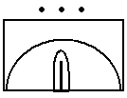

ANNEX F TO
SERIAL 3 OF EX KAASHE GBEYE BRAVO
DATED ………….. APR 24
(Yellow)

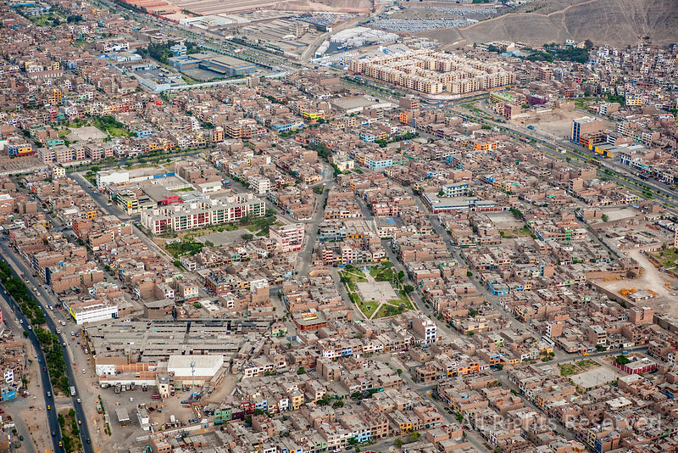
AIR PHOTOGRAPH OF ACCRA METROPOLIS

ARMY OFFICERS’ PRACTICAL PROMEX 2024
EXERCISE KAASHE GBEYE BRAVO
CAPTAIN TO MAJOR

SERIAL 4 TO
EX KAASHE GBEYE BRAVO
(Yellow)

NARRATIVE ONE AND REQUIREMENT ONE

NARRATIVE ONE

1. You are Comd 111 BG. Info available to you indicates that MILS elements are fomenting trouble within GA EAST, LA NKWANTANANG and ACCRA Metropolis with the intention of taking control of those areas so as to proceed and capture TEMA Port. After your meeting with the Bde Comd, you left immediately to prepare for the impending operation. As you were about to enter your room, Bde Comd called to give you some additional information. “Comd Sharp, I forgot to add that, the Bde Conc area is at MICHEL CAMP. I want you to conc your BG there and commence preparation imm. I have sent my dispatch rider to deliver an encoded msg to you so stand by”.

2. While waiting to receive the msg from the Bde dispatch rider, you reflected on the happenings in the area, especially within GA EAST, LA NKWANTANANG and ACCRA Metropolis. As you anticipated your future task and AOR the dispatch rider delivered the msg to you. You immediately called your Ops Offr and IO to stand by with the Master Ops and other relevant maps.

REQUIREMENT ONE

3. As CO 111 BG:
a. Mark out your area of Operational Responsibility. (Note: Eastings 72 – 89, Northing 34 – 62)
b. Decode the encoded msg from your Bde Comd.
c. React to the msg.
d. Issue yours to subordinate Comds.
e. Hand over your Playfair worksheet, decoded msg and your msg to sub-units to the DS.

TIMINGS
4. Consider - 40 mins.
5. Deliver - 30 mins.

SCORING
6. HPS - 40.
7. Pass Mark - 24.

8. Playfair Code
a. 150600 – 160600ZAPR24 GYINAPINTIIN.
b. 160600 – 170600ZAPR24 PROFESSIONAL.
c. 170600 – 180600ZAPR24 KAASHE GBEYE B.
d. 180600 – 190600ZAPR24 MANOUEVRISTS.
e. 190600 – 200600ZAPR24 WAYS AND MEANS.
f. 200600 – 210600ZAPR24 SUPERIORCOMD.
g. 210600 – 220600ZAPR24 FIRM RESPONSE.

9. Meteorology.
a. First Li – 0530 hrs.
b. Last Li – 1830 hrs.
c. Weather:
(1) Misty/Foggy.
(2) Wind – 8.0 SW.
(3) Temperature – 28 – 32 degrees Celsius.
(4) Humidity – 80 -90 per cent.
(5) Visibility – 200m.
(6) Precipitation – Moderate rains with lightning.

ANNEX A TO
SERIAL 4 OF EX KAASHE GBEYE BRAVO
DATED …………………………. APR 24
(Yellow)
ENCODED 11 BDE GP WNG O
GP 105
PBDMR NAVSR EGO1O CESEN AT1AT
GPKND ODOAL T0EDV PQALS OPMLA
IEEWR ALGIM THCRD EGLES TTPRP
COAN1 0PT0A SLKGW ITWRP SWHCP
SSOCL GRTDO OLRUM AIEWS ITIPA
EE1DM EXOEP LTIRI EORER 1TRDM
TOLN1 ENFIN UNPPC FOIB4 PRAHT
AKRSS OGRIT DAIBB FHFWR IWHBT
HAAWI ALSNC IH9XO CRPIL AAIFU
RENOE TOADI CEIAO AEDME ELACC
IUTCS I0CGM 2DLAE DMNSE NDATC
AMATO INASR ITEAM CNLMO SLELG
ZRM1B CTXBN LIIAD TAIRP NPSAS
REOEN DMENM NTTNF NREDP CA0EM
RYOEG HCDRD GRPDR ADLAI EIDFI
OCAMA OELOP WM2ED ZPEDE GSNTC
1ONNA DPAEN EEGRR PESAI LGYRM
UGOSN RCN0G DPAVT OBEGT RRENB
EDMAT CTNRE IGAIN ICSCR RA16E
PM4CS CHPDE ETONL IASEP VLMIR
EOGPS NTYAA ADELM DB0TI 8TSAX

ANNEX B TO
SERIAL 4 OF EX KAASHE GBEYE BRAVO
DATED ……………………. APR 24
(Yellow)
PLAYFAIR WORKSHEET

ARMY OFFICERS’ PRACTICAL PROMEX 2024
EXERCISE KAASHE GBEYE BRAVO
CAPTAIN TO MAJOR

ANNEX C TO
SERIAL 4 OF EX KAASHE GBEYE BRAVO
DATED ………………………….. APR 24
(Green)
DS GUIDELINES AND POSSIBLE SOLUTION TO REQUIREMENT ONE

NARRATIVE ONE

1. You are Comd 111 BG. Info available to you indicates that MILS elements are fomenting trouble within GA EAST, LA NKWANTANANG and ACCRA Metropolis with the intention of taking control of those areas so as to proceed and capture TEMA Port. After your meeting with the Bde Comd, you left immediately to prepare for the impending operation. As you were about to enter your room, Bde Comd called to give you some additional information. “Comd Sharp, I forgot to add that, the Bde Conc area is at MICHEL CAMP. I want you to conc your BG there and commence preparation imm. I have sent my dispatch rider to deliver an encoded msg to you so stand by”.

2. While waiting to receive the msg from the Bde dispatch rider, you reflected on the happenings in the area, especially within GA EAST, LA NKWANTANANG and ACCRA Metropolis. As you anticipated your future task and AOR the dispatch rider delivered the msg to you. You immediately called your Ops Offr and IO to stand by with the Master Ops and other relevant maps.

REQUIREMENT ONE

3. As CO 111 BG:
a. Mark out your area of Operational Responsibility. (Note: Eastings 72 – 89, Northing 34 – 62)
b. Decode the encoded msg from your Bde Comd.
c. React to the msg.
d. Issue yours to subordinate Comds.

Note: Candidates are not expected to do a ground orientation/christening at this stage.

TIMINGS

4. Consider - 40 mins.
5. Deliver - 30 mins.

SCORING
6. HPS - 40.
7. Pass Mark - 24.

8. Playfair Code
a. 150600 – 160600ZAPR24 GYINAPINTIIN.
b. 160600 – 170600ZAPR24 PROFESSIONAL.
c. 170600 – 180600ZAPR24 KAASHE GBEYE B.
d. 180600 – 190600ZAPR24 MANOUEVRISTS.
e. 190600 – 200600ZAPR24 WAYS AND MEANS.
f. 200600 – 210600ZAPR24 SUPERIORCOMD.
g. 210600 – 220600ZAPR24 FIRM RESPONSE.

AIM

9. This reqmt is aimed at testing the knowledge of candidates on:

a. Map marking and the use of correct map symbols.

b. Decoding of Encoded Text.

c. Acknowledgement and issuing of own wng o.

d. Preparation for IS/COIN operations.

SUGGESTED APPROACH

10. Review of Sit / Map Marking.
a. Candidates are to review the sit to set the stage for all other discussions. Candidates are expected to clearly mark their maps with the aval Info/Int. Info aval is found in the Gen and Special Ideas and INTSUM given. A marked map of the AO is attached to DS guide as a checklist.

b. DS are to inspect candidates’ maps for the fol:

(1) Sy Classification.
(2) North Pointer.
(3) A set of 3 Coordinates.
(4) Map title in Block Letters (underlined).
(5) Time Zone used Throughout (underlined where nec).
(6) Expected en Loc/Incidents.
(7) Depl of own Forces.
(8) Map Refs (underlined where nec).
(9) Sit as at …………..(underlined where nec)

c. Map Marking. FF and En posns.

d. Decoding of Playfair Text. The candidates are to decode the encoded Bde Gp Wng O. DS are to inspect the candidates' work and assess how they got their answers. Candidates who are unable to decode their msgs should be given a copy of the decoded msg. Such candidates would lose the marks for that part of the reqmt.

Appendices:
1. Sample of Marked Map.
2. Marked 111 BG AOR.

3. Decoded 11 BDE GP Wng O.
4. Ack of Wng O.
5. 111 BG Wng O.

APPENDIX 1 TO
ANNEX C TO
SERIAL 4 OF EX KAASHE GBEYE BRAVO
DATED ……………………….. APR 24
(Green)

SAMPLE OF MARKED MAP

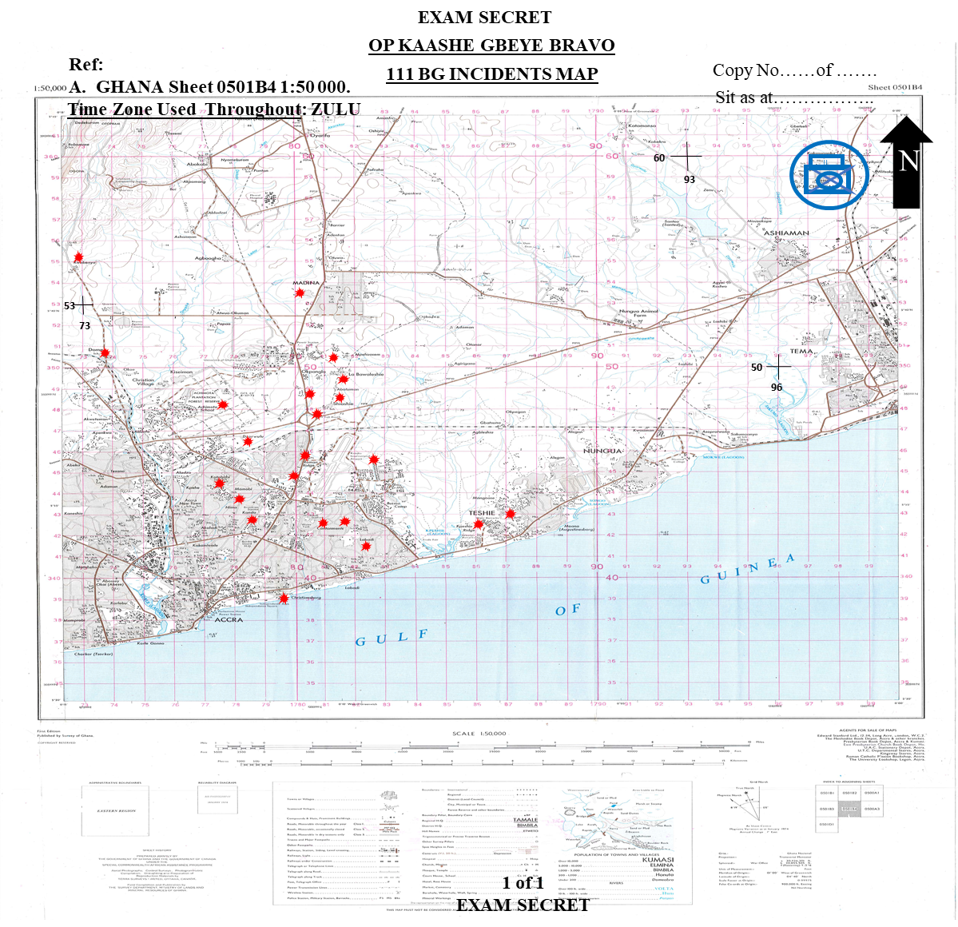

APPENDIX 2 TO
ANNEX C TO
SERIAL 4 OF EX KAASHE GBEYE BRAVO
DATED ……………………….. APR 24
(Green)
MARKED 111 BG AOR

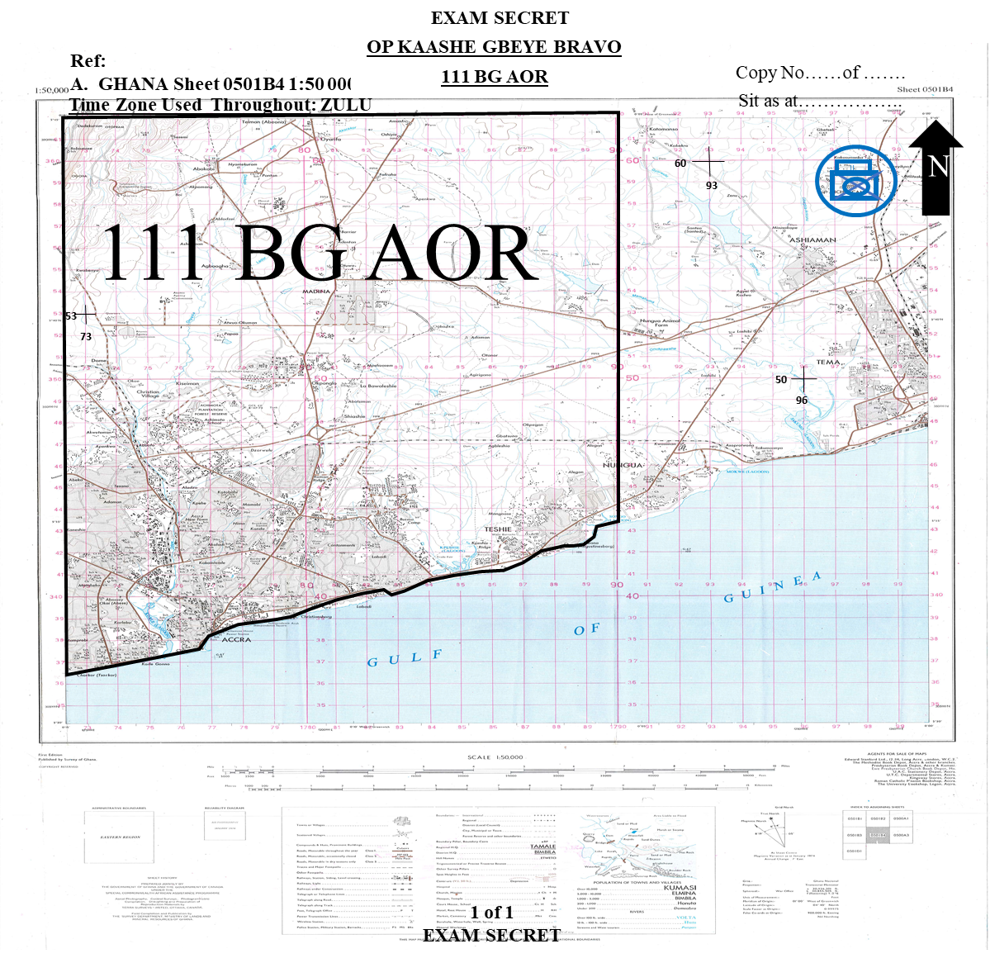

APPENDIX 3 TO
ANNEX C TO
SERIAL 4 EX KAASHE GBEYE BRAVO
DATED ………………………. APR 24
(Green)
DECODED MSG OF 11 BDE GP WNG O
 | M | A | N | O | U | E | V | R | I | S | T | S
 | 4 | 1 | 5 | 6 | 11 | 2 | 12 | 7 | 3 | 8 | 10 | 9
 | O | P | K | A | A | S | H | E | G | B | E | Y
 | E | B | R | A | V | O | P | D | W | N | G | O
 | P | D | S | I | T | P | D | M | I | L | S | E
 | L | M | S | F | O | M | E | N | T | I | N | G
 | T | R | O | U | B | L | E | S | W | I | T | H
 | I | N | G | R | E | A | T | E | R | A | C | C
 | R | A | R | E | G | I | O | N | P | D | 1 | D
 | I | V | I | N | T | E | N | D | S | T | O | R
 | E | S | T | O | R | E | L | A | W | A | N | D
 | O | R | D | E | R | W | I | T | H | I | N | G
 | R | E | A | T | E | R | A | C | C | R | A | R
 | E | G | I | O | N | A | S | A | P | P | D | P
 | R | O | B | A | B | L | E | M | S | N | P | D
 | 1 | 1 | B | D | E | G | P | A | S | P | A | R
 | T | O | F | 1 | D | I | V | T | O | S | E | A
 | R | C | H | C | M | M | L | O | C | A | N | D
 | D | E | F | E | A | T | M | I | L | S | E | L
 | M | S | W | I | T | H | I | N | G | R | E | A
 | T | E | R | A | C | C | R | A | R | E | G | I
 | O | N | I | O | T | R | E | S | T | O | R | E
 | L | A | W | A | N | D | O | R | D | E | R | I
 | N | T | H | E | R | E | G | I | O | N | P | D
 | 1 | 1 | B | D | E | G | P | T | O | D | E | F
 | E | A | T | M | I | L | S | E | L | M | S | I
 | N | T | H | E | G | E | N | A | R | E | A | O
 | F | G | A | E | A | S | T | M | U | N | I | C
 | I | P | A | L | I | T | Y | C | M | M | L | A
 | N | K | W | A | N | T | A | N | A | N | G | M
 | U | N | I | C | I | P | A | L | I | T | Y | A
 | N | D | A | C | C | R | A | M | E | T | R | O
 | P | O | L | I | S | P | D | O | W | N | M | E
 | P | D | S | U | C | C | E | S | S | F | U | L
 | C | O | N | T | R | O | L | L | I | N | G | O
 | F | A | C | C | R | A | M | E | T | R | O | P
 | O | L | I | S | A | N | D | L | I | E | S | W
 | I | T | H | 1 | 1 | 1 | B | G | P | D | N | M
 | B | 0 | 9 | 0 | 6 | 0 | 0 | Z | A | P | R | 2
 | 4 | E | X | C | E | P | T | R | E | C | C | E
 | P | D | O | G | P | T | I | M | E | A | N | D
 | R | V | C | M | M | 0 | 8 | 1 | 1 | 0 | 0 | Z
 | A | P | R | 2 | 4 | A | T | B | D | E | G | P
 | H | Q | P | D | C | S | S | C | M | M | D | E
 | T | A | I | L | S | L | A | T | E | R | P | D
 | A | L | L | A | C | K | X | X | X | //////// | ///// | //////
 | //////// | ////// | ///// | ////// | ////// | ////// | ///// | ///// | ///// | ///// | ///// | /////
 | ///// | ///// | ///// | /////// | /////// | ////// | ////// | ////// | ////// | ////// | ////// | //////
 |  |  |  | ////// | //// | /////// | ////// | ////// | ////// | ////// | ////// | //////
 | ////// | ////// | ////// | ////// | //// | ////// | ////// | ////// | ////// | ////// | ////// | //////
 | ////// | ////// | ////// | ////// | //// | ////// | ////// | ////// | ////// | ////// | ////// | //////
 | ////// | ////// | ////// | ////// | //// | ////// | ////// | ////// | ////// | ////// | ////// | //////

APPENDIX 3 TO
ANNEX C TO
SERIAL 4 OF EX KAASHE GBEYE BRAVO
DATED ………………………. APR 24
(Yellow)
11 BDE GP WARNING ORDER

FM: 11BDEGP 061700Z APR 24
TO: 111 BG
112 BG
113 BG
ARMDRECCESQN
ENGRSQN
BTYARTY
INFO: 1 DIV HQ 11BDE GP/OPS/01/24
OP KAASHE GBEYE BRAVO PD WNG O PD SIT PD MILS ELMS FOMENTING TROUBLES WITHIN GREATER ACCRA REGION PD 1 DIV INTENDS TO RESTORE LAW AND ORDER WITHIN GREATER ACCRA REGION ASAP PD PROBABLE MSN PD 11 BDE GP AS PART OF 1 DIV TO SEARCH CMM LOC AND DEFEAT MILS ELMS WITHIN GREATER ACCRA REGION IOT RESTORE LAW AND ORDER IN THE REGION PD 11 BDE GP TO DEFEAT MILS ELMS IN THE GEN AREA OF GA EAST MUNICIPALITY CMM LA NKWANTANANG MUNICIPALITY AND ACCRA METROPOLIS PD OWN ME PD SUCCESSFUL CONTROLLING OF ACCRA METROPOLIS AND LIES WITH 111 BG PD NMB 090600Z APR 24 EXCEPT RECCE PD OGP TIME AND RV CMM 081100Z APR 24 AT BDE GP HQ PD CSS CMM DETAILS LATER PD ALL ACK/////

APPENDIX 4 TO
ANNEX C TO
SERIAL 4 OF EX KAASHE GBEYE BRAVO
DATED ……………………………. APR 24
(Green)
ACK OF 11 BDE GP WNG O

FM: 111 BG 06………ZAPR24
TO: 11 BDEGPHQ
INFO: 112 BG
113 BG
ARMDRECCESQN
ENGRSQN
BTYARTY 111BG/OPS/01/24

OP KAASHE GBEYE BRAVO PD REF 11BDE GP/OPS/01/24 OF 06………Z APR 24 PD RECEIPT ACK///

APPENDIX 5 TO
ANNEX C TO
SERIAL 4 OF EX KAASHE GBEYE BRAVO
DATED ……………………………. APR 24
(Green)
111 BG WNG O

FM: 111BG 06………ZAPR24
TO: A CT
B CT
C CT
D CT
TP ARMDRECCE
TP ENGR
INFO: 11 BDEGPHQ
FOO 111 BG/OPS/02/24
OP KAASHE GBEYE BRAVO PD WNG O PD SIT PD MILS ELMS FOMENTING TROUBLES WITHIN GREATER ACCRA REGION PD 11BG INTENDS TO RESTORE LAW AND ORDER WITHIN GA EAST MUNICIPALITY CMM LA NKWANTANANG MUNICIPALITY AND ACCRA METROPOLIS ASAP PD PROBABLE MSN PD 111 BG AS PART OF 11 BDE GP TO SEARCH CMM LOC AND DEFEAT MILS ELMS WITHIN GA EAST MUNICIPALITY CMM LA NKWANTANANG MUNICIPALITY AND ACCRA METROPOLIS IOT RESTORE LAW AND ORDER WITHIN AOR PD 111 BG TO DEFEAT MILS ELMS IN THE GEN AREA OF GA EAST MUNICIPALITY CMM LA NKWANTANANG MUNICIPALITY AND ACCRA METROPOLIS PD OWN ME PD SUCCESSFUL CONTROLLING OF ACCRA METROPOLIS AND LIES WITH C CT PD NMB 090600Z APR 24 EXCEPT RECCE PD OGP TIME AND RV CMM 131300Z APR 24 AT BG HQ PD CSS CMM DETAILS LATER PD ALL ACK/////

ANNEX D TO
SERIAL 4 OF EX KAASHE GBEYE BRAVO
DATED …………………………… APR 24
(Pink)
DS MARKING GUIDE/SCORE SHEET

DIRECTING STAFF NAME ……………………………………… GH ………………..
REQUIREMENT ONE

Candidate’s Index Number……………………………...
Stand: ………….

Srl | Details | HPS | Score | Remarks
(a) | (b) | (c) | (d) | (e)
1. | Review of Sit | 2
2. | Marked AOR. | 2
3. | Sub Total | 4
4. | Map Marking.  a. Friendly Forces.  b. MILS act | 3  3
5. | Sub Total | 6
6. | Playfair.  a. Use of correct key.  b. Correct numbering of keys.  c. Decoding of text. | 2  2  11
7. | Sub Total | 15
8. | Ack of 111 BG Wng O | 2
9. | Sub Total | 2
10. | WNG O OF C CT  Sit  Probable Msn  Own ME  Timings  O Gp RV and time  CSS  ACk | 2  2  2  2  2  2  1
11. | Sub Total | 13
12. | TOTAL | 40

ARMY OFFICERS’ PRACTICAL PROMEX 2024
EXERCISE KAASHE GBEYE BRAVO
CAPTAIN TO MAJOR
SERIAL 5 TO
EX KAASHE GBEYE BRAVO
(Yellow)
NARRATIVE TWO AND REQUIREMENT TWO

NARRATIVE TWO

1. Your engagement with the key stakeholders has given you a deeper understanding of the sit in the AO. You are very much aware of the operational environment and the modus operandi of the MILS fighters and therefore poised to deal with them. Your Wng O and the INTSUM cfm the need for a mil intervention to maintain/restore law and order as appropriate. Note that your battle procedure/preparation starts from 061700Z APR 24.

2. You retired to your accn to plan for the imminent depl of your tps to dominate the area. Lo and behold, your Adjt approached you with an envelope containing Extracts of your Bde Comds OPORD for the pending Ops. The details of the OPORD extracts are contained in Annex A.

REQUIREMENT TWO

3. As 111 BG Comd, conduct Stage 1 (Q1 to Q3) of your Combat Estimate. Be prepared to back-brief your Bde Gp Comd represented by the DS on the fol:
a. Terrain Analysis.
b. Weather/Met Analysis.
c. Human Terrain Analysis (HTA).
d. Threat Evaluation - COWARD/ROBOT, HVT/HPTL, En Intent Schematic.
e. Situation Integration – Situation Overlay, Event Overlay, Draft DSO, Draft ICP.
f. MLCOA/MDCOA.
d. Mission Analysis.
e. Comd’s Intent Statement.
f. Comd’s Effects Schematic.
g. Submit the following products; Time Analysis/Matrix, HVT/HPTL, Threat MLCOA/MDCOA, Priotization/Msn Essential Tasks, CCIRs/RFIs/Clarifacation/ Planning Guidance and Directions you need to develop your plan.
TIMINGS
4. Consider - 120 mins.
5. Deliver - 60 mins.
SCORING
6. HPS - 125 Marks.
7. Pass Mark - 75 Marks.

Annexes:
A. Extracts of 11 Bde Gp OPORD 01/24.

B. DS Guide and Possible Solution to Requirement Two.

C. DS Marking Guide and Score Sheet for Requirement Two.

ANNEX A TO
SERIAL 5 EX KAASHE GBEYE BRAVO
DATED ………………………… APR 24
(Yellow)
EXTRACTS FROM 11 BDE GP OPO 1/24
Ref:

A. GHANA Sheet 0501B4 1:50,000.

Time Zone Used Throughout the Order: ZULU.

Task Org: As Issued.

1. SITUATION

a. MILS. Addl to Special Ideas and INTSUM.

(1) Str. Unknown.
(2) Loc. Hideout in bases and camps in Greater Accra Region.
(3) Dress. Assorted Mil Uniform/Civil.
(4) Wpns. AK47, MGs, Grenades, Automatic Wpns, Explosives.
(5) Intention. To take control of important facilities and infrastructures within ACCRA Metropolis and proceed to cease TEMA Port.
(6) Tactics.
(a) Hit-and-Run and Ambushes.
(b) Ability to make a clean break from any contact
(c) Aggressive fighting ptls in the neighbourhood of their firm bases.
(d) Inducement of persuit with the object of luring the opposition into ambushes.
(e) Empl of small stay-behind parties of single MGs and snipers possibly protected by mines and booby traps, to force attk troops to depl away from selected approach routes and thereby delay their advance.
(f) Counter-attacks likely to be quickly executed but in minor strength as reserves will be held some distance away.
g) Light reconnaissance patrols placed well forward on all likely approach routes to give early warning.

(h) Covering troop positions some 1,000 to 2,000 metres forward of the main position.
- The main position itself, well-constructed and concealed.

b. Friendly Forces.

- COAS
(a) Intent. COAS intends to assist the Civil Auth to restore/maintain law and order in the Greater Accra Region.
(b) ME. The defeat of MILS and lies with 1Div.

(2) 1 DIV
(a) Mission. To defeat MILS IOT assist Civ Auth restore/maintain law and order in the Greater Accra Region ASAP.
(b) CONOPS.
(i) Intent. To defeat MILS within Greater Accra Region and restore/maintain law and order.
(ii) SoM. Conduct Ops using 11 Bde Gp to search, loc and defeat MILS elements within Greater Accra Region with 12 and 13 Bde Gp as res sp by Armd Recce Regt, Arty Regt, FGA and Engr Regt.
(iii) ME. The defeat of MILS within GA EAST, LA NKWANTANANG and ACCRA Metropolis and lies with 11 Bde Gp.
- Locals.
- Mixture of Ga Adangbe, Akans, Ewes and Hausas.
- Majority are friendly and loyal to the Govt and Security forces.
- Chiefs and Opinion leaders are a good int source.
- Some locals hold allegiance to the MILS and sp their cause.
- Discretionary engagement should be employed.

2. MISSION. 11 Bde Gp to search, loc, and defeat MILS in the gen areas of GA EAST, LA NKWANTANANG and ACCRA Metropolis IOT assist the Civ Auth restore/maintain law and order in the Greater Accra Region ASAP.

3. EXECUTION.

- CONOPS.

(1) Intent. Defeat MILS elements within GA EAST, LA NKWANTANANG and ACCRA Metropolis.

(2) SoM. 111BG to conduct an independent IS/COIN Op to defeat MILS fighters in the gen areas of GA EAST, LA NKWANTANANG and ACCRA Metropolis with 112BG and 113BG in res sp by Sqn Armd Recce, 2 x Bty Arty, Sqn Engr, Sect UAV, Sect SF, Sect EOD, ACCRA Regional Pol and NIB.

(3) ME. Successful control of GA EAST, LA NKWANTANANG and ACCRA Metropolis and it lies with 111 BG.

b. Mission and Tasks to Sub-Units.

(1) 111 BG.

(a) Mission/Task

i. Control AOR.

ii. Assist the Civ Pol to restore/maintain law and order.

iii. Stand by for any other task on order.

All IOT defeat MILS within GA EAST, LA NKWANTANANG and ACCRA Metropolis in the Greater Accra Region.

(2) 112 BG. Be prep to rft 111BG during Op.

(3) 113BG. Reserve.

(4) Sqn Armd Recce. Intimate fire sp and rear area sy. Det Tp Armd Recce to 111 BG under OPCOM.

(5) Bty Arty. Provide indirect fire sp for 111 BG.

(6) Sqn Engr. Provide engr sp for the op.

c. Co-ord Instrs.

- Timings.

- D - Day is 27 APR 24.
- Time now - 061700ZAPR 24.

- Depl completed by – 271800Z APR 24.

- SP. MICHEL CAMP.

- Route. BGs to determine.

- Road Classification.

(a) MICHEL CAMP – TEMA MOTORWAY - Grey.

(b) TEMA MOTORWAY - AOR - Black.

(5) Bdrys. 111 BG bdry is Eastings72-89 and Northings 34-62.

(6) ROE for IS Ops to be adhered to.

4. SERVICE SUPPORT. As per SOP.

5. COMMAND AND SIGNAL.

a. Loc of HQs.

(1) Bde HQ - MICHEL CAMP

(2) BG HQ - BG Comd to determine

- Nicknames.

Srl | Nickname | Meaning
(a) | (b) | (c)
1. | FAST LANE | AOR
2. | HARD CORE | Bde HQ
3. | KANKPE BOYS | MILS Elms

c. Codewords.
Srl | Codeword | Meaning | Issued by
(a) | (b) | (c) | (d)
1. | YENKO | Op commences | CO 111 BG
2. | YAAMOTU | Op completed | CO 111 BG
3. | OGYA | Rft required | CO 111 BG
4. | SUCCESS | BG return to base | BDE COMD
5. | MUTEY | Terminate op and wdr | BDE COMD

SWK PARBEY
Brig Gen
Bde Gp Comd

Authenticated

ET NELSON
Col
COO
ARMY OFFICERS’ PRACTICAL PROMEX 2024
EXERCISE KAASHE GBEYE BRAVO
CAPTAIN TO MAJOR

ANNEX B TO
SERIAL 5 OF EX KAASHE GBEYE BRAVO
DATED …………………. APR 24
(Green)
DS NOTES AND GUIDELINES TO REQUIREMENT TWO
NARRATIVE TWO

1. Your engagement with the key stakeholders has given you a deeper understanding of the sit in the AO. You are very much aware of the operational environment and the modus operandi of the MILS fighters and therefore poised to deal with them. Your Wng O and the INTSUM cfm the need for a mil intervention to maintain/restore law and order as appropriate.

2. You retired to your accn to plan for the imminent depl of your tps to dominate the area. Lo and behold, your Adjt approached you with an envelope containing Extracts of your Bde Comds OPORD for the pending Ops. The details of the OPORD extracts are contained in Annex A.

REQUIREMENT TWO

3. As 111 BG Comd, conduct Stage 1 (Q1 to Q3) of your Combat Estimate. Be prepared to back-brief your Bde Comd represented by the DS on the fol:
a. Terrain Analysis.
b. Weather/Met Analysis.
c. Human Terrain Analysis (HTA).
d. Threat Evaluation - COWARD/ROBOT, HVT/HPTL, En Intent Schematic.
e. Situation Integration – Situation Overlay, Event Overlay, Draft DSO, Draft ICP.
f. MLCOA/MDCOA.
d. Mission Analysis.
e. Comd’s Intent Statement.
f. Comd’s Effects Schematic.

TIMINGS
4. Consider - 120 mins.
5. Deliver - 60 mins.
SCORING
6. HPS - 125 Marks.
7. Pass Mark - 75 Marks.

AIM

8. The aim of this requirement is to test candidates’ ability to use the 7 Questions Combat Estimate Format to develop a timely, insurgent-focused and effects-based plan to assist the local auth to restore/maint law and order.

SUGGESTED APPROACH

9. DS to be guided by the IS/COIN Estimate Format using the 7 Questions. This reqmt demands that candidates carry out an estimate for an IS/COIN op in a Gen Sit. Candidates are expected to produce the complete outputs for this requirement. DS should also carry out an inspection of candidates’ maps to ensure that all details of the sit that can be marked have been done. These should incl flash pts, loc of vital Instl for VPs/KPs, proposed depl, Ptl routes, Govt buildings, holding areas, etc. Candidates are expected to do a ground orientation/christening. The following sequence is recommended.
a. Indicate present loc.
Candidates are not req to consider this point considering the non-conventional nature of the ops and the adversary invl. Unless it’s for ref only. They should be using the Municipal boundries
b. Indicate dir of North.
c. Indicate Axis/12 O’Clock.
d. Indicate full left and full right.
Indicate foreground, middle distance and distance.
e. Ground christening.
f. Ground description taking note of important landmarks.

QUESTION 1: WHAT IS THE SITUATION AND HOW DOES IT AFFECT ME?

10. Candidates should talk the DS through their marked maps as a background to the discussion of the 4 distinct steps under Question 1. These steps are the Battle Area Evaluation (BAE) /Human Terrain Analysis (HTA), Threat Evaluation (TE) and Threat Integration (TI) as follows:

a. Battlefield Area Evaluation (BAE). The BAE step must highlight the effects the ground and environment will have on both own and MILS forces. For such a special op, candidates are to use either of the mnemonics: ROBOT/OCOKA method of terrain analysis to fit the operational concept to Dominate an Area. These are the principal factors that should be analysed by candidates. It also incl analysis of the effects of weather on the op.

b. Human Terrain Analysis (HTA). The key with HTA is to identify local enablers that can be exploited IOT improve sp for own troops while denying or reducing support for MILS among the population. Candidates are not expected to produce a detailed analysis. However, IOT determine whether candidates have a holistic understanding of the op environment, DS should ask candidates to relate their analysis to the Area, Structures, Capabilities, Org, People and Events using the mnemonic ASCOPE as well as Political, Military, Economic, Social, Information, Infrastructure, Physical and Time (PMESII-PT) matrix. A third HTA tool that can be used by students in combination with any of the 2 above as an analytical matrix is Political, Economic, Social, Technological, Legal, Environment and Information (PEST/PESTLEI).

c. Threat Evaluation. This step consists of a series of discrete actions aimed at reviewing ‘What We Know’ about MILS (Facts) and ‘What We Think We Know’ (Assessment) IOT inform us of How MILS might try to achieve its intent. Assessment of MILS’s Capabilities, Org, Wpns and Eqpt, Asymmetric Tac, Rfts and Doctrine using the mnemonic COWARD can help in analyzing MILS basic threat reqmt based on its doctrine (for MILS). To do this, a candidate must have gone through 3 stages of identifying Adversary Capability, Description, Tactics and Identification of Vulnerabilities. Throughout this analysis, int gaps (What We Don’t Know) should be identified by candidates incl critical req. At this stage candidates should begin to formulate some Comd’s Critical Info Reqmts (CCIR). Candidates should also ‘show’ the Doctrinal Overlay, which is a product of the Threat Evaluation to portray how MILS would operate in a built-up area taking into consideration other environmental factors. Finally, from the Threat Evaluation, candidates should also be able to id MILS’s High Value and High Payoff Tgts and Vulnerabilities.

d. Situation/Threat Integration. In the fourth step of Question 1, the results of the BAE are combined with the results of the Threat Evaluation. Threat integration seeks to id how operationally, MILS’s doctrine will be shaped by the ‘battlefield’ and environment. From the outcome of the threat sit/integration candidates should produce the MILS’s Intent or Effects Schematics as well as MILS’s Most Likely/Most Dangerous COA. The Sit and Event overlays must also be produced.

QUESTION 2: WHAT HAVE I BEEN TOLD TO DO AND WHY?

11. This question is to tests candidates’ understanding of his Superior Comd’s intentions and the given msn. Candidates must also show understanding of the effects his comd seeks to achieve and his own contribution to the overall desired effect(s). After stating the msn exactly as given him, candidates will be required to conduct 4 stages of interconnected analysis namely; Intentions of their Comds 2 levels up/1 level up and their role in the Comd’s plan, Specified/Implied Tasks, Freedoms/Constraints and finally determine whether the tac sit has changed and how it might affect the given mission. Candidates must come out with their CCIRs, RFIs, Clarifications, etc to enhance their decision-making and show how it will eventually affect the successful formulation of the plan. DS is to ensure that candidates identify their specified tasks and implied tasks appropriately and SOPs are not to be accepted as deductions.

QUESTION 3: WHAT EFFECTS DO I NEED TO ACHIEVE AND WHAT DIRECTION MUST I GIVE TO DEVELOP MY PLAN?

12. Candidate’s plan must begin to take shape at this stage. Candidates should therefore begin to formulate the winning ideas and the effects (kinetic, non-kinetic or offensive, defensive or psychological) they wish to have on MILS and the pop. These effects should be articulated to the DS using Effects Schematics with each Effect having a purpose to clarify the intent. Addl, candidates must use the Tactical Functions or Principles of the Ops or War as a basis for the dev of their plans. Candidates should be ready to articulate their ME effect, and a probable Winning Concept or COAs. DS should be flexible and not expect candidates to have the very same Effects Schematics as provided in this guide due to differences in tac judgment. Addl, candidates should also give directions using the tac functions, the principles of war or the principles of that particular Ops. DS to note that Effects are different from Actions since candidates may confuse them for each other. Effects are the change brought about in a target (Objective) by the consequence of an action or activity. An objective is an object (target) that the change is sought upon through an effect.

POSSIBLE SOLUTION TO REQUIREMENT TWO

13. Possible Timeline.

a. TIME NOW – 061700Z APR 24.
- TIME TO OCCUPY AOR -- 271800Z APR 24.
- TOTAL TIME AVAILLABLE -- 21 DAYS 1 HR.
d. OPERATIONAL TIME -- 10 HRS.
(1) REHEARSAL (1HR)
(2) MOV (2 HRS)
(3) BUFFER (1 HR)
(4) DEPL ( 6 HRS)
e. PLANNING TIME (1/3, 2/3) -- 20 DAYS 15 HRS.
f. SUBORDINATES TIME (2/3) -- 13 DAYS 18 HRS.
g. COMD PLANNING TIME/BP -- 6 DAYS 21 HRS.
(1) ACK WNG O BY (1HR) -- 061800Z APR 24.
(2) EST COMPLETED BY (2 HRS) -- 062000Z APR 24.
(3) WNG O ISSUED BY (2 HRS) -- 062200Z APR 24.
(4) COMPLETE RECCE BY (15 HRS) -- 071300Z APR 24.
(5) COMPLETE Q0 BY (12 HRS) -- 080100Z APR 24.
(6) COMPLETE Q1 BY (12 HRS) -- 081300Z APR 24.
(7) COMPLETE Q2 BY (12 HRS) -- 090100Z APR 24.
(8) COMPLETE Q3 BY (12 HRS) -- 091300Z APR 24.
(9) COMPLETE Q4 BY (12 HRS) -- 100100Z APR 24.
(10) COMPLETE Q5 BY (12 HRS) -- 101300Z APR 24.
(11) COMPLETE Q6 BY (12 HRS) -- 110100Z APR 24.
(12) COMPLETE Q7 BY (12 HRS) -- 111300Z APR 24.
(13) COMPLETE PLAN BY (24 HRS) -- 121300 Z APR 24.
(14) COMPLETE Os PREPARATION BY (24 HRS)-- 131300Z APR 24.
(15) O GP (1 HR) -- 131400Z APR 24.
h. SUBs BP and O GP COMPLETED BY -- 270800Z APR 24.

061700Z APR 24

ACK WNG O 061800Z APR 24
TIME/MAP EST 062000Z APR 24
ANNEX A TO…...
EX KAASHE GBEYE BRAVO
DATED………. APR 24
111 BG TIMELINE MATRIX
ST 271030 APR 24
RECCE 071300Z APR 24
WNG O 062200Z APR 24
080100Z APR 24
081300Z APR 24
TIME NOW
271800Z APR 24
TIME TO OCCUPY AOR
131400Z APR 24
Q1
090100ZAPR 24
Q2
Q3
Q4
Q5
COMD OGP
COMD PLANNING TIME (6 DAYS 21 HRS)
Q6
Q7
091300ZAPR24
100100ZAPR24
101300ZAPR24
110100ZAPR24
111300ZAPR24
SUB COMD BP AND O GP ( 13 DAYS 18 HRS)
270800 APR 24
REH 271000 APR 24
BUFFER 271100 APR 24
MOV 271200 APR 24
DEPL 6HRS
Q0
14. Ground Orientation. It should be in the sequence as fols:

a. Indicate present loc.
Candidates are not req to consider this point considering the non-conventional nature of the ops and the adversary invl. Unless it’s for ref only. They should be using the Municipal boundries

b. Indicate dir of North.

c. Indicate Axis/12 O’clock.

d. Indicate full left and right.

e. Indicate fore ground, middle distance and distance.

f. Indicate bdrys.

g. Ground christening.

h. Important landmarks should be stated.

15. Ground General Description. The ground is generally undulating. It is good going for both armr and inf. It is however marshy at the banks of the many streams and rivers which crisscross the area during the rainy season. The prominent high grds are OGOHA Hill, LEGON Hill, BURMA Hill and AIRPORT Hill. The area is drained by River ODAW, KORDJOR, ONUKPAMAHE, ONYASIA, LADOR, DAKOBI, AKORAKOR, DZORWULU, KPESHIE LAGOON, SONGO LAGOON, MOKWE LAGOON, SAKUMONO LAGOON and the ATLANTIC OCEAN. The vegetation is open and mainly savanna type dominated by farmlands and shrubs. The main settlements in the area are KWABENYA, DOME, MADINA, CANTONMENTS, ACHIMOTA, DZORWULU, LEGON, ASHALEY-BOTWE, SPINTEX, ASHAIMAN, TESHIE and LA. The comm networks in the area are Rds TEMA – LA BEACH RD, TEMA MOTORWAY – SHIASHIE – 37, OYARIFA – MADINA – 37, DZORWULU – 37 – LA and ACCRA – LA BEACH RD. There are numerous second and third class rds that crisscross the major towns and settlements.
16. Deductions.

a. Ground is hard standing for Inf and Armr Units. However, marshy and flood prone areas will restrict mov to rds and tracks. Need to cover rds on likely threats. High grds LEGON Hill, BURMA Hill and AIRPORT Hill provide good OP and obsn which will enhance surveillance activities of opposing forces.

b. River ONUKPAWAHE and other streams likely to be rft with obs and covered with fire by MILS. Engr recce parties and asslt pnr to breach obs and to facilitate mov of own tps.
c. Settlements dominated by numerous concrete storey buildings and isolated storey buildings which provide good cover and good fds of fire for MILS. Settlements afford own forces concealed mov and protection but also offer MILS cover from which to fight and terrorise inhabitants. MILS could possibly mine areas around settlements and use sniper fire to disrupt own force mov. MILS would likely stand and fight in built up areas and isolated villages. This could lead to IDP sit. Need to dominate the area and plan for early evac and con of IDPs. MP assistance to control traffic and IDPs.

d. First class rds offer fast approach route to own forces and MILS. Need to ensure Armr and Inf cooperation to maintain momentum. Patrol routes and road blocks of main artery. Other roads crisscrossing the area could be used as report lines.

e. High grds LEGON Hill, AIRPORT Hill and BURMA Hill are key terrain which should be denied to the MILS.

Question/Fact | Consideration/Deduction | Task/Output
(a) | (b) | (c)
Q1. WHAT IS THE SITUATION AND HOW DOES IT AFFECT ME?  a. Battlespace Area Evaluation (BAE).  (1) Routes (Leading into, within and out of AOR).  Rd TEMA - 37, OYARIFA - 37, SAKUMONO – LA, NSAWAM – CIRCLE, KASOA - 37 leads into the Op area through major settlements. Numerous 1st, 2nd and 3rd class rds crisscross the entire AO. The first class rds offer fast AA. Obsn within the corridor is good. | MILS to use good rds to facilitate ops.  All activities on major rds likely to be observed during the day.  MILS likely to empl IEDs along rds.  Most rds may define the AOR and sectors.  Rds to be used for re-sups.  Rds within could be used as ptl routes and inter sector bdrys when area is sectorised. | Task: Monitor insugents activities on rds.  Task: Need to depl standing and mobile patrols to dominate the area.  PG Need to conduct offensive ops.  PG: Depl under cover of darkness with limited mov in day time  PG: Need to depl EOD team for critical ops.  PG Sectorize AORs using major rds and other natural landmarks where nec.  Task: Dominate rds with Inf and Armr ptls.  Task: Estb Veh Check pts and carry out  snap ops on the road to check insurgent  activities
(2) Obstacles. The area has both natural and artificial obstacles. Rivers, high grds and settlements are some of the obs in the area. | Major settlements will restrict mov of MILS and own forces.  Some rivers may be dry during the period of op  MILS to rft obs with IED | PG: Id altn routes for ops.  Task: Depl ptls/Int agents within settlements to give early wng of MILS’ mov.  RFI: Drainage system in settlement areas to be cfm.  PG: EOD teams to be part of leading elms.  Task: Engrs to breach obs  RFI. Availability of special eqpt for op.
(3) Boundaries. Bdry for AOR covers the 3 Municipalities of GA EAST, LA NKWANTANANG AND ACCRA METRO. | MILS activites may fall outside of own demarcated boundries.  Bdrys may overlap in settlements area  AOR may be too large to be ocovered by aval troops. | PG Gather info within AII.  Clar: Engagement of MILS when outside AOR.  PG: Liaise with other Agencies outside AOR.  PG: Deconflict bdrys between sub-units.  PG: Consider sectorizing AOR into Sectors for sub-units.
Obsn. Hills OGOHA, LEGON and BURMA HILS provide good obsn and offers good fd of fire to own forces and MILS. Buildings in built up areas and villages obstruct obsn from low lying areas. Vegetation and farmlands offer good hideouts for MILS. The high buildings in the area also offers good view of any mov within the area. | MILS may use high grounds to monitor own activities during day time  High grounds may offer own forces good obsn of adversarys’ activities.  May be difficult to locate MILS in thick vegetation | PG: Need to operate under the cover of darkness.  RFI: NVGs.  Task: Deny use of high ground by MILS.  Effect: DENY  PG: Need for continues info gathering on MILS.  PG: Need to depl in areas that will afford better fds of view for the intervening areas btn own forces and other friendly forces.  Task: Depl and DOMINATE AOR.  PG: Deception Ops.  Effect: DOMINATE
5) Key Terrain. Key terrain incl LEGON Hill, MOD, KIA, JUBILEE HOUSE, BURMA CAMP, TESHIE CAMP, MICHEL CAMP, 1st class Rds MADINA – 37, ACCRA - TEMA MOTORWAY and SAKUMONO - LA. Others incl AIRPORT West Settlement, EAST LEGON Settlement, SPINTEX Settlement, TESHIE Township, LA Township and Achimota Forest Reserve. | Major roads could serve as MSRs and rft routes.  MILS likely to infiltrate and disrupt activities in KT.  Str of MILS within settlements unknown.  MILS likely to influence locals.  Offensive Op within settlements likely to generate fear and panic. IDP sit may arise. Sp of other stakeholders required. | PG: Depl must take cognizance of MSRs within sectors.  Task: Deny MILS access to KT.  RFI. What is the actual str and depl of MILS at major township in the area.  Task: Conduct Pysops to reassure civilins.  Task: Protect civilians and properties.  Effect: PROTECT  PG. Plan for civ evac.  PG. Coord with NADMO, Civ Pol.
Approaches.  Major Avenues aval to MILS are:  (a) AA1 ref to map: KWABENYA -DOME-ACHIMOTA - AOR. Total dist on AA1 is 40 km.  .  (i) Route. KWABENYA -DOME-ACHIMOTA.  (ii) Obsn. Obsn along approach is obstructed by settlements and tall buildings.  (iii) Bdry. Main Roads.  (iv) Obs. Dense settlements in DOME and ACHIMOTA.  (iv) Key Terrain. ACHIMOTA FOREST RESERVE.  (b) AA 2 ref to map: ABOKOBI – AGBOGBA – AIRPORT - AOR.  (i) Route. ABOKOBI – AGBOGBA – LEGON – AIRPORT.  (ii) Obsn. Obsn in AA 2 is good due dominance HILL OGAHA.  (iii) Bdry. Restricted to main rd.  (iv) Obs. River LADOR.  (v) Key Terrain. Kotoka Intl Airport, EAST LEGON Settlement.  (c) AA3 Refer to Map. DODOWA – ADENTA - SHIASHIE - AIRPORT - AOR.  (i) Route. DODOWA – ADENTA - SHIASHIE - AIRPORT – LA.  (ii) Obsn. Obsn in AA 3 is good.  (iii) Bdry. Restricted to main road.  (iv) Obs. Tfc on ADENTA – MADINA – SHIASHIE Rd.  (v) Key Terrain. Rd MADINA – 37, Univ of Ghana, Kotoka Intl Airport. | MILS to would have multiple routes to use with AA1  Could be MSR for MILS  Settlements may used by adversaries as hide outs.  Insurgent suspected to use reserve as base camp.  MILS to use high ground to monitor own activities.  Likely to be dry during period of ops  MILS likely to disrupt ops at KIA  MILS likely to estb sleeper cells in East Legon.  Likely to be a deceptive route while AA1 is used as the main route by MILS.  MILS may want to avoid day movment and operate at ni.  Tfc likely to divert MILS ops more eastwards and some elemants likey to use MOTORWAY to TEMA.  MILS likely to infiltrate 37 Mil Hosp and University of Ghana, Legon to disrupt activities. | Task: Recce Tps to observe and monitor all subsidiary routes.  Task: Disrupt MILS resupply.  PG: Need to conduct ops to search densely populated ares.  Task: Monitor activities in the ACHIMOTA FOREST RESERVE  Task: Deny MILS use of dominating hill features.  Task: Neutralise any MILS OP.  IR: Cfm condition of River LADOR.  PG: Plan to defend KIA.  PG: Info Ops to locacte MILS sleeper cells.  PG: Need to observe all AAs for MILS activities.  PG: Need to monitor MILS activities at ni on AA3.  PG: Dply to ensure MILS do not bypass posn to TEMA.  PG: Coord operations to ensure safety of the hosp and the school.
Weather Analysis  (a) Temperature is between 26 to 32 degrees celcius.  (b) Visibility good at day. Foggy at ni and early morning.  (c) Illumination is low at ni except at full moon.  (d) Humidity high up to about 81 %.  (e) Precipitation high due to onset of rainy season. | MILS likely to take advantage of bad weather conditions to conduct cladenstine activities.  MILS dawn ops likely to increase during early mornings.  Hi humidity, temps and rain require care of ammo, charges, explosives and eqpt.  Pers to prep for wet weather conditions and extremes of heat and humidity. | PG: Ops to be conducted in all weather conditions.  Task: Log reqmt to consider all weather operations.  PG: Adequate eqpt sp.  PG: Consider dawn ops to achieve surprise on MILS.  PG. Engr to assist to assess impact of weather on eqpt and pers.  PG: Need to adjust daily water reqmt upwards.  Task: Water aval for troops.

HTA (ASCOPE/PMESII-PT MATRIX)

 | Political | Mil | Economic | Social | Infra |  | Info |  | Physical | Time
 | (a) | (b) | (c) | (d) | (e) |  | (f) |  | (g) | (h)
Area | Op area in GA EAST, LA NKWANTANANG and ACCRA METRO.  LEGON  MADINA  CANTONMENTS  TESHIE  DOME  ACHIMOTA | Op area within 11 Bde AOR. Own forces in charge of  GA EAST, LA NKWANTANANG and ACCRA METRO Area.  5 Bn, 153 Armr, 64 Inf Regt and CSS Units loc in area. Portions of area within Municpalities infiltrated by MILS. | Commerce and svcs are mainstay of the pop. Main act being airport and related svcs employing about 90 percent of labour force. Vegitables farming and fishing done on subsistence level. Small-scale enterprises and industrial concerns conc in LEDZOKUKU (SPINTEX) Area. | About 80 percent of the locals are literate. Gen area has a mix of Ghanaians and Foreigners especially expatriate communities. Expatriate communities comprise business owners and diplomats due to large number of embassies and foreign owned business establishments.  Malls and Beaches. | 37 Mil Hosp, BOG Warehse, LEKMA Hosp, Pol Hosp, UG Med Centre, KIA, ELWAK Stadium, GBC, Univ of Ghana, Acc – Tema Motorway. First class rds linking the Airport to communities and infrastructure. Electricity penetration is 100 per cent. Portable water supply is aval across entire AO though GWCL supply to homes is unreliable (tanker svc. |  | National and private TV and radio coverage in area is high. Internet and social media through MTN, Telecel, AT etc. Info facilities to aid Media Ops. |  | The ground is generally undulating. It is good going for both armr and inf. The vegetation is open and mainly coastal savanna type with scattered farmlands and shrubs. | Time of travel to and between locs is relatively short due to good rds. Tfc sit at chokepts can prolong travel time.
 | (a) | (b) | (c) | (d) | (e) |  | (f) |  | (g) | (h)
Structures | District centres in GA EAST, LA NKWANTANANG and ACCRA METRO. All major political parties are present and active and well represented. | Burma Camp, AFB Acc, BOD, 37 Mil Hosp, AFCB, S/Comd, TRADOC, ATRAC, GAFCSC, KAIPTC, GMA. | Communities have hotels, market centres, malls for various svcs. Main economic hub is around KIA and malls. KIA, major hotels and sy agencies provide employment for the locals. | Hosp and healthy posts loc in all maj settlements in op area. Mosques and church hses aval.  . | 37 Mil Hosp, BOG Warehse, LEKMA Hosp, Lister Hosp, Pol Hosp, UG Med Centre, KIA, ELWAK Stadium, GBC, Univ of Ghana, Acc – Tema Motorway. First class rds linking the Airport to communities and infrastructure. |  | Info Svcs Dept, Local Govt structures, education system (schools) police and other sy agencies info depts, NGOs and traditional leadership form structures through which info is disseminated. |  | Inhabited areas largely accessible through existing rds. Achimota Forest reserves and uncompleted building structures poss MILS hideouts. | Hy tfc between 0700 - 0900 hrs and 1600 – 1900 hrs on Rd DODOWA -ADENTA, Liberation Rd, Giffard, Spintex and N1.
Capability | Political parties capable of influencing and educating people, propagating political ideologies.  Community ldrs influence people. | Mil units responsibility for sy within the area. Burma Camp, AFB Acc, BOD, 37 Mil Hosp, AFCB, S/Comd, TRADOC, ATRAC, GAFCSC, KAIPTC, GMA are loc within AOR. Pol depl in major cities to protect civs. | Heavily reliant on Avn, hospitality and commerce. High number of industries especially along the Spintex Rd. | Close relationship, ties and tribal id in communities. Great influence by traditional ldrs in communities. |  | Good state of lines of comm in area. Almost all rds are tarred and motorable all season. Health and educational facilities are satisfactory. |  | High access to electronic and print media. Social media accessibility which enhances passage of information. | Ground is gen undulating dominated by built-up areas. Vegetation is coastal savannah with sparse veg farms. | N/A
Organisation | Political parties are vibrant and represented at the Regional and district centres. | Heavy presence of other GAF units and other sy agencies. Mil Units organised to support civ pol in all communities. | Industrial unions found at most manufacturing and industrial centres within the Municipalities. | Mainly GA and AKAN dominate area. Chiefs and sub chiefs exist within the area. Youth groups exist within communities. |  | Gov offices, pte companies and NGOs mainly in Municipal capitals. First and second class rds linking main settlements. |  | Major Telecom companies have outlets in the AoR. Public and Private radio stn exists for some catchment areas. | N/A | N/A
People | Regional Min MCEs, MPs, Ass Members, chiefs and community ldrs and ordinary citizen sp one political party or the other. | Presence of Mil pers and other sy agencies exist. | People contribute actively to economy of the area through pte businesses and public sector jobs. | Assembly members, political, family and religious ldrs. Influence op/KLE. |  | Infra is used by the people for personal and community benefit. |  | People are satisfactorily informed on local and national issues. | People are present all seasons. | People’s response time not satisfactory.
Event | Political parties embarking on reforms and strategies. Political Campaigns. Registration and Voting. | Strategic, operational and tactical level planning to defeat MILS. Mil Parade  Mil Traiing and joint exercises. | Major farming season yet to commence. | Christians have ended Easter. Muslims have also celebrated Eid. |  | N/A |  | Traditional Durbars. | N/A | Annual festivals.

(a) | (b) | (c)
b. Human Terrain Analysis (ASCOPE)  (1) Political Area. Op area in GA EAST, LA NKWANTANANG and ACCRA METRO.  LEGON  MADINA  CONTONMENTS  TESHIE  DOME  ACHIMOTA | Ops would req sp from political and key Leader.  MILS likely to operate within settlements in id political areas.  MILS might disrupt political and economic activites in the area. | PG: Need to estb close coord with DCE and local leaders.  Task: REGSEC and DISEC meetings.  PG: Need to prep for community protection and FIBUA ops.  Need to protect the routine and commercial activities of civ.
(2) Structures. MCE/DCE offices, ECG/Water stns, police/fire stns, hospitals, religious and recreational centres, bridges, TV and radio stns, BOG Warehse, KIA and Security Installations. | Op could lead to destruction and disruption of facilities in the community.  Naviagation through dense settlements may delay operations without detailed layouts.  MILS likely to deny use of some rds and brs | PG: Need to plan for KP/VP protection.  PG: Liaison to obtain detailed layout of settlement, sewage system and essential svc.  Task: Secure bridges and routes.
(3) Capabilities. Mil and pol capabilities, health, water and energy capabilities. | Mil and Pol coorperation might be key for successful msn.  Mil ops likely to affect civ populace and destruction of infrastructure  MILS/Mil actions to interrupt delivery of essential services.  Health facilites may be overwhelmed during period of ops | Task: Liaison with sister sy agencies.  PG: Apply ROE.  PG: Collateral damage.  PG. Avoid damage to power generation plant.  Liaison with sister sy agencies to protect social svc infrastructures in ACCRA Metropolis.  Neep to protect essential svc in area of op.  PG: Ensure adequate medical sp.  Task: Liaison with local auth for increase in emergency svcs.
4) Org. Non mil gps in AO incl NGOs,  major political parties, CSOs and religious gps. | NGOs and CSOs may leave AOR due insecurity. They might provide assistance for IDPs  Political and religious activities may cause MILS to strike for impact. | Task: PROTECT NGOs and CSOs within AOR  PG: Need to coord with NGOs to assist in times of disaster and mass cas sit.  Task: Need to monitor acts of political parties and religious gps.
(5) People. Mainly GA-ADANGBE with significant AKANS, EWES and a few ethnic groups from the North. Leaders in family, religion, political, union and social acts. Most of them are Christians and others are moslems and traditionalists. The people are gen loyal to the state. | MILS will endeavour to indoctrinate and influence people against the state.  Effective comm in the local dialect could help with Info ops. | Task: Key Leader Engagement (KLE) and op to build confidence.  Task: Influence op (Info/Media op, CIMIC op)  Task: Need to win heart and minds.  RFI. What is the relation between MILS fighters and the Civ Populace?  RFI: Aval of interpreters.
(6) Events. Some of the scheduled events in the area are Festivals, (Homowo), Installation of chiefs, social gatherings, Political party acts etc. | MILS might infiltrate activities to gather info and conduct propaganda ops  Mil ops may affect conduct of civil events. | PG: Need to plan and monitor events to prevent MILS taking advantage.  Task: Liaison. Influence op. Media/Info op.  Evac of civ staff  PG: Cultural awareness for own tps.  CCIR: Legal Advisor sp.

Q1. WHAT IS THE SITUATION AND HOW DOES IT AFFECT ME? (CONT)  c. Threat Evaluation.  (1) Capabilities.  (a) Has rd and cross-country capabilities.  (b) Harassment attks using small, mob gps armed with rockets, RPG and automatic wpns.  (c) Aggressive, fighting ptls in the neighbourhood of their bases.  (d) Ability to make a clean break from any contact.  (e) Inducement of pursuit with the object luring the opposition into an amb.  (f) Empl of small stay-behind parties of single MGs and snipers, poss protected by mines and booby traps, to force attk tps to depl away from selected approach routes. | May avoid main rds and mostly use unusual route.  MILS ops might cover entire AOR but with smaller gps difficult to loc. Smaller gps would be reinforced when overwhelmed.  Approach to known MILS loc may encounter stiff resistance  MILS may use multiple routes to escape  Pursuit may lead into ambush of own forces.  Mines and booby traps might delay ops and demoralize own tps | Task: Neutralize insurgent’s assets along unusual routes.  Task: Need to dominate the AO (Ptls, Amb, Raids, Attk on Bandit Camps, Curfews, Cordon & Search Op)  PG: Maint adequate mob res.  Task: Conduct plain cloth recce  PG: conduct VCPs/Rd blks, ambushes leading to MILS loc.  Task: Prevent MILS escape duing ops  PG: Contingency plans for possible C-attks.  Task: Engr to breach obs
(2) Org  - Str. Numerous Section minus of sleeper  cells.  - Dress. Assorted OG/Camouflage/Civil.  (3) Wpns. Ak 47, RPGs, Authomatic wpns, MGs, Grenades, Explosives and Pistols.  (4) Asymmetric Tactics. Very good at unconventional warfare. Hit and run tac and good at ambushes.  (5) Doctrine/ Disposition.Temporal hide out in DODOWA, ACHIMOTA, SANTEO, LA, TESHIE.  (6) Activities/ Habit. Bank Robberies, Kidnapping, harassing civ, Arson | Exact str within AOR is still not known.  MILS might make use of civil clothing to disguise most ops.  MILS likely to conceal all wpns during movement within AOR  MILS likely to draw own forces into well prepared posns.  MILS might use forest reserves to estb trg/admin bases  MILS might require financial sp for ops through bank robberies and ransoms. | Task: Need for air recce/Int to cfm MILS’ str.  CCIR. What is the str of the MILS?  PG: To conduct cordon and search and rd blks.  Task: Ptls to search loc and retrieve MILS wpns.  Task: Estb Chkpts  PG: Need to consider contingency for Counter attk.  PG: Need offensive / defensive operations to defeat MILS.  Effect: DOMINATE AOR, PROTECT civ.
d. Threat Integration.  (1) MILS Aim and Intention. To gain access to and control the ports in Ghana to facilitate activities of arms and drugs smuggling.  (2) MILS Most Likely COA. To SECURE bases in peripheral settlements and forest reserves, HOLD temporary posns, INFILTRATE local population to gain int on own forces, DENY own forces use of key infrastructure and CAPTURE CNI by hit and run tacs.  - Advantages.  - Difficult to loc.  - Have well prep and def posns.  - Good cover and concealment.  - Intimidate and coerce the citizens.  - Freedom of action to operate.  - Loc could stretch resources of own tps.  (b) Disadvantages  (i) MILS susceptible to ambush.  (ii) Easy to isolate locals from them.  (iii) Easy to cut off supply routes.  (3) MILS Most Dangerous COA. To reconfigure and conduct a large-scale op on own forces to DOMINATE settlements and built-up areas. Engage to DEFEAT own forces decisively. SECURE route to CAPTURE TEMA Port.  - Advantages  i Effectively terrorise and intimidate the pop.  ii Difficult to distinguish from local pop.  iii Maint local support.  (iv) Effective propaganda.  (v) Identification of MILS difficult.  (vi) Difficult for Govt forces to destroy insurgent bases within settlements.  (vii) Use civilians as human shield and attk on them may cause collateral damage.  (b) Disadvantages.  i Not easy to be isolated and cordoned.  ii Easy to cut off supply routes.  EN EFFECTS SCEMATIC: INFILTRATE, DOMINATE, CAPTURE, SECURE, HOLD, DENY and DEFEAT (These could be possible En Effects to be depicted by candidates). | MILS might capture key infrastructure as a bagaining chip for TEMA Port.  Need for IS/COIN OP to defeat MILS in line with superior comds intent.  Close tgt recce.  Fighting, standing and recce Ptls.  Locals to contact JHQ.  Deny MILS freedom of action.  Need for aggressive fighting ptls.  Max depl of OSG.  Dominate MSRs.  Need for IS/COIN Ops to defeat MILS.  Depl and dominate the area. WHAMs.  Depl Int and locals as informants.  Need for Contingency for MILS MDCOA  Need to isolate fm locals.  Info/influence ops to counter MILS propaganda.  Need to avoid collateral damage.  Need for informants, plain cloth recce.  Need to rely on local info. | PG: Need to deal decisively with MILS.  Task: Deny KP/VP to MILS.  Task: Liaison with Pol and NIB for info sharing.  Recce to loc MILS’s posns.  Rd blks, influence ops.  PG. Sustainment plan.  Task: Psyops.  PG. Jt Int collection and sharing.  Task: Cordon and search Ops.  FFIR: Aval of snipers.  Task: Liaise with NIB
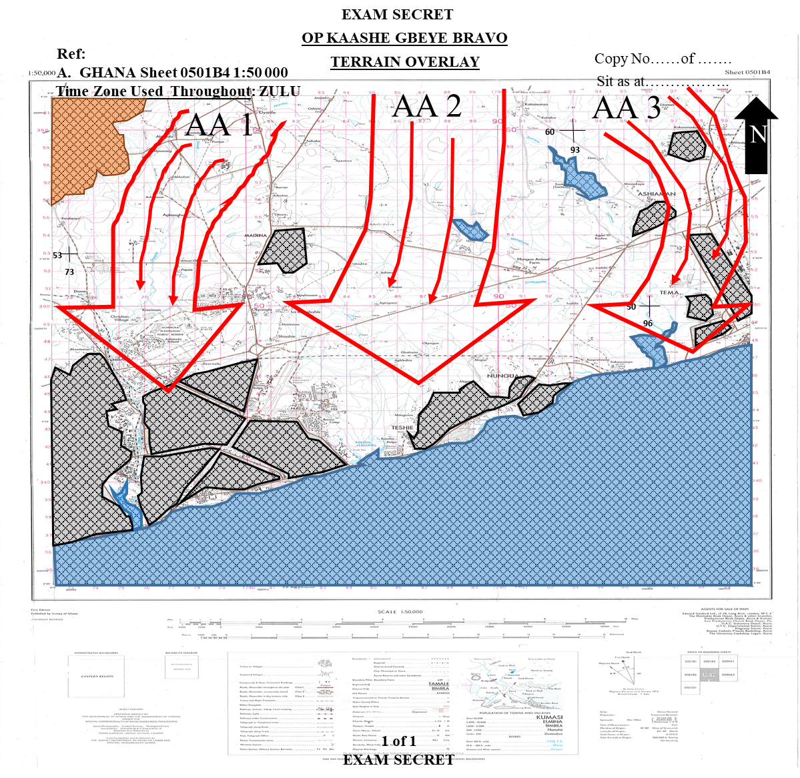

Question/Fact | Consideration/Deduction | Task/Output
(a) | (b) | (c)
23. Q2: WHAT HAVE I BEEN TOLD  TO DO AND WHY  Mission. 111 BG to conduct an independent IS/COIN Op to CONTROL the general areas of GA EAST, LA NKWANTANANG and ACCRA Metropolis from 271800Z APR 24 IOT to defeat MILS fighters.  a. 1 Div Intent (2 Up).  (1) Intent. To defeat MILS within Greater Accra Region and restore/maintain law and order.  (2) ME. The defeat of MILS within GA EAST, LA NKWANTANANG and ACCRA Metropolis and lies with 11 Bde Gp.  b. 11 Bde Comd (1 Up).  - Mission. 11 Bde Gp to search, loc, and defeat MILS in the gen areas of GA EAST, LA NKWANTANANG and ACCRA Metropolis IOT assist the Civ Auth restore/maintain law and order in the Greater Accra Region ASAP.  (2) CONOPS.  (a) Intent. Defeat MILS elements within GA EAST, LA NKWANTANANG and ACCRA Metropolis.  (b) SoM. 111BG to conduct an independent IS/COIN Op to defeat MILS fighters in the gen areas of GA EAST, LA NKWANTANANG and ACCRA Metropolis with 112BG and 113BG in res sp by Sqn Armd Recce, Bty Arty, Sqn Engr, ACCRA Regional Pol and NIB.  (c) ME. Successful control of GA EAST, LA NKWANTANANG and ACCRA Metropolis and it lies with 111 BG. | Ops may extend beyond assigned AOR.  Likely to be assigned Bde’s ME  Liaison with Civ auth and sister sy svcs key in executing mandate.  Credibility of sy forces is nec for success  Bde ops could be limited to 111 BG throughout the period of deplt.  111 BG’s effort crucial to achieving Bde’s intent. All areas must be covered but with limited forces, the AOR could be sectorized. Rft may be req. | PG: Consider reserve for future ops beyond AOR.  PG: BG to be well-resourced  Task: Estb Liaison with NIB and Police.  RFI. Police to cfm relationship with locals.  PG: Minimize and avoid collateral damage to enhance credibility of sy forces.  PG: Need to consider sp from Civ Police.  PG: Need to dominate, conduct aggressive ptls, liaison with Civ auth and other sy svcs, info gathering, psyops. Know the extent of AOR.  PG: Plan for ME. Need to know resources to achieve the ME.  PG: Need to Sectorize to dominate the AOR.  RFI: Rft plan.
(3) My Role in his Plan. Conduct Op to control GA EAST, LA NKWANTANANG and ACCRA Metropolis gen area.  (4) Tasks  (a) Specified Tasks.  i. Mov and depl in AO.  ii. Dominate AOR.  iii. Conduct Op in Sp of the Civ Auth.  (b) Implied Tasks.  i. Force Protection.  ii. Casualty evac.  iii. Provide technical assistance to sp essential svcs.  iv. Liaison with political and Opinion Ldrs.  v. VIP protection, KPs/VPs  vi. Info/Media Ops/Psyops,WHAMS.  vii. Conduct Rd blocks, Ambushes, Raids, Ptls, Attk on Bandit Camp, Cordon & Search Ops.  viii. Estb JHQs.  Mission Essential Task List  i. Control AOR  ii. Dominate AOR  ii. Conduct Ops in Sp of Civ Auth  iii. Mov and depl in AO  iv. Force Protection  v. Estb JHQ  vi. Liaison with flanking Units  vii. Restore law and order | Effective con may require Police and NIB sp.  MILS likely to disrupt own mov into AOR  Effective domination would require both offensive and defensive ops. Own force sy is paramount.  Mil activities would have to be well coordinated with numerous civ org id within AOR  Critical info/assets have to be hidden from MILS  Cas may incl MILS elements  Own pers to provide tech assist may not be aval  Detail plan of all KPs/VPs may not be aval  Not all media hses may sp the state  Most IS/COIN ops may be conducted simultaneously.  A centrally loc police stn such as CANTONMENTS Police stn is ideal for a JHQ  Likely ME | PG: Need to conduct Jt Op with NIB and Pol to isolate MILS.  Task: Force Protection.  PIR. Update on MILS mob and mov.  Tasks: Conduct Rd blocks, Ambushes, cordon & search.  Sy of camps/ammo dumps/Comd policy guardlines.  Tasks: Estb JHQ with Pol.  Liaise with Dist Auth.  VIP and KP protection.  Collaborate with sister sy svcs.  Conduct CIMIC acts.  Media plan.  Provide technical assistance to sp essential svcs.  EEFI: OPSEC of own forces/assets.  PG: Medical Plan to cover all forces.  Task: Liaise with civ auth for tech assists.  RFI: Existing plans of all KPs/VPs.  Clar. Cfm media allegiance to the State and MILS  PG: Effective TASKORG to achieve multiple tasks.  Task: Recce of JHQ  Effect. CONTROL.  Effect. PROTECT.  Effect. NEUTRALISE.  Effect. DOMINATE.  Effect. RESTORE.  Effect. ISOLATE.  Task: Cfm recce of own depl/accn.  Task: Ptl plan

(5). Freedoms and Constraints.  (a) Timings.  i. Time Now – 061700Z APR 24.  ii. Depl to AO completed by - 271800Z APR 24.  iii. First li – 0530 hrs.  iv. Last li - 1830 hrs. | Total time Aval-21 days 1 hr.  Total Day hrs- 274hrs.  Total Ni hrs- 231hrs.  Travelling time- 1 hr.  Buffer- 30mins.  Depl Time- 6 hrs.  Time aval for Battle Procedure-21 days 1 hr.  Applying 1/3, 2/3 rule.  Comds Time- 6 days 21 hrs.  Subordinates time. 13 days 18 hrs. | Concurrent activities to save time.
(2) Space  - BG Bdry. Boundaries of GA EAST, LA NKWANTANANG and ACCRA Metropolis.  - Inter Sector Bdrys  i. Sector A. – GA EAST Municipality Bdry with LA NKWANTANANG and ACCRA Metropolis.  ii. Sector B. LA NKWANTANANG Municipality Bdry with GA EAST and ACCRA Metropolis.  iii. Sector C. ACCRA Metropolis Bdry with GA EAST and LA NKWANTANANG. | Bdrys may overlap some settlments and major rds.  Internal rds and key features could be used as inter CT bdry. | PG: Need to clearly demarcate bdrys for sub-units.
(3) Resources.  - 4 x CTs  - OPCON Tp Armr Recce  - OPCON Tp Engrs  - Bty Arty  - Sect UAV  - Sect EOD  - Sect SF  g. Other Factors.  (1) Civ Pol  (a) ACCRA Regional HQ -340 pers  (b) NUNGUA Dist Pol Stn - 40 pers  (c) TESHIE Dist Pol Stn -40 pers  (d) AIRPORT Dist Pol Stn -30 pers  (e) LEGON Dist Pol Stn -35 pers  (f) EAST LEGON Dist Pol Stn -30 pers  (g) LA Dist Pol Stn -35 pers  (h) OSU Dist Pol Stn -40 pers  (i) CANTONMENTS Div Pol HQ -82 pers  (j) MADINA Dist Pol Stn -55 pers  (k) KWABENYA Dist Pol Stn -40 pers  (l) NIMA Dist Pol Stn -50 pers  (m) ADABRAKA Dist Pol Stn -30 pers  (n) KOTOBABI Dist Pol Stn - 30pers  (o) TESANO Dist Pol Stn -35 pers  (p) ACHIMOTA Mile 7 Dist Pol Stn -30 pers  (q) ACHIMOTA School Dist Pol Stn -25 pers  (r) SAKUMONO Dist Pol Stn. -45 pers  (s) ADENTA Dist Pol Stn -50 pers  (t) ABOKOBI Dist Pol Stn -45 pers  (u) ASHALEY-BOTWE Dist Pol Stn -50 pers  (v) OYIBI Dist Pol Sn -35 pers  (w) BAATSONA Dist Pol Stn -40 pers | Resources may not be enough to cover entire AOR.  MILS drug activities may require dog search which is not aval  Estb Mil/Pol JHQ at ACCRA Regional Police HQ.  Differentiate Mil and Pol duties.  Revision of ROE, IS SCHEME/SOP  Jt Psyops/Info Ops with Pol to win hearts and minds.  JHQs at BG AOR. | PG: Need to combine and prioritise tasks.  RFI: Aval of Dog Coy  Task: Comms set up.  Joint briefings.  Liaisons.  Issue ROE to pers.  Jt Coord conf.
(2) Logistics.  - Tpt aval for ptls.  - POL.  - Tentage/accn, maint sp.  - Fresh Ration.  - Def Stores. | Log sustainment for the ops would have to be well coordinated.  Local sp for aval ration may be difficult. Depl to be self sustained throughout the period. | PG: Plan for effiecient maint of eqpt and spares.  PG: Need for adequate storage facilities for ration/ spares.
(3) Civ Pop.  (4) Media.  (5) NGOs/INGOs.  (6) Civil Authority DCE/MCE | Refer to HTA. | Refer to HTA.
(7) Has the Sit Change or how might it change and how does it affect me?  - Sit hasn’t changed.  - Sit may change if:  - Op MAGANA KENKENI is conducted earlier than 29 Apr 24.  - There is any major disaster prior to deployment. | Mission valid. Restate your mission.  Likely to affect planning timelines and depl.  Scope of op likely to be expanded to include humanitarian aspects. | Coordinate all efforts in areas such as trg, log and planning to achieve your desired end state.  PG: CONPLAN for early depl.  PG: CONPLAN for Disaster Magt.

Q3. WHAT EFFECT DO I WANT TO HAVE ON THE MILS
Mission. 111 BG to conduct an independent IS/COIN Op to CONTROL the general areas of GA EAST, LA NKWANTANANG and ACCRA Metropolis from 271800Z APR 24 IOT to defeat MILS fighters.
DEFEAT  NEUTRALISE  DOMINATE  PROTECT  FIND  COMD&CON  Mission Comd to ensure use of initiative and the requisite knowledge in IS/COIN Op.  MANOUEVRE  Manoeuvre expected to be maint through the use of armr mob res and domination of the AOR through ptls, ambushes, search and rescue ops.  INFO & INT  Maximise use of ISTAR integrated with Arty, Armr, Engrs, OP/Ptls, higher comd and locals as well as NIB and Pol  CONTROL  REASSURE | Ser | Effect | Purpose
 | 1. | CONTROL | IOT render MILS activities ineffective.
 | 2. | NEUTRALISE | IOT diminish the effectiveness of MILS assets.
 | 3. | DEFEAT | IOT eliminate MILS’ resistance in the area.
 | 4. | DOMINATE | IOT deny MILS freedom of action.
 | 5. | FIND | IOT id, loc, and defeat the MILS.
 | 6. | PROTECT | IOT deny MILS access to KP/VP and VIPs
 | 7. | REASSURE | IOT allay fears in the locals
Main Effort Effect. CONTROL.
End State. Total annihilation of the MILS in the Greater Accra Region.
Potential COA. CTs to move into sectors and conduct offensive and defensive Op to flush out MILS sp by, Tp Armr, Tp engrs, Arty Bty/FGA, Sect UAV, Sect EOD, Sect SF, NIB and Civ Pol.
PROTECTION
OPSEC critical to success of op. Strong sectors, survivability of tps, security of facilities and instls can influence local sp.
FIREPOWER
Effective coord and integration of aval fire sp assets aimed at dominating the entire AOR. Avoid collateral damage.
SUSTAINMENT
Need a flexible, proactive and robust log plan which can accn emergencies to ensure sustained op. Rear area and MSR protection to be executed.
Intent Statement: To CONTROL and DOMINATE GA EAST, LA NKWANTANANG and ACCRA Metropolis, FIND and NEUTRALISE MILS assets to facilitate DEFEAT of MILS elements. REASSURE locals, PROTECT civilians and critical instls with AOR in sp of 11 Bde Gp ops in Greater Accra.

ANNEX C TO
SERIAL 5 TO
EX KAASHE GBEYE BRAVO
DATED ………… APR 24
(Pink)

DS MARKING GUIDE/SCORE SHEET
DIRECTING STAFF NAME ……………………………………… GH ………………..
REQUIREMENT TWO

Candidate’s Index Number………………………………… Stand No…………………..

Ser | Details | HPS | Marks Scored | Remarks
(a) | (b) | (c) | (d) | (e)
1. | Review of Sit | 3
2. | Christening/Orientation  - Present Loc  - Show dir of N  - 12 O’clock or Direction of threat  - Bdry  - Limit of AoR  - Christening  - Gen description of terrain  - Vegetation  - Settlements  - L of Cs  - Water Bodies  - Indicate features to “take note of” | 0.5  0.5  0.5  0.5  0.5  1  0.5  0.5  0.5  0.5  0.5  1
3 | Sub-Total | 10
4. | Map Marking  a. Sy classification  b. North Pointer  c. Coordinates (x3)  d. Title of Map  e. References  f. Sit As At……  g. Time Zone Used…  h. Direction of threat  i. Copy No/Page No | 0.5  0.5  1  0.5  0.5  0.5  0.5  0.5  0.5 |  | Sy Classification should be top and bottom of page  Sit as At to be completed  Copy No to be filled
5. |  | 5
(a) | (b) | (c) | (d) | (e)
6. | QUESTION 0
7. | Time Analysis  Timeline Matrix | 5  5
8. | Sub Total | 10
9. | QUESTION 1
 | a. IPE  (1) Gd Gen with deductions.  (2) Gd In Detail:  (a) Routes  (b) Observation  (c) Boundaries  (d) Obstacles  (e) Terrain  b. Weather Analysis  (1) Temperature  (2) Rainfall  (3) Humidity  (4) Wind  (5) Visibility  (6) Moon state  c. Human Terrain Analysis  (1) Area  (2) Structure  (3) Capabilities  (4) Organization  (5) People  (6) Event  (7) ASCOPE/PMESII-PT Matrix  d. Threat Evaluation  (1) Capabilities  (2) Organization  (3) Weapons  (4) Asymmetric Tactics  (5) Reinforcement  (6) Disposition  (7) Doctrinal Overlay  (8) HVTs/HPTL  (9) En Intent Schematic  e. Situation/Threat Integration  (1) En Intent  (2) En Likely COA  (3) En Most Dangerous COA  (4) Advantages/Disadvantages | 2  1  1  1  1  1  0.5  0.5  0.5  0.5  0.5  0.5  0.5  0.5  0.5  0.5  0.5  0.5  1  1  1  1  1  1  1  1  6  2  1  4  4  2
(a) | (b) | (c) | (d) | (e)
 | f. Outputs  (1) Terrain overlay  (2) AA/MC  (3) Situation/Event Overlay | 1  1  2
 | (4) En Effects Schematic  (5) Draft DSO  (6) Intelligence Collection Plan | 2  1  1 |  | Effects and Purpose to be stated
10. | Sub-Total | 48
11. | QUESTION 2
 | a. Stated Mission  b. Intention of Higher Comd  (1) 2 UP – 1 Div  (a) Intent.  (b) ME.  (2) 1 Up – 11 Bde Comd  (a) Mission.  (b) CONOPS  i. Intent  ii. SoM  iii. ME  (3) My Role in his plan  c. Specified and Implied Tasks  (1) Specified Tasks.  (2) Implied Tasks.  (3) Prioritization/Msn Essential Tasks  d. Freedoms and Constraints.  (1) Constraints.  (a) Time  (b) Space  (c) Resources  (2) Freedoms  e. Other Factors  (1) Civ Pop | 1  0.5  0.5  0.5  0.5  0.5  0.5  1  2  2  6  2  1  1  1  1
(a) | (b) | (c) | (d) | (e)
 | (2) Civ Police  (3) Legal  (4) Media  (5) NGO | 1  1  0.5  0.5
 | f. Has the situation Changed?  (1) Has the Situation Changed and How Does it Affect Me?  (2) How Might the Situation Change and How Might it Affect Me?  g. During Analysis of Column 3  (1) CCIR  (2) RFI  (3) Planning Guidance  (6) Clarification | 0.5  0.5  3  3  3  3 |  | Candidates are to indicate how the situation might change and what action they would take. This should lead to PG for contingency plan
12. | Sub-Total | 37
13. | QUESTION 3
 | a. Stated Mission  b. Effects, Object and Purpose  c. Effect Schematic  d. Intent Statement  e. Potential COA  f. Directions from Comd  (1) Confirm en COA to plan against  (2) Articulate Main Effort Effect  (3) Set criteria to evaluate COA | 1  4  2  1  1  2  2  2
14. | Sub-Total | 15
15. | Grand Total | 125

ARMY OFFICERS’ PRACTICAL PROMEX 2024
EXERCISE KAASHE GBEYE BRAVO
CAPTAIN TO MAJOR
SERIAL 6 TO
EX KAASHE GBEYE BRAVO
DATED ……………. APR 24
(Yellow)

NARRATIVE THREE AND REQUIREMENT THREE
1. The Bde Comd was satisfied with your Stage 1 analysis and expressed his confidence in your ability to develop a good plan to dominate GA EAST, LA NKWANTANANG and ACCRA Metropolis general areas and flush out MILS elmns. He was however unhappy about your Intelligence Collection Plan and inability to identify en timelines. He stressed that you needed to produce detailed DSOM and Synchronization Matrix to deal with that lapse.

REQUIREMENT THREE

2. As 111 BG Comd, conduct stage 2 (Q4 to Q7) of the Combat Estimate to be discussed with your Bde Comd (PLAN INCLUSIVE). Be prep to explain your outputs including:
a. DSO/DSOM.
b. COA Formulation and Evaluation for 2 COAs.
c. Synch Matrix.
d. Mission and Tasks.
e. Trace and Scheme of Manoeuvre.
f. Graphical Control Measures.
g. Plan (Handover your Synch Matrix and plan to the DS, with your INDEX number written on them).

3. TIMINGS

a. Consider - 120 mins.
b. Deliver - 60 mins.

4. SCORING

a. HPS - 130
b. Pass Mark - 75

ARMY OFFICERS’ PRACTICAL PROMEX 2024
EXERCISE KAASHE GBEYE BRAVO
CAPTAIN TO MAJOR

ANNEX A TO
SERIAL 6 TO
EX KAASHE GBEYE BRAVO
DATED …………………APR 24
(Green)

DS NOTES AND GUIDELINES TO REQUIREMENT THREE

NARRATIVE THREE
1. The Bde Comd was satisfied with your Stage 1 analysis and expressed his confidence in your ability to develop a good plan to dominate GA EAST, LA NKWANTANANG and ACCRA Metropolis general area and flush out MILS elmns. He was however unhappy about your Intelligence Collection Plan and inability to identify en timelines. He stressed that you needed to produce detailed DSOM and Synchronization Matrix to deal with that lapse.

REQUIREMENT THREE

2. As 111 BG Comd, conduct stage 2 (Q4 to Q7) of the Combat Estimate to be discussed with your Bde Comd (PLAN INCLUSIVE). Be prep to explain your outputs including:
a. DSO/DSOM.
b. COA Formulation and Evaluation for 2 COAs.
c. Synch Matrix.
d. Mission and Tasks.
e. Trace and Scheme of Manoeuvre.
f. Graphical Control Measures.
g. Plan (Handover your Synch Matrix and plan to the DS, with your INDEX number written on them).

3. TIMINGS

a. Consider - 120 mins.
b. Deliver - 60 mins.

4. SCORING

a. HPS - 125
b. Pass Mark - 75
AIM

5. The aim of this requirement is to test candidates’ ability to use the tools provided under Stage 2 of the Combat Estimate Format which would culminate in the development of a plan.

SUGGESTED APPROACH

6. Candidates are to commence this stage by stating the effects identified in Q3, probable COA and Comd’s Direction for evaluating COA. This forms the basis for Stage 2 of the Combat Estimate.

7. DS to be guided by Stage 2 of the Combat Estimate Format. This stage is the development of the plan, taking the commander’s Effects Schematic, relating it to the ground and then resourcing each effect. Qs 4 - 6 need to be conducted sequentially. Candidates are expected to produce the complete outputs for Stage 2 and DS should also carry out inspection of candidates’ outputs to ensure that they contain enough details to be able to develop a plan. DS should collect the sync matrix and plan of the candidates to be handed over to the PROMEX Writing Team.

QUESTION 4: WHERE CAN I BEST ACHIEVE EACH ACTION/EFFECT?

8. Candidates must now use their knowledge of the ground to id the best loc to site the effects they wish to have on MILS as outlined in Question 3. Some effects will be strictly dictated by the ground ie for the FIND effect. Other effects could be possible in a number of locs – ie dominate, deny, deceive, interdict, neutralise, protect, control, reassure and block effects. These effects should match the towns and distances from delivery points. These effects will offer varying options and potentially lead to one or more draft DSOs. The effects are then to be superimposed onto the map and NAIs and TAIs alloc. DS to inspect candidate’s maps or overlays and Draft DSOs.

QUESTION 5: WHAT RESOURCES ARE REQUIRED TO ACCOMPLISH EACH EFFECT?
9. Candidates must approach this question of the 7QCE with an open mind by carefully matching combat power required to prosecute the effects identified. Candidates must resource each effect IOT achieve the desired effect starting with their ME Effects, Shaping and Sp Effects, NAIs and TAIs are then broadly resourced. Candidates must not be constrained by the TASKORG at this time to ensure all tasks are resourced. The Draft DSOM is continually refined at this stage to incl DP/DLs to arrive at a Decision Support Overlay Matrix (DSOM). This is likely to result in over committing resources and will therefore lead to the need to ask for addl resources and to synchronize actions in Question 6. This leads to the reqmt to sequence an op or combine tasks.

QUESTION 6: WHEN AND WHERE DO THE ACTIONS TAKE PLACE IN RELATION TO EACH OTHER?

10. As the plan is dev, the synchronization of combat activities of all arms within each TAI needs to be recorded. Synch Matrix (SM) provides a clear method for ensuring that planners address all elements within a formation when developing a COA, by ensuring that all the resources on the TASKORG have been used in the most effective and efficient manner. SM is a means of showing the relationship between activities (both enemy and other actors and friendly), supporting functions and key events, indicating timings of MILS as well as own forces activities.
QUESTION 7: WHAT CONTROL MEASURES NEED TO BE IMPOSED?
11. Candidates should address the final question by outlining the control measures needed to control activities in the battle space. Candidates must list them out to complete the estimates. For control that can be shown on the ground, DS should insist that candidates point them out on the ground where applicable.

QUESTION 4. WHERE CAN I BEST ACCOMPLISH EACH ACTION/EFFECT
Effect | Location
(a) | (b)
Q4. WHERE CAN I BEST ACCOMPLISH EACH ACTION/EFFECT?  - NEUTRALISE  - DEFEAT  - DOMINATE  - FIND  - PROTECT  - CONTROL  - REASSURE | 1. Neutralise MILS assets loc in Sectors A, B and C.  2. Defeat MILS at Sectors A, B and C.  3. Dominate subunit sectors.  4. Find MILS in Subunit sectors including recreational areas, hosp, population centres and forests reserves.  5. Protect Civ, VIPs, KPs/VPs and instls in Sub sectors A, B, and C  6. Control respective AOR.  7. Reassure the vulnerable and the gen populace of the importance of the mil intervention in Sectors A, B, C.

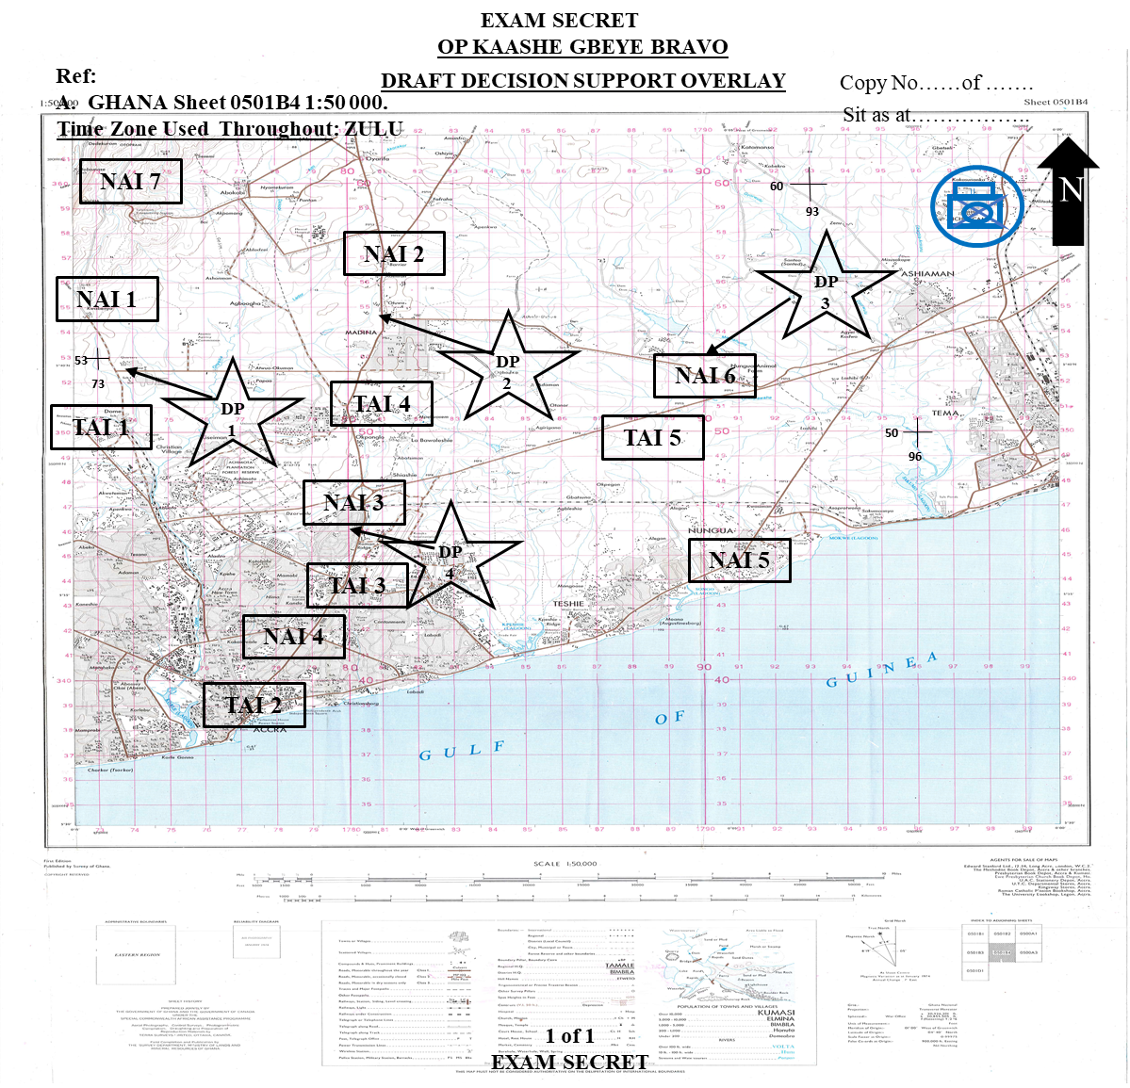

QUESTION 5. WHAT RESOURCES DO I NEED TO ACCOMPLISH EACH ACTION/EFFECT
EFFECTS | COA 1 | COA 2
(a) | (b) | (c)
SoM | 111BG to FIND MILS using Tp Armr Recce, Recce Pl and Drone Team. NEUTRALIZE MILS ISTAR assets with 1 x CT. 2 x CTs to concentrate at CANTONMENTS Div Police HQ to CONTROL and DOMINATE GA EAST, LA NKWANTANANG and ACCRA Metropolis. 3 x CTs to DEFEAT MILS elements. REASSURE locals, PROTECT civilians and critical instls using 1 x CT. 1 x CT to be in res. Ops to be sp by 1 x SF Sect, 1 x UAV Sect, Bty Arty, Tp Engrs, Civ Pol and NIB. Ops to be conducted in 4 phases as fol:  (a) Phase 1. Mov to and estb sector(s) in AOR.  (b) Phase 2. Op to search, loc and defeat MILS fighters.  (c) Phase 3. Stabilization.  (d) Phase 4. Wdr. | 111BG to FIND MILS using Tp Armr Recce, Recce Pl and Drone Team. NEUTRALIZE MILS ISTAR assets with 3 x CTs. 3 x CTs to CONTROL and DOMINATE Sector A (GA EAST), B (LA NKWANTANANG), and C (ACCRA Metropolis) respectively. 3 x CTs to DEFEAT MILS elements. REASSURE locals, PROTECT civilians and critical instls using 1 x CT. 1 x CT to be in res. Ops to be sp by 1 x SF Sect, 1 x UAV Sect, Bty Arty, Tp Engrs, Civ Pol and NIB. Ops to be conducted in 4 phases as fol:  (a) Phase 1. Mov to and estb sector(s) in AOR.  (b) Phase 2. Op to search, loc and defeat MILS fighters.  (c) Phase 3. Stabilization.  (d) Phase 4. Wdr.
CONTROL | 3 X CT | 4 X CT
 | Tp Engr | Tp Armr Recce
 | Mor Pl | Pol
 | Bty Arty, | NIB
FIND | CTs, Recce Pl, OP | CTs, Recce Pl, OPs
 | Tp Armd Recce, Pol | Tp Armd Recce, Pol, NIB
NEUTRALISE | 1 X CT | 3 X CT
 | Bty Arty | Tp Armr
 | Mor Pl, MMG Pl | Mor Pl
 |  | MMG Pl
 |  | Atk Pl
 |  | Tp Engrs
 |  | Bty Arty
DEFEAT | 2 X CT | 3 X CT
 | Tp Engrs, MMG Pl | Tp Engrs
 | TP Armr | MMG Pl
 | Asslt Pnr Pl | Recce Pl
 |  | Asslt Pnr Pl
DOMINATE | Bty Arty | 3X CTs
 | Mor Pl, MMG Pl and Atk Pl | Mor Pl, MMG Pl and Atk Pl
 | MFC, FOO, 3XCTs | Bty Arty
 | Pol | Pol
PROTECT | 2 X CT | 3X CT
 | Bty Arty | Hel
 | Tp Engrs | Tp Engrs
 | Asslt Pnr Pl | Bty Arty
 | Mor Pl | Tp Armr
 | Pol | Pol
CONTROL | 3XCT | 3XCT
 | Tp Engr | Tp Armr
 | Mor Pl | Pol
 | Bty Arty | NIB
REASSURE | 3XCT | 3X CT
 | Tp Armr | NIB
 | Pol | Pol

COA 1. CENTRALIZED CONTROL
Mission. 111 BG to conduct an independent IS/COIN Op to CONTROL the general areas of GA EAST, LA NKWANTANANG and ACCRA Metropolis from 271800Z APR 24 IOT to defeat MILS fighters.  Intent. To CONTROL and DOMINATE GA EAST, LA NKWANTANANG and ACCRA Metropolis, FIND and NEUTRALISE MILS assets to facilitate DEFEAT of MILS elements. REASSURE locals, PROTECT civilians and critical instls with AOR in sp of 11 Bde Gp ops in Greater Accra.  SoM. 111BG to FIND MILS using Tp Armr Recce, Recce Pl and Drone Team. NEUTRALIZE MILS ISTAR assets with 1 x CT. 2 x CTs to concentrate at CANTONMENTS Div Police HQ to CONTROL and DOMINATE GA EAST, LA NKWANTANANG and ACCRA Metropolis. 3 x CTs to DEFEAT MILS elements. REASSURE locals, PROTECT civilians and critical instls using 1 x CT. 1 x CT to be in res. Ops to be sp by 1 x SF Sect, 1 x UAV Sect, Bty Arty, Tp Engrs, Civ Pol and NIB. Ops to be conducted in 4 phases as fol:  (a) Phase 1. Mov to and estb sector(s) in AOR.  (b) Phase 2. Op to search, loc and defeat MILS fighters.  (c) Phase 3. Stabilization.  (d) Phase 4. Wdr.  ME. Successful control of ACCRA Metropolis and it lies with 2 x CTs |  | Schematic to be shown by Candidates
Advantages | Disadvantages
Easy control and Admin.  Large force at hand to deal with situations which require large number of tps.  No need to protect L of C | Difficult to dominate whole AOR at the same time.  Difficult to react to incidents on time  Reaction to fleeting situations may be slow.  Sub unit may not be familiar with AO.
Mob res provide rapid responses and maint flexibility.
Simple CSS Plan
Requires less resources
Re-sup easy to coord.
Provide good source of Info and Int

COA 2 DECENTRALIZED CONTROL
Mission. 111 BG to conduct an independent IS/COIN Op to CONTROL the general areas of GA EAST, LA NKWANTANANG and ACCRA Metropolis from 271800Z APR 24 IOT to defeat MILS fighters.  Intent. To CONTROL and DOMINATE GA EAST, LA NKWANTANANG and ACCRA Metropolis, FIND and NEUTRALISE MILS assets to facilitate DEFEAT of MILS elements. REASSURE locals, PROTECT civilians and critical instls with AOR in sp of 11 Bde Gp ops in Greater Accra.  SoM 111BG to FIND MILS using Tp Armr Recce, Recce Pl and Drone Team. NEUTRALIZE MILS ISTAR assets with 3 x CTs. 3 x CTs to CONTROL and DOMINATE Sector A (GA EAST), B (LA NKWANTANANG), and C (ACCRA Metropolis) respectively. 3 x CTs to DEFEAT MILS elements. REASSURE locals, PROTECT civilians and critical instls using 1 x CT. 1 x CT to be in res. Ops to be sp by 1 x SF Sect, 1 x UAV Sect, Bty Arty, Tp Engrs, Civ Pol and NIB. Ops to be conducted in 4 phases as fol:  (a) Phase 1. Mov to and estb sector(s) in AOR.  (b) Phase 2. Op to search, loc and defeat MILS fighters.  (c) Phase 3. Stabilization.  (d) Phase 4. Wdr.  ME. Successful control of Sector C (ACCRA Metropolis) and it lies with 1 x CTs. |  | Schematic to be shown by Candidates
Advantages | Disadvantages
Presence of tps will be felt in AO.  Maximum mil/civ Pol cooperation.  Confidence of local populace will be won.  Initiative of sub-unit comds ensured.  Remote areas will be covered. | Admin Sp will be difficult.  Comd and Con will be difficult if radio comm fails.  Admin veh subj to ambushes hence need to protect LoC
Mob res provide rapid responses and maint flexibility.
Stressful CSS Plan.
Requires huge resources since CTs are depl far apart.
Re-sup diff to coord.
Provide good source of Info and Int.

COA COMPARISON
COA 1 | COA CRITERIA | COA 2
Score (1-5, 5 being Highest) |  | Score (1-5, 5 being Highest)
5 | Comd and Con | 5
2 | Manoeuvre | 5
4 | Firepower | 3
4 | Protection | 4
4 | CSS | 4
3 | Info and Int | 5
22 | Total | 26
COA2 selected because it provides the better workable options for achieving all the tasks assigned and identified for a successful BG mission.

Q6. WHERE AND WHEN DO EACH ACTION/EFFECT TAKE PLACE IN RELATION TO EACH OTHER?
1. Actions are de-conflicted leading to the co-ord actions of manoeuvre units, direct and indirect fire wpns etc, in relation to time aval.
2. Mission: 111 BG to conduct an independent IS/COIN Op to CONTROL the general areas of GA EAST, LA NKWANTANANG and ACCRA Metropolis from 271800Z APR 24 IOT to defeat MILS fighters.

3. CONOPS.
a. Intent. To CONTROL and DOMINATE GA EAST, LA NKWANTANANG and ACCRA Metropolis, FIND and NEUTRALISE MILS assets to facilitate DEFEAT of MILS elements. REASSURE locals, PROTECT civilians and critical instls with AOR in sp of 11 Bde Gp ops in Greater Accra.
b. SoM. 111BG to FIND MILS using Tp Armr Recce, Recce Pl and Drone Team. NEUTRALIZE MILS ISTAR assets with 3 x CTs. 3 x CTs to CONTROL and DOMINATE Sector A (GA EAST), B (LA NKWANTANANG), and C (ACCRA Metropolis) respectively. 3 x CTs to DEFEAT MILS elements. REASSURE locals, PROTECT civilians and critical instls using 1 x CT. 1 x CT to be in res. Ops to be sp by 1 x SF Sect, 1 x UAV Sect, Bty Arty, Tp Engrs, Civ Pol and NIB. Ops to be conducted in 4 phases as fol:

(1) Phase 1. Mov to and estb sector(s) in AOR.
(2) Phase 2. Op to search, loc and defeat MILS fighters.
(3) Phase 3. Stabilization.
(4) Phase 4. Wdr.

c. ME. Successful control of Sector C (ACCRA Metropolis) and it lies with 1 x CTs.

 | D-2 | D-1 | D-DAY | D+1 and beyond
Insurgent Acts | Subversive activities  FIND | Subversive activities continue  Psyops  Fortification of MILS bases.
Own Forces | PREP | PRELIM MOV | FIND/NEUTRALISE/CONTROL/DOMINATE  REASSURE/PROTECT | DEFEAT
CT | Preparation | Recce and Adv Party dep for AO | Main body dep for AO  Dominate Sector A | Dominate Sector, Psyops, Def & Offensive Ops
CT | Preparation | Recce and Adv Party dep for AO | Main body dep for AO  Dominate Sector B | Dominate Sector, Psyops, Def & Offensive Ops
CT | Preparation | Recce and Adv Party dep for AO | Main body dep for AO  Dominate Sector C | Dominate Sector, Psyops, Def & Offensive Ops
CT | Preparation | Recce and Adv Party dep for AO | Main body dep for AO  Dominate Sector. | Dominate Sector, Psyops, Def & Offensive Ops
Tp Armr Recce | At base at 153 Armr Regt | Marry up with CT | Main body dep for AO  Dominate AO as mob res | VCP /Rd Blk/KP/VPs/VIP Escort.
Bty Arty | At base at 66 Arty Regt | Marry up with CT | Main body dep for AO. Dominate and Co-loc with BG HQ | Provide fire sp on call
Tp Engrs | Preparation | Recce and Adv Party dep for AO | Main body dep for AO  Mob & counter mob task | Mob & counter mob task
UAV Sect | Preparation | Recce and Adv Party dep for AO | Main body dep for AO. Monitor and report activities of MILS | Monitor and report activities of MILS
Sect EOD | Preparation | Recce and Adv Party dep for AO | Main body dep for AO  EOD task | EOD task
Sect SF | Preparation | Recce and Adv Party dep for AO | Main body dep for AO.  Undertake special tasks to sp CT in Sector C | Undertake special tasks to sp CT in Sector C
Res | Preparation | Preparation | Preparation | Preparation

QUESTION 7 : WHAT CONTROL MEASURES DO I HAVE TO IMPOSE?
Candidates should list all the con measures and indicate on the grd or map where they could have a bearing on the Ops and provide details or justification on each con measure.
Q7. What control measures do I need to impose?  a. Bdrys/Sectorise.  - Estb JHQ.  - Report lines.  - Routes, Coordination pts.  - Timings.  - ROE.  - SOPs / Camp Standing Orders/ Comd Policy Guidelines.  - Liaison.  - Media.  - NGOs.  - FSCM.  - Convoy Speed- 40 Km/hr by day/20km/by ni. | Boundaries/Sectors as given in trace.  BG HQ Main must have comms with BG Comd and lead Coy at all times  ST: and Time to be in Posn :  Need for ROE to regulate activities of own tps.  To guide tps in their duties.  Liaison with Civil auth, Civpol and other sy svcs.  Estb rapport with media not to propagate insurgent sentiments.  Need to monitor activities of NGOs.

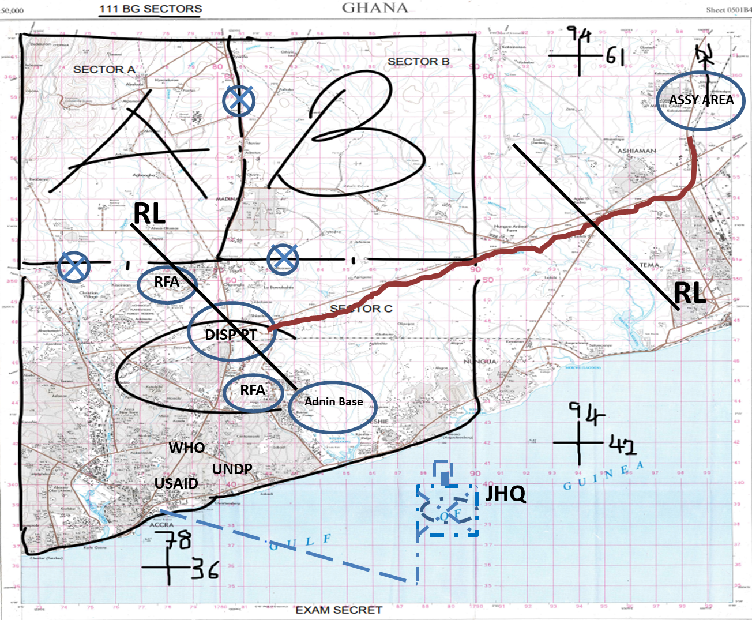
GRAPHICAL CONTROL MEASURES

PLAN

1. SITUATION

a. MILS. Addl to Special Ideas and INTSUM.

(1) Str. Unknown.
(2) Loc. Hide out in bases and camps in Greater Accra Region.
(3) Dress. Assorted Mil Uniform/Civil.
(4) Wpns. AK47, MGs, Grenades, Automatic Wpns, Explosives.
(5) Intention. To take control of important facilities and infrastructures within ACCRA Metropolis and proceed to seize TEMA Port.
(6) Tactics.
(a) Hit and Run and Ambushes.
(b) Ability to make a clean break from any contact.
(c) Aggressive fighting ptls in the neighbourhood of their firm bases.
(d) Inducement of pursuit with the object of luring the opposition into ambushes.
(e) Empl of small stay-behind parties of single MGs and snipers possibly protected by mines and booby traps, to force attk troops to depl away from selected approach routes and thereby delay their advance.
(f) Counter attacks likely to be quickly executed but in minor strength as reserves will be held some distance away.
g) Light reconnaissance patrols placed well forward on all likely approach routes to give early warning.

(h) Covering troop positions some 1,000 to 2,000 metres forward of the main position.

- The main position itself, well-constructed and concealed.

b. Friendly Forces.

(1) 1 DIV
(a) Intent. To defeat MILS within Greater Accra Region and restore/maintain law and order.
(b) ME. The defeat of MILS within GA EAST, LA NKWANTANANG and ACCRA Metropolis and lies with 11 Bde Gp.

(2) 11BDE
(a) Mission. 11 Bde Gp to search, loc, and defeat MILS in the gen areas of GA EAST, LA NKWANTANANG and ACCRA Metropolis IOT assist the Civ Auth restore/maintain law and order in the Greater Accra Region ASAP.

(b) CONOPS.
i. Intent. Defeat MILS elements within GA EAST, LA NKWANTANANG and ACCRA Metropolis.

ii. SoM. 111BG to conduct an independent IS/COIN Op to defeat MILS fighters in the gen areas of GA EAST, LA NKWANTANANG and ACCRA Metropolis with 112BG and 113BG in res sp by Sqn Armd Recce, Bty Arty, Sqn Engr, ACCRA Regional Pol and NIB. Ops to be conducted in 4 phases as fol:
aa. Phase 1. Mov to and estb sector(s) in AOR.
bb. Phase 2. Op to search, loc and defeat MILS fighters.
cc. Phase 3. Stabilization.
dd. Phase 4. Wdr.

- ME. Successful control of GA EAST, LA NKWANTANANG and ACCRA Metropolis and it lies with 111 BG.

- Locals.
- Mixture of Ga Adangbe, Akans, Ewes and Hausas.
- Majority are friendly and loyal to the Govt and Security forces.
- Chiefs and Opinion leaders are a good int source.
- Some locals hold allegiance to the MILS and sp their cause.
- Discretionary engagement should be employed.

2. MISSION 111 BG to conduct an independent IS/COIN Op to CONTROL the general areas of GA EAST, LA NKWANTANANG and ACCRA Metropolis from 271800Z APR 24 IOT to defeat MILS fighters.

3. EXECUTION

- Concept of Ops

(1) Intent. To CONTROL and DOMINATE GA EAST, LA NKWANTANANG and ACCRA Metropolis, FIND and NEUTRALISE MILS assets to facilitate DEFEAT of MILS elements. REASSURE locals, PROTECT civilians and critical instls within AOR in sp of 11 Bde Gp ops in Greater Accra.

(2) Scheme of Manoeuvre. 111BG to FIND MILS using Tp Armr Recce, Recce Pl and Drone Team. NEUTRALIZE MILS ISTAR assets with 3 x CTs. 3 x CTs to CONTROL and DOMINATE Sector A (GA EAST), B (LA NKWANTANANG), and C (ACCRA Metropolis) respectively. 3 x CTs to DEFEAT MILS elements. REASSURE locals, PROTECT civilians and critical instls using 1 x CT. 1 x CT to be in res. Ops to be sp by 1 x SF Sect, 1 x UAV Sect, Bty Arty, Tp Engrs, Civ Pol and NIB. Ops to be conducted in 4 phases as fol:

(a) Phase 1. Mov to and estb sector(s) in AOR.
(b) Phase 2. Op to search, loc and defeat MILS fighters.
(c) Phase 3. Stabilization.
(d) Phase 4. Wdr.

(3) ME. Successful control of Sector C (ACCRA Metropolis) and it lies with 1 x CTs.

- Mission and Tasks to sub units

- 1 X CT

- Sector A.
i. Assist civ auth to restore law and order in GA EAST MUNICIPALITY (Sector A).
ii. Force Protection within Sector.
iii. Conduct Rd Blocks, ambushes, raid, attk on en camp, crowd dispersal, cordon and search ops.
iv. Conduct Info/media ops/PSYOPS to win hearts and minds.
v. VIP and KP/VP Protection.
vi. Provide technical assistance to support essential services.
vii. Liaise with political ldrs, opinion ldrs, police and NIB in order to facilitate further ops.

- 1 X CT.

- Sector B.

i. Assist civ auth to restore law and order in LA NKWANTANANG MUNICIPALITY (Sector B).
ii. Force Protection within Sector.
iii. Conduct Rd Blocks, ambushes, raid, attk on en camp, crowd dispersal, cordon and search ops.
iv. Conduct Info/media ops/PSYOPS to win hearts and minds.
v. VIP and KP/VP Protection.
vi. Provide technical assistance to support essential services.
vii. Liaise with political ldrs, opinion ldrs, police and NIB in order to facilitate further ops.

- 1 X CT.

(a) Sector C.
i. Assist civ auth to restore law and order in ACCRA Metropolis (Sector C).
ii. Force Protection within Sector.
iii. Conduct Rd Blocks, ambushes, raid, attk on en camp, crowd dispersal, cordon and search ops.
iv. Conduct Info/media ops/PSYOPS to win hearts and minds.
v. VIP and KP/VP Protection.
vi. Provide technical assistance to support essential services.
vii. Liaise with political ldrs, opinion ldrs, police and NIB in order to facilitate further ops.

- 1 X CT.

(a) Reserve.

- MOR PL.

(a) Task

- Provide OS as required.
- Provide covering fire for the Coy offensive ops.

(5) MG PL.

(a) Task.

i. Provide covering fire for the Coy offensive ops.

(6) Aslt Pnrs PL.

(a) Task.

i. Be prepared to sp fwd Pls to breach Obs.
ii. Be prepared to undertake further tasks on order.

(7) Sect UAV.

(a) Task.

i. Be prepared to find MILS elmns.
ii. Be prepared to undertake further tasks on order.

(8) Sect SF.

(a) Task.

i. Be prepared to sp CTs to control AOR.
ii. Be prepared to undertake further tasks on order.

(9) Sect EOD.

(a) Task.

i. Be prepared to deal with IEDs in the AOR.
ii. Be prepared to undertake further tasks on order.

c. Coordinating Instructions.

(1) Timings:

(a) Start Time - 271030Z APR 24.
(b) Time to be in posn - 271800Z APR 24.
(c) First Light - 0530 hrs.
(d) Last Light - 1830 hrs.

- (2) Bdrys. Refer to map.

(3) Start Point. MICHEL CAMP.

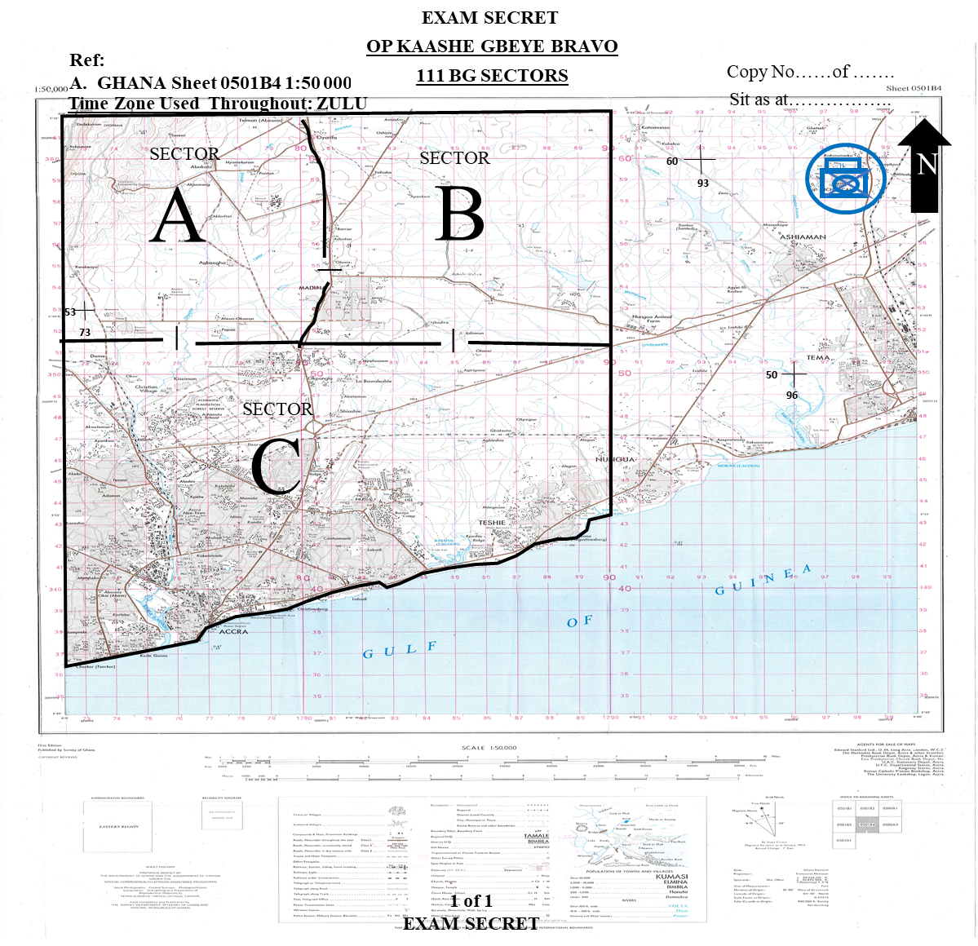

ANNEX B TO
SERIAL 6 OF EX KAASHE GBEYE BRAVO
DATED ………… APR 24
(Pink)

DS MARKING GUIDE/SCORE SHEET
DIRECTING STAFF NAME ……………………………………… GH ………………..

REQUIREMENT THREE

Candidate’s Index Number……………………………… Stand No…………………..

Ser | Details | HPS | Marks Scored | Remarks
(a) | (b) | (c) | (d) | (e)
1. | QUESTION 4
 | a. DSO (NAIs/TAIs/DPs)  b. DSOM  (1) Grid Reference  (2) Physical Description of NAI/TAIs/DPs)  c. Action/Effect/Purpose  d. Collection Asset/TAI Responsibility  e. Indicators/Special Coordination  f. Linkages between NAI/DP/TAI | 2  1  2  2  1  1  1 |  | DSOM could be produced in Q5  Primary and secondary assets should be stated for full marks  Linkages between NAI/DP/TAI should be created
2. | Sub-Total for Ser 1 - 2 | 10
3. | QUESTION 5 (Complete SoM)
 | a. Effects Required  b. Resource required to achieve Effects for 2 x COAs  c. Identification/Selection of COA  (1) COA 1  (a) Intent  (b) SoM  (c) ME  (d) Advantages of COA 1  (e) Disadvantages of COA 1 | 2  3  1  2  1  2  2
 | (2) COA 2  (a) Intent  (b) SoM  (c) ME  (d) Advantages of COA2  (e) Disadvantages of COA2  (3) COA Selection  (4) Task Org | 1  2  1  2  2  3  5
4. | Sub-Total | 29
5. | QUESTION 6 (SYNCHRONISATION MATRIX)
 | a. Synchronization Matrix  (1) Mission  (2) CONOPS  (a) Intent  (b) SOM  (c) ME  (3) Schematics  (4) En Action Time Lines  (5) Manoeuvre Forces Timeline/acts | 2  4  6  2  4  4  10 |  | Intent should have min 4 Effects (one mark for each effect)  SOM should outline tasks for sub-units in logical sequence (able to achieve effects id)  Sketch could be used by candidates for schematic  Min 10 sub-unit activities should be synchronized for full marks
6. | Sub-Total | 36
7. | QUESTION 7 (CONTROL MEASURES)
 | a. Graphical representation of Control Measures.  (1) De-confliction  (2) Integration  (3) Command and Control  (4) Protection  (5) Sustainment. | 2  2  2  2  2 |  | Min 3 control measures under each category should be depicted on overlay and/or mentioned for full marks.
 | Sub-Total | 10
8. | PLAN
 | SITUATION  a. En.  b. Friendly Forces.  (1) 2 Up Intent and ME  (2) 1 Up Msn and CONOPS  c. Flanking Unit Loc and Activities  c. Civ situation. | 2  2  4  1  1
 | MISSION | 2
 | EXECUTION  a. CONOPs  (1) Intent  (2) SoM  (3) ME | 3  6  3 |  | Intent and SoM should be effects based
 | b. Mission and Tasks  (1) 1 x CT Tasks  (2) 1 x CT Tasks  (3) 1 x CT Tasks  (4) Tp Armr Recce  (5) MG Pl  (6) Recce Pl  (7) Tp Engrs  (8) Sect UAV/SF/EOD | 3  3  3  1  1  1  1  1 |  | Min of 3 tasks for each Pl for full marks.  Candidates who specify Pls should lose a mark each for each Pl.
 | a. Coord Instrs  (1) Timings  (a) O Gp  (b) Dep Assy Area.  (b) Arr JHQ.  (c) Sub-units dep JHQ by.  (d) Depl Complete by  (e) Ops commence by….  (2) Staging areas.  (3) etc. | 1  1  1  1  1  1  1 |  | Essential timings extracted from timeline  Key areas
 | Sub-total | 45
12. | GRAND TOTAL | 130

ARMY OFFICERS’ PRACTICAL PROMEX 2024
EXERCISE KAASHE GBEYE BRAVO
CAPTAIN TO MAJOR

SERIAL 7 TO
EX KAASHE GBEYE BRAVO
DATED ……………APR 24
(Yellow)
NARRATIVE FOUR AND REQUIREMENT FOUR
NARRATIVE FOUR
1. Your Bde Comd was very happy with the detailed estimate you presented to him yesterday. He was also amazed by the workable plan presented as a product of your estimate to control your AOR and its immediate environs against MILS clandestine activities. He further directed that you go ahead and quickly deliver orders to your subordinate commanders and prepare the Unit for deployment imm. The Bde Comd indicated he will be present at your ‘O’ Gp so he gets the opportunity to directly talk to the troops, convey his motivation and encouragement.
2. Your 2IC has been busy organising the troops and getting the ‘O’ Gp ready to receive orders, complete the battle procedure and deploy. Your Ops Team has also done adequate preparations and all is almost set for orders. You however intended to make a few adjustments to get things right since the Bde Comd would be present. You therefore decided to arrive at the ‘O’ Gp RV at 0700 hrs, one hour earlier than the scheduled time for the orders at 0800 hrs.
REQUIREMENT FOUR
3. As CO 111 BG prepare and issue your orders for the control of GA EAST, LA NKWANTANANG and ACCRA Metropolis to your ‘O’ Gp represented by the DS.
4. TIMINGS
a. Consider - 90 mins.
b. Deliver - 60 mins.
5. SCORING
a. HPS - 100.
b. Pass Mark - 60.
ARMY OFFICERS’ PRACTICAL PROMEX 2024
EXERCISE KAASHE GBEYE BRAVO
CAPTAIN TO MAJOR

ANNEX A TO
SERIAL 7 TO
EX KAASHE GBEYE BRAVO
DATED ……………APR 24
(Green)
DS NOTES AND GUIDELINES TO REQUIREMENT FOUR

NARRATIVE FOUR
1. Your Bde Comd was very happy with the detailed estimate you presented to him yesterday. He was also amazed by the workable plan presented as a product of your estimate to control your AOR and its immediate environs against MILS clandestine activities. He further directed that you go ahead and quickly deliver orders to your subordinate commanders and prepare the Unit for deployment imm. The Bde Comd indicated he will be present at your ‘O’ Gp so he gets the opportunity to directly talk to the troops, convey his motivation and encouragement.
2. Your 2IC has been busy organising the troops and getting the ‘O’ Gp ready to receive orders, complete the battle procedure and deploy. Your Ops Team has also done adequate preparations and all is almost set for orders. You however intended to make a few adjustments to get things right since the Bde Comd would be present. You therefore decided to arrive at the ‘O’ Gp RV at 0700 hrs, one hour earlier than the scheduled time for the orders at 0800 hrs.
REQUIREMENT FOUR
3. As CO 111 BG prepare and issue your orders for the control of GA EAST, LA NKWANTANANG and ACCRA Metropolis to your ‘O’ Gp represented by the DS.
4. TIMINGS
a. Consider - 90 mins.
b. Deliver - 60 mins.
5. SCORING
a. HPS - 100.
b. Pass Mark - 60.

AIM

6. The aim of the Requirement is to test the candidates ability to:
a. Develop their plan from the Combat Estimate into orders.
b. Prepare a model/sketch.
c. Deliver orders to an O Gp.

ONE SUGGESTED APPROACH

7. The approach to be adopted is as fol:
a. Prep of a model/sketch.
b. Prep orders based on a workable plan.
c. Delivery of orders to satisfy the fol:
(1) Stage mgt.
(2) Description of model and its relevance to the obj and mission.
(3) Delivery of OPORD to capture all details bearing in mind the posture and the confidence of the deliverer.

ONE POSSIBLE SOLUTION

8. Preliminaries.

a. Sy of O Gp - Location.
- Sentries.
- Action on Attk.

b. Stage mgt - Intro of att pers.
- Seating Plan.
- Map Orientation.
c. Task Org (Op) - DS should probe students to cfm their understanding of how they have Task Organised their subunits for the Op.

d. Ground orientation/model description.
(1) Preliminaries:
(a) Direction of the North and Scale of Model.
(b) Current loc and obj.
(c) Colour codes.
(d) Model christening and description.
(2) Relief.
(3) Vegetation.
(4) Settlements.
(5) Lines of Communication.
(6) Water Bodies.
(7) Features to note (maj con measures rep by features on the grd).
e. Weather - Climate.
- Rainfall.
- Visibility.
- First Light.
- Last Light.
1. SITUATION
a. MILS.
(1) Idet. MILS.
(2) Str. Unknown but operates in sleeper cells of sect (-).
(3) Loc. Hideout in bases and camps in Greater Accra Region.
(4) Dress. Assorted Mil Uniform/Civil.
(5) Wpns. AK47, MGs, Grenades, Automatic Wpns, Explosives.
(6) Qqpt. Mortorbike, Quad bikes, pickup vehs, off the shelf drones.
(7) Intention. To take control of important facilities and infrastructures within GA EAST, LA NKWANTANANG and ACCRA Metropolis and proceed to Seize TEMA Port.
(8) Tactics.
(a) Hit-and-Run and Ambushes.
(b) Ability to make a clean break from any contact.
(c) Aggressive fighting ptls in the neighbourhood of their firm bases.
(d) Inducement of pursuit with the object of luring the opposition into ambushes.
(e) Empl of small stay-behind parties of single MGs and snipers possibly protected by mines and booby traps, to force attk troops to depl away from selected approach routes and thereby delay their advance.
(f) Counter attacks likely to be quickly executed but in minor strength as reserves will be held some distance away.
g) Light reconnaissance patrols placed well forward on all likely approach routes to give early warning.

(h) Covering troop positions some 1000 to 2000 metres forward of the main position.

- The main position itself, well-constructed and concealed.

(9) Morale. Very high due to recent successful ops within the Southern Belt.

b. Friendly Forces.

(1) 1 DIV.
(a) Intent. To defeat MILS within Greater Accra Region and restore/maintain law and order.
(b) ME. The defeat of MILS within GA EAST, LA NKWANTANANG and ACCRA Metropolis and lies with 11 Bde Gp.
(2) 11 BDE GP.
(a) Mission. 11 Bde Gp to search, loc, and defeat MILS in the gen areas of GA EAST, LA NKWANTANANG and ACCRA Metropolis IOT assist the Civ Auth restore/maintain law and order in the Greater Accra Region ASAP.
(b) CONOPS.
i. Intent. Defeat MILS elements within GA EAST, LA NKWANTANANG and ACCRA Metropolis.
ii. SoM. 111BG to conduct an independent IS/COIN Op to defeat MILS fighters in the gen areas of GA EAST, LA NKWANTANANG and ACCRA Metropolis with 112BG and 113BG in res sp by Sqn Armd Recce, 2 x Bty Arty, Sqn Engr, ACCRA Regional Pol and NIB .
iii. ME. Successful control of GA EAST, LA NKWANTANANG and ACCRA Metropolis and it lies with 111 BG.
(3) Activities of Neighbouring Fcs. 112BG and 113BG in res at MICHEL CAMP
c. Att/Det. As per task org.
d. Locals.
- Mixture of Ga Adangbe, Akans, Ewes and Hausas.
- Majority are friendly and loyal to the Govt and Security forces.
- Chiefs and Opinion leaders are a good int source.
- Some locals hold allegiance to the MILS and sp their cause.
- Discretionary engagement should be employed.

2. MISSION. 111 BG to conduct an independent IS/COIN Op to CONTROL the general areas of GA EAST, LA NKWANTANANG and ACCRA Metropolis from 271800Z APR 24 IOT to defeat MILS fighters.
3. EXECUTION.

a. CONOPS.

(1) Intent. To CONTROL GA EAST, LA NKWANTANANG and ACCRA Metropolis, FIND and NEUTRALISE MILS assets to facilitate DEFEAT of MILS elements. REASSURE locals, PROTECT civilians and critical instls within AOR in sp of 11 Bde Gp ops in Greater Accra Region.
(2) SoM. Tp Armr Recce, Recce Pl and Drone Team to FIND and NEUTRALIZE MILS ISTAR assets. A, B, C CTs to CONTROL, DOMINATE and DEFEAT MILS elements in Sector A (GA EAST), B (LA NKWANTANANG), and C (ACCRA Metropolis) respectively. REASSURE locals, PROTECT civilians and critical instls. D CT to be in res. Ops to be sp by 1 x Tp Armd Recce, 1 x SF Sect, 1 x UAV Sect, A Bty 66 Arty Regt, 1 x Tp Engrs, ACCRA Regional Pol and NIB. Ops to be conducted in 4 phases as fol:

(a) Phase 1. Mov to and estb sector(s) in AOR.

(b) Phase 2. Op to search, loc and defeat MILS fighters.

(c) Phase 3. Stabilization.
(d) Phase 4. Wdr.
(3) ME. Successful domination of Sector C (ACCRA Metropolis) and it lies with C CT.

b. Mission and Tasks to Sub-Units.

(1) A CT.

(a) Mission/Task.

i. Phase 1.

(i) Move to AOR.

(ii) Defeat all pockets of MILS elms enroute.

ii. Phase 2.

(i) Dominate Sector A.

(ii) Conduct Ops to defeat the MILS.

(iii) Protect civilians and critical Instls.

(iv) Assist the Civ Pol to restore/maintain law and order.

(v) Stand by for any other task on order.

iii. Phase 3. Stabilization - details later.

iv. Phase 4. Wdr- details later.

All IOT control BG AOR.

(2) B CT.

(a) Mission/Task.

i. Phase 1.

(i) Move to AOR.

(ii) Defeat all pockets of MILS elms enroute.

ii. Phase 2.
(i) Dominate Sector B.

(ii) Conduct Ops to defeat the MILS.

(iii) Protect civilians and critical Instls.

(iv) Assist the Civ Pol to restore/maintain law and order.

(v) Stand by for any other task on order.
iii. Phase 3. Stabilization - details later.

iv. Phase 4. Wdr- details later.

All IOT control BG AOR.

(3) C CT.

(a) Mission/Task.

i. Phase 1.

(i) Move to AOR.

(ii) Defeat all pockets of MILS elms enroute.

ii. Phase 2.

(i) Dominate Sector C.

(ii) Conduct Ops to defeat the MILS.

(iii) Protect civilians and critical Instls.

(iv) Assist the Civ Pol to restore/maintain law and order.

(v) Stand by for any other task on order.
iii. Phase 3. Stabilization - details later.

iv. Phase 4. Wdr- details later.

All IOT control BG AOR.

(4) D CT. All Phases - Reserve.

(5) Recce Pl. Monitor and report MILS activities within BG AOR.

(6) Tp Armd Recce.
(a) Monitor and report MILS activities within BG AOR.
(b) Degrade MILS surveillance activities.

(7) Armd Sqn. Conduct patrol to find and neutralize MILS capabilities. Intimate fire sp and rear area sy.

(8) Tp Engr.

(a) Survivability and C-mob task for defensive posn.
(b) Mobility task for offensive ops.

(9) Sig Pl. Provide comms sp for the op.

(10) EOD Team. Stand by for EOD task on order.

(11) A Bty 66 Arty. Provide indirect fire sp to CTs. All fires to be on call.
(12) Sect UAV. Monitor and report activities and loc of MILS elmns.
(13) Sect SF. Stand by to sp CTs to control AORs.

c. Co-ord Instrs.

- Timings.

- Mov to AOR - 271030Z APR 24.

- Depl to AO completed by – 271800Z APR 24.

- SP. MICHEL CAMP.

(3) Dispersal Point. BG Comd to determine.

(4) Route. BG Comd to determine.

(5) Road Classification.

(a) MICHEL CAMP – TEMA MOTORWAY - Grey.

(b) TEMA MOTORWAY - AOR - Black.

(6) Bdrys. Sectorised Map.

(7) Fire plan. BG Comd to determine.

(8) Actions on. BG Comd to determine.

d. Summary of execution.

4. SERVICE SUPPORT.

a. As per SOP.

b. ROE for IS Ops to be adhered to.

5. COMMAND AND SIGNAL.

a. Loc of HQs.

(1) Bde HQ - MICHEL CAMP.

(2) BG HQ - BG Comd to determine for all Phases. (Airport Police Station Suggested).

b. Chain of Comd. Candiadates to provide for all phases.

- Sig.
(1) Radio Instrs. Candiadates to provide.
(2) Nicknames.

Ser | Nickname | Meaning
(a) | (b) | (c)
1. | FAST LANE | AOR
2. | HARD CORE | Bde HQ
3. | BASE OVER | BG HQ
3. | KANKPE BOYS | MILS Elms

(3) Codewords.
Ser | Codeword | Meaning | Issued by
(a) | (b) | (c) | (d)
1. | YENKO | Op Commences | BG HQ
2. | YAAMOTU | Op completed | BG HQ
3. | OGYA | Rft required | CT HQs
4. | SUCCESS | BG return to base | BG HQ
5. | MUTEY | Terminate op and wdr | BG HQ

(4) Password. Candidates to provide.
d. Question.
e. Synchronization of watches.

ARMY OFFICERS’ PRACTICAL PROMEX 2024
EXERCISE KAASHE GBEYE BRAVO
CAPTAIN TO MAJOR

ANNEX B TO
SERIAL 7 OF EX KAASHE GBEYE BRAVO
DATED ......................................... APR 24
(Pink)

DS MARKINGS GUIDE /SCORE SHEET

DIRECTING STAFF NAME ……………………………………… GH ………………..

REQUIREMENT FOUR

Candidate’s Index Number…………………….……. Stand: ………………
Ser | Details | HPS | Score | Remarks
(a) | (b) | (c) | (d) | (e)
1. | Review of Sit | 1
2. | PRELIMINARIES  a. Stage Management  b. Model/Sketch Preparation  c. Description of Model/Sketch  d. Task Org (if prepared separately) | 2  5  2  1 |  | .
 | Sub Total | 10
3. | Situation  a. En  b. Fr Forces  (1) Two up  (a) Intent  (b) ME  (2) One Up  (a) Msn  (b) CONOPS  c. Flanking units Loc and activities  d. Civs | 2  2  1  1
 | Sub-Total | 6
4. | Mission | 3
5. | Execution.  a. CONOPS  (1) Intent  (2) SoM  (3) ME  b. Sub-Unit Msn / Tasks  (1) A CT  (2) B CT  (3) C CT  (4) D CT  (5) Recce Pl  (6) Tp Recce  (7) Sqn Armr  (8) Tp Engr  (9) Sig Pl  (10) EOD Team  (11) Arty/FOO | 4  6  2  3  3  3  3  2  2  2  2  2  2  2
 | Sub Total | 38
 | c. Coord Instrs.  (1) Timings.  (a) NMB  (b) ETD  (c) ETA  (d) Depl completed by  (e) AOR defensible  (f) Other timings  (2) Staging areas.  (a) Start Point  (b) Dispersal Point  (c) OOM  (d) Routes  (e) Mode of Mov  (f) Rate of Mov  (g) Sectorization  (h) Bdrys  (i) Report Lines.  (j) FSCM  (k) RVs  (3) Fire Plan  (4) Actions on  (a) Rd Blk  (b) Amb  (c) IED  (d) Hostile assembly | 1  1  1  1  1  1  1  1  1  1  1  1  1  2  1  1  2  1  3
 | d. Summary of Execution | 5
 | Sub-Total | 28

(a) | (b) | (c) | (d) | (e)
6. | - Combat Service Support | 5
 | Sub-Total | 5
7. | COMMAND AND SIGNAL  a. Loc  - BG Hq  - Jt Hq  b. Chain of Comd  c. Altn Comds  d. Los/Coord pts  e. Sig instr  f. Codewords  g Nicknames  h. Passwords | 5
 | Sub-Total | 5
8. | Synchronisation of Watches | 1
9. | Bonus for Confidence/Delivery | 3
 | Sub-Total | 4
 | TOTAL | 100

ARMY OFFICERS’ PRACTICAL PROMEX 2024
EX KAASHE GBEYE BRAVO
CAPTAIN TO MAJOR

SERIAL 8 TO
EX KAASHE GBEYE BRAVO
(Yellow)

NARRATIVE FIVE AND REQUIREMENT FIVE

NARRATIVE FIVE

1. Your depl was a success and so far, you have been able to stamp your feet on the ground. You have completely taken over, dominating and controlling the area. While planning to visit your Combat Teams Sectors to get first hand info, your IO came to you with some hot intelligence. According to him, MILS have run short of ammo and were planning to replenish. Also, while thinking about how to get resupply they are planning a silmultaneous operation of first sponsoring people to organize a violent demonstration in front of the Jubilee House as a decoy or feint while they conduct operation to seize control of the 111 BG Magazine.

2. You immediately issued a frago to A and B CTs to stand by to deal with a possible violent crowd or rioters and defend your unit magazine respectively.

REQUIREMENT FIVE

3. As Comd 111 BG, discuss the fol with your Bde Gp Comd rep by the DS:

a. What factors do you expect B CT Comd to consider in determining the str of the KP/VP Gd?
b. Advise your B CT Comd on measures that can help to increase the efficiency of the KP/VP Gds without increasing the number.
c. How do you envisage the Ideal KP/VP Gds dispositions in day and ni time?
d. Discuss the procedure you expect A CT to go through from the time they take over from the Police till the crowd or rioters are successfully dispersed. Remember to start from non-violent means before violent means.
e. Discuss the factors your crowd control tps/Comd should consider before using Riot Control Agent (CS Smoke).
f. Discuss the actions to be taken immediately after firing ceases.
g. As part of after firing actions, your crowd control Comd reported that 2 x Rioters were killed, 5 wounded, 5 arrested, 2 x Machetes, 2 x locally manufactured Pistols, 2 x AK 47 and 50 rounds of ammo seized. For his troops; no one died and no one got lost, however, 3 of them sustained various degree of injuries. His team fired 7 rounds of ammo to successfully disperse the crowd. Water and Ammo replenishment required. Morale of Troops Very High, awaiting further instructions. Advise him on what to do with the dead, wounded and arrested Rioters, his own wounded pers and prepare to submit your Situational Report to the Bde Gp Comd rep by your DS.
h. Hand over all points discussed to the DS.

TIMINGS
4. Consider - 50 mins.

5. Discuss - 30 mins.

SCORING

6. Total Marks. - 100 Marks.

7. Pass Marks. - 60 Marks.

Annexes:
A. Air Photograph of Jubilee House.
B. A Sketch of 111 BG Magazine.
C. DS Guidelines and Possible Solution to Requirement Five.
D. DS Marking Guide/Score Sheet.

ANNEX A TO
SERIAL 8 OF EX KAASHE GBEYE BRAVO
DATED ……………………….. APR 24
(Yellow)

AIR PHOTOGRAPH OF JUBILEE HOUSE
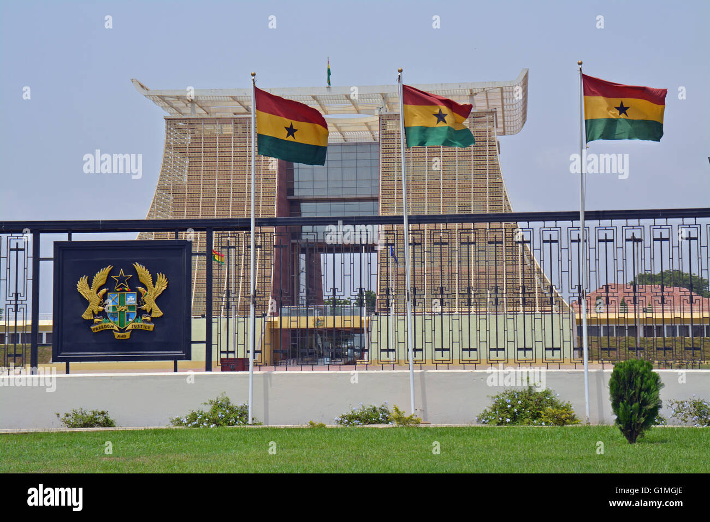

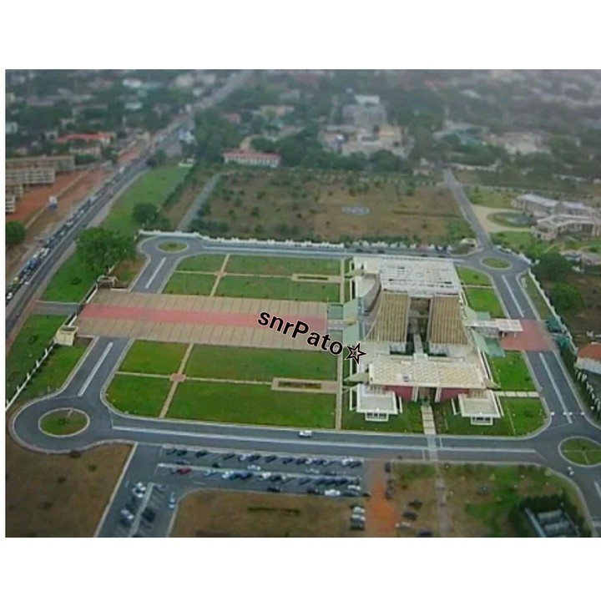
ANNEX B TO
SERIAL 8 OF EX KAASHE GBEYE BRAVO
DATED ……………………….. APR 24
(Yellow)

A SKETCH OF 111 BG MAGAZINE
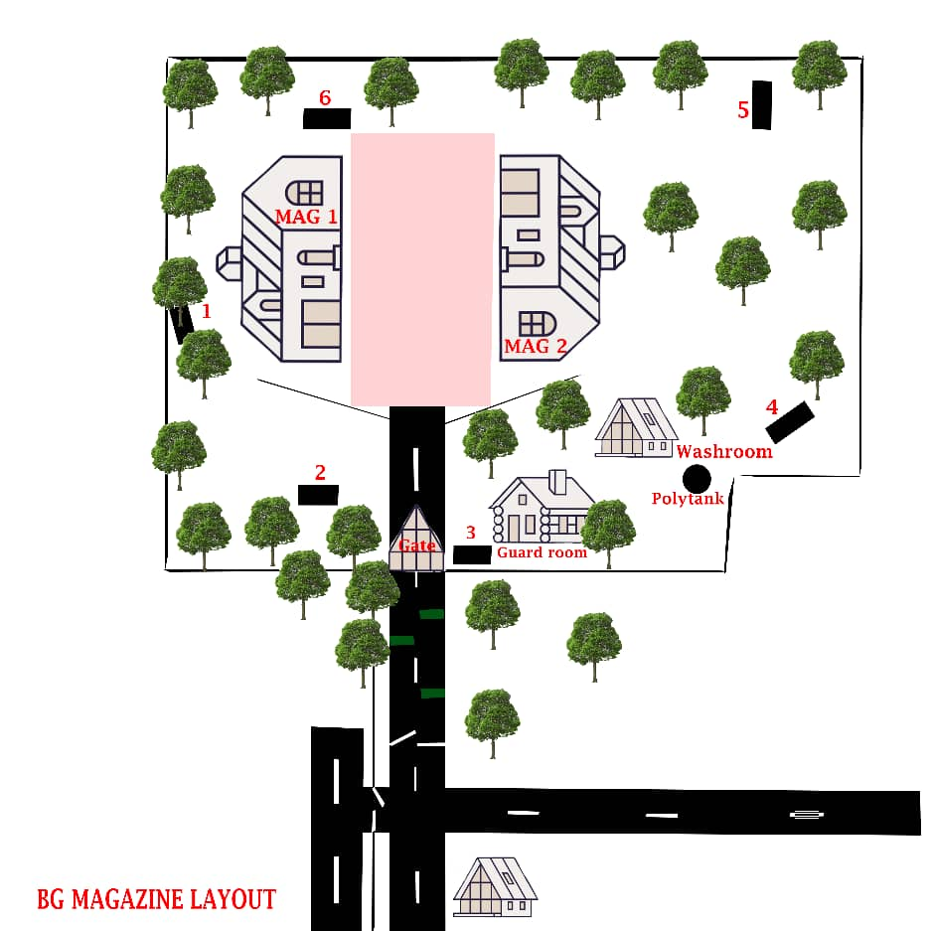

ANNEX C TO
SERIAL 8 OF EX KAASHE GBEYE BRAVO
DATED ……………………….. APR 24
(Green)

DS GUIDELINES AND POSSIBLE SOLUTION TO REQUIREMENT FIVE

NARRATIVE FIVE

1. Your depl was a success and so far, you have been able to stamp your feet on the ground. You have completely taken over, dominating and controlling the area. While planning to visit your Combat Teams Sectors to get first hand info, your IO came to you with some hot intelligence. According to him, MILS have run short of ammo and were planning to replenish. Also, while thinking about how to get resupply they are planning a silmultaneous operation of first sponsoring people to organize a violent demonstration in front of the Jubilee House as a decoy or feint while they conduct operation to seize control of the 111 BG Magazine.

2. You immediately issued a frago to A and B CTs to standby to deal with a possible violent crowd or rioters and defend your unit magazine respectively.

REQUIREMENT FIVE

3. As Comd 111 BG, discuss the fol with your Bde Gp Comd rep by the DS:

a. What factors do you expect B CT Comd to consider in determining the str of the KP/VP Gd?
b. Advise your B CT Comd on measures that can help to increase the efficiency of the KP/VP Gds without increasing the number.
c. How do you envisage the Ideal KP/VP Gds dispositions in day and ni time?
d. Discuss the procedure you expect A CT to go through from the time they take over from the Police till the crowd or rioters are successfully dispersed. Remember to start from non-violent means before violent means.
e. Discuss the factors your crowd control tps/Comd should consider before using Riot Control Agent (CS Smoke).
f. Discuss the actions to be taken immediately after firing ceases.
g. As part of after firing actions, your crowd control Comd reported that 2 x Rioters were killed, 5 wounded, 5 arrested, 2 x Machetes, 2 x locally manufactured Pistols, 2 x AK 47 and 50 rounds of ammo seized. For his troops; no one died and no one got lost, however, 3 of them sustained various degree of injuries. His team fired 7 rounds of ammo to successfully disperse the crowd. Water and Ammo replenishment required. Morale of Troops Very High, awaiting further instructions. Advise him on what to do with the dead, wounded and arrested Rioters, his own wounded pers and prepare to submit your Situational Report to the Bde Gp Comd rep by your DS.
h. Hand over all points discussed to the DS.
TIMINGS
4. Consider - 60 mins.

5. Discuss - 30 mins.

SCORING

6. Total Marks. - 100 Marks.

7. Pass Marks. - 60 Marks.

AIM

8. To assess candidates’ knowledge on KP/VP Protection, Mechanics of Crowd Dispersal and test candidates’ ability to draft SITREPs after a serious crowd control/dispersal Ops.

SUGGESTED SOLUTIONS
9. The first part of this requirement is to cfm candidates’ knowledge of KP/VP protection duties in a typical IS/COIN operation. Candidates are expected to be conversant with the factors that determine the str of the KP/VP Gd so as to decide and detail the correct str for the operation at hand. Also, knowing measures that can help to increase the efficiency of KP/VP Gds without increasing the number will help deal with any unforeseen deficiency in str. Candidates are also expected to know an ideal KP/VP Gds disposition by day and ni so as to employ/deploy troops correctly.
10. The second part of this reqmt is to cfm candidates’ knowledge on the mechanics of Crowd Dispersal and how to report situation to the appropriate HQ through routine Situational Reports making use of the appropriate headings. Candidates were expected to be conversant with the procedure the crowd control team will go through from the time they take over from the Police till the Crowd or Rioters are successfully dispersed, factors the crowd control tps/Comd should consider before using Riot Control Agent (CS Smoke) and actions to be taken immediately after firing ceases.
11. What factors do you expect B CT Comd to consider in determining the str of the KP/VP Gd?
a. The size of the installation to be guarded.
b. The threat.
c. The troops available.
d. The time taken for reinforcements to arrive.

12. Advise your B CT Comd on measures that can help to increase the efficiency of the KP/VP Gds without increasing the number.
a. OPs from roof-tops or watchtowers.
b. An efficient alarm system which ensures that a sentry can be quickly reinforced from a local reserve, thus enabling men to rest rather than be on watch.
c. Surveillance devices including closed circuit television (CCTV) and intrusion alarm.
d. Improved physical protection with effective boundary fences, screens on windows, steel shutters on doors, exterior lighting etc.
e. Guard dogs which will both deter and detect intruders and assist in their capture.

13. How do you envisage the Ideal KP/VP Gds dispositions in day and ni time?
a. Day Time Guards.
(1) Sentry at the main entrance checking the right of entry, covered by another sentry.
(2) Sentry in tower or on roof-top, paying particular attention to the perimeter fence.
(3) Reserve that can be called out immediately.
b. Night Time Guards. Isolated and patrolling sentries must be doubled. Patrolling should be done in an irregular pattern with one man covering the other. Sentries should report to the guardroom at timed, but irregular intervals. Dogs are an advantage at night because of their sense of smell and sharpness of hearing.
14. Discuss the procedure you expect A CT to go through from the time they take over from the Police till the crowd or rioters are successfully dispersed. Remember to start from non-violent means before violent means.
a. Non-violent means should always be tried first in dispersing crowds. Some of the means are:
(1) Persuasion. A crowd should always be persuaded to disperse peacefully if possible. Some of the methods available are:
(a) Voluntarily. As a first step and one which may often be the most effective and the least provocative, unobtrusive discussion with a ringleader may lead to the orderly dispersal of a crowd. Moreover, this dispersal will appear to be voluntary rather than enforced by the security forces.
(b) By a Show of Force. This may be ostentatious, which can be provocative or it may be conducted more circumspectly. An ostentatious display of force may be very effective on those drawn into the crowd more by curiosity than conviction; if however it inflames feelings the situation may get rapidly worse. Less provocation can be achieved by posting OPs, particularly on roof-tops and high buildings where they can be seen, so that the crowd becomes aware of a military presence, and individuals may begin to fear being surrounded and decide to leave. Their departure can be infectious and the crowd should be allowed to melt away. While an open show of force may require that everything be put in place, a more unobtrusive approach should always be backed up by a reserve. This may be needed should an isolated detachment be attacked or surrounded.
(c) Verbal and visual persuasion using loud speakers, banners and bugles.
(d) Reading the riot act or other local act or ordinance. This must be done in English and as many local languages as possible.
(e) Use of Photography. Agitators and indeed the general public realise that photographs implicating them in violence may hasten their arrest and conviction. The appearance of a photographer may therefore help to disperse a crowd. It can however have an opposite effect either because the ringleaders have kept in the background or because those who believe they have been photographed either set out to smash the cameras and destroy the evidence. Overt photography must therefore be used circumspectly and cameramen must be protected.
(f) A steady advance of a line of soldiers with fixed bayonets; provided close contact with the crowd can be avoided.
(g) The use of dye and special weapons such as prodders and pushers, water under pressure, baton rounds and riot control agents (Tear gas) must form part of the unit equipment and must be used before opening of fire is ordered.
(h) Observation and Containment. There are numerous occasions when to contain, observe and threaten a crowd is enough. The lack of a suitable target, in the shape of the security forces, may cause the crowd to disperse from fear or boredom. The ringleaders may have particular difficulty in inciting the crowd if there is no suitable target for them to attack.
(2) Use of Special Weapons. Special weapons will rarely be decisive in themselves. They may, however, give the security forces a temporary advantage which must be quickly exploited, perhaps by the use of arrest squads. In the early stages of operations in any area, it is preferable to precede their use by a warning to the crowd. Some of these special weapons are prodders and pushers, water under pressure, baton rounds and riot control agents.
(3) Riot Control Agents. The standard riot control agent is CS smoke (2-chlorobenzalmalononitrile) which causes watering and irritation of the eyes, choking and coughing.
b. If non-violent means fail the comd at his own discretion may have to use effective fire. His subsequent action will then be as follows:
(1) The rioters must be warned by all available means that effective fire will be opened unless they disperse at once. This can be done by a call on a bugle, followed by the display of banners showing the necessary warning in vernacular, and an announcement over a loud hailer, megaphone or public address system.
(2) The comd must himself give the actual order to a fire unit specifying target/ring leaders, number of rounds and riflemen to fire the number of rounds. The number of rifle men used should be the minimum necessary for the task.
(3) Marksmen should be used to provide fire and for their identity to be concealed, other men should go through the motion of firing only.
(4) Firing must be effective and blank must not be used.
(5) Rapid fire should be used only in the gravest emergency and only after single shots have proved ineffective. Automatic weapons are not used.
(6) Firing must cease as soon as the required effect is achieved.

15. Discuss the factors your crowd control tps/Comd should consider before using Riot Control Agent (CS Smoke).
a. The size, temper and composition of the crowd.
b. Whether wind conditions will allow the speedy build-up of an effective
concentration.
c. The downwind hazard to uninvolved persons or traffic.
d. The need to avoid CS cartridges entering confined spaces such as the interior of buildings, as the smoke can be dangerous in a confined space.
e. Whether the reduction in visibility caused by the use of CS will hamper the arrest
of ringleaders.
f. The most appropriate means of delivery taking account of these factors, safety
and the achievement of the aim.
g. The degree of protection of security forces.

16. Discuss the actions to be taken immediately after firing ceases.
a. Collect and count empties.
b. Help with the wounded.
c. Clear the area. The crowd should not be hurried and no action should be taken against persons attempting to disperse.
d. Get the names and addresses of neutral witnesses.
e. Collect the dead and hand the bodies over to the police (not to relative).
f. Hand over prisoners to the police.
g. Remain on the site until the situation is quiet.
h. Report the details of the action to the immediate superior officer.
17. As part of after firing actions, your Crowd control Comd reported that 2 x Rioters were killed, 5 wounded, 5 arrested, 2 x Machetes, 2 x locally manufactured Pistols, 2 x AK 47 and 50 rounds of ammo seized. For his troops; no one died and no one got lost, however, 3 of them sustained various degree of injuries. His team fired 7 rounds of ammo to successfully disperse the crowd. Water and ammo replenishment required. Morale of Troops Very High, awaiting further instructions. Advice him on what to do with the dead, wounded and arrested Rioters, his own wounded pers and prepare to submit your Situational Report to the Bde Gp Comd rep by your DS.
a. The Comd will have to hand over dead and arrested rioters to the police. All necessary documentations should be made including photographing of dead rioters.

b. All wounded rioters and own forces should be given first aid and sent to the hospital for further treatment.

c. The SITREP should cover the fol:
(1) Title.
(2) SITREP No.
(3) Period Covered.
(4) Gen Sit.
(5) Threat/Rioters Sit.
(6) Own/FF Sit.
(7) Admin.
(8) Morale.

111 BG SITREP
FROM: 111 BG 290630ZAPR24
TO: 11 BDE GP HQ
INFO: 112 BG
113 BG 113/OPs

OP KAASHE GBEYE BRAVO PD SITREP NO 01 PD PERIOD COVERED FM 290600Z APR24 TO 300600ZAPR24 PD
ONE PD SIT PD AGGRESSIVE AND VIOLENT CROWD/RIOTERS BELIEVED TO BE SPONSORED BY MILS CMM DEMONSTRATING IN FRONT OF JUBILEE HOUSE CMM SEAT OF GOVT PD OWN FORCE SUCCESSFULLY DISPERSED CROWD/RIOTERS PD AREA CURRENTLY SECURED PD
TWO PD MILS/CROWD/RIOTERS PD
ALPHA PD MILS SPONSORED RIOTERS SUCCESSFULLY DISPERSED PD
BRAVO PD RIOTERS CAS PD KILLED CMM 2 PD WOUNDED CMM 5 AND ARRESTED CMM 5 PD
CHARLIE PD QTY 2 X MACHETES CMM 2 X LOCALLY MANUFACTURED PISTOL CMM 2 X AK 47 AND 50 ROUNDS OF AMMO SEIZED PD
THREE PD OWN SIT PD
ALPHA PD MSN SUCCESSFULLY ACCOMPLISHED PD
BRAVO PD PERS CAS PD X-RAY CMM NIL PD YANKEY CMM 3 PD ZULU CMM NIL PD IMM FA CARRIED OUT PD PERS REFERRED FOR FURTHER TREATMENT PD
FOUR PD ADMIN PD 7 X ROUNDS OF AMMO FIRED PD WATER AND AMMO REPLEN REQD PD
FIVE PD MORALE OF TPS PD VERY HIGH///

ANNEX D TO
SERIAL 8 OF EX KAASHE GBEYE BRAVO
DATED ………………………….. APR 24
(Pink)

DS MARKING GUIDE/SCORE SHEET

DIRECTING STAFF NAME ……………………………………… GH ………………..

REQUIREMENT FIVE

Candidate’s Index Number……. …………………. … Stand: ……………….

Ser | Details | HPS | Score | Remarks
(a) | (b) | (c) | (d) | (e)
1. | Review of Sit | 2
2. | Factors to consider in determining the str of the KP/VP Gd.  a. The size of the installation to be guarded.  b. The threat.  c. The troops available.  d. The time taken for reinforcements to arrive. | 1  1  1  1
3. | Sub Total | 6
4. | Measures that can help to increase the efficiency of the KP/VP Gds without increasing the number.  a. Ops from roof-tops or watchtowers.  b. An efficient alarm system which ensures that a sentry can be quickly reinforced from a local reserve, thus enabling men to rest rather than be on watch.  c. Surveillance devices including closed circuit Television and intrusion alarm.  d. Improved physical protection with effective boundary fences, screens on windows, steel shutters on doors, exterior lighting ect.  e. Guard dogs which will both deter and detect intruders and assist in their capture. | 2  2  2  2  2
5. | Sub Total | 10
6. | Ideal KP/VP Gds dispositions in day and ni time.  a. Day Time Guards.  (1) Sentry at the main entrance checking the right of entry, covered by another sentry.  (2) Sentry in tower or on roof-top, and/or armed prowlers, paying particular attention to the perimeter fence.  (3) Reserve that can be called out immediately.  b. Night Time Guards. Isolated and patrolling sentries must be doubled. Patrolling should be done in an irregular pattern with one man covering the other. Sentries should report to the guardroom at timed, but irregular intervals. Dogs are an advantage at night because of their sense of smell and sharpness of hearing. | 2  2  2  4
7. | Sub Total | 10
8. | Procedure to take till the crowd or rioters are successfully dispersed.  a. Persuasion. A crowd should always be persuaded to disperse peacefully if possible. Some of the methods available are:  b. Voluntarily. Unobtrusive discussion with a ringleader may lead to the orderly dispersal of a crowd. Moreover, this dispersal will appear to be voluntary rather than enforced.  c. By a Show of Force. This may be ostentatious or circumspectly. An ostentatious display of force may be very effective on those drawn into the crowd more by curiosity than conviction.  d. Verbal and visual persuasion using loud speakers, banners and bugles.  e. Reading the riot act or other local act or ordinance.  f. Use of Photography. Agitators and indeed the general public realise that photographs implicating them in violence may hasten their arrest and conviction. The appearance of a photographer may therefore help to disperse a crowd.  g. A steady advance of a line of soldiers with fixed bayonets.  h. The use of dye and special weapons.  i. Observation and Containment.  j. Use of Special Weapons.  k. Riot Control Agents.  l. The rioters must be warned by all available means that effective fire will be opened unless they disperse at once.  m. The comd must himself give the actual order to a fire unit specifying target/ringleaders, number of rounds and riflemen to fire the number of rounds.  n. Marksmen should be used to provide fire and for their identity to be concealed, other men should go through the motion of firing.  o. Firing must be effective and blank must not  be used.  p. Rapid fire should be used only in the gravest  emergency and only after single shots have proved  ineffective.  q. Firing must cease as soon as the required effect is achieved. | 1  1  1  1  1  1  1  1  1  1  1  1  1  1  1  1  2
 | Sub Total | 18
9. | Factors to consider before using Riot Control Agent (CS Smoke).  a. The size, temper and composition of the crowd.  b. Whether wind conditions will allow the speedy build-up of an effective concentration.  c. The downwind hazard to uninvolved persons or traffic.  d. The need to avoid CS cartridges entering confined spaces such as the interior of buildings, as the smoke can be dangerous in a confined space.  e. Whether the reduction in visibility caused by the use of CS will hamper the arrest of ringleaders.  f. The most appropriate means of delivery taking account of these factors, safety and the achievement of the aim.  g. The degree of protection of security forces. | 2  2  2  2  2  2  2
 | Sub Total | 14
10. | Actions to be taken immediately after firing ceases.  a. Collect and count empties.  b. Help with the wounded.  c. Clear the area. The crowd should not be hurried and no action should be taken against persons attempting to disperse.  d. Get the names and addresses of neutral  witnesses.  e. Collect the dead and hand the bodies over  to the police (not to relatives).  f. Hand over prisoners to the police.  g. Remain on the site until the situation is quiet.  h. Report the details of the action to the immediate superior officer. | 2  2  2  2  2  2  2  2
 | Sub Total | 16
11. | Advice on dead, wounded, arrested Rioters and own wounded pers.  a. The Comd will have to hand over dead and arrested rioters to police. All necessary documentations should be made including photographing of dead rioters.  b. All wounded rioters and own forces should be given first aid and sent to the hospital for further treatment.  c. SITREP  a. Title  b. SITREP No.  c. Period Covered.  d. Gen Sit.  e. En Sit.  f. Own/FF Sit.  g. Admin.  h. Morale. | 3  3  2  2  2  3  5  4  3  2
12. | Sub Total | 29
13. | Confidence/Delivery | 2
14. | TOTAL | 105

